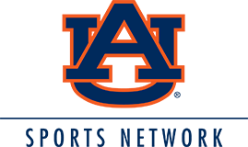

The Auburn Sports Network returns for another exciting sports season for 2019-2020. WWIC Radio will be the radio home for Auburn Tiger football, men’s basketball, baseball and the weekly “Tiger Talk” radio show.

You can join the excitement of another Tiger sports season with an affordable sponsorship.

This sponsorship includes:

Ads within each weekly “Tiger Talk” Radio Show
Ads within each Auburn Tiger Football Broadcast
Ads within each Auburn Tiger Men’s Basketball Broadcast
Ads within each Auburn Tiger Baseball Broadcast
PLUS

One 30-second ad each day, Monday-Friday, August 2019-May 2020. (20+ ads per month)

Monthly Net Investment: Call for more information

Greg Bell
256-599-2433 or 256-259-1050

Business - ____________________________
Approved By - ________________________
Date - _______________________________

