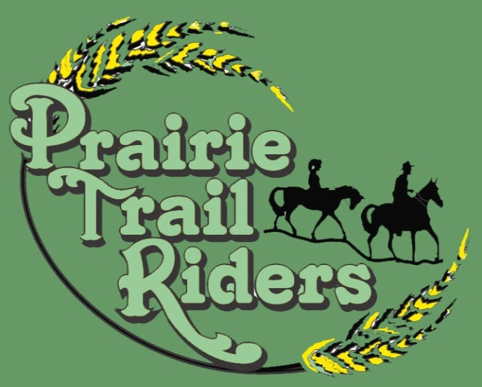
Tales & Trails
NEWSLETTER
Established 1990
Prairie Trail Riders, Inc is a not for profit organization
Web Site: http://www.prairietrailriders.com/

Here......Comes the News

The meeting was held at Mario’s on November 14, 2018
7 Members present 1 new members no guests

Pledge of Allegiance was said and meeting was called to order with 6 board members present

Secretary and Treasurers reports were accepted

Old business: Christmas Party will be December 1, 2018 @ Abes on Dirkson
at 6pm. Club will have a $10.00 grab bag gift exchange

New Business: 2018 Officers: President - Ellen Hart, V. President – Gloria Heggy or Judy Williams, Secretary - News Linda Gines, Treasurer – Rebecca Reed
Board: Lyle Beal, Gary Hampsmire and Rebecca Reed
Trail Ride Committee: Ellen Hart, Vicky Vandeveer & Linda Gines

Ride Point Winners: 1st Judy W, 2nd & 3rd Tie Ellen and Linda G
Happenings: 1/1/18 - Crazy Cold Man Ride

Next Meeting will be March 13th tba
Door prize won by Judy W
No 50/50
Meeting Adjourned

HAPPY THANKSGIVING

