- Where Quilts are Launched  Volume 12 Issue 1  February 2019  February Schedule  2. Groundhogs Day  3. Super Bowl  5. Am Group 9am (G)  5. PM Group 6pm(B)  6. Workshop “String Purse” 9am (G)  6. Sit N Sew 9am (B)  12. Am Group 9am (G)  12. Pm Group 6pm (B)  13. Sit N Sew 9am (B)  13. Board Meeting 9:30am (B)  14. Valentine’s Day  18. Washington’s Birthday/ President’s Day  19. AM Group 9am (G)  19. PM Group 6pm (B)  20. Meeting 9:30am (B)  26. AM Group 9am (G)  26. PM Group 6pm (B)  27. Sit N Sew 9am (B)  Symbols: (B) First Baptist Church  (G) St. Gabriel’s Church  February Birthdays  14th – Karen Lee  15th- Juanita Couch  19th – Donna Baldwin  19th – Joan Fachetti  19th – Shirley Moore  24th- Connie Duff  2019 Fat Quarters  February – Green  March – Yellow  April – Pink  May – Purple  June - Blue  July – No Drawing  August – Polka Dots  September – Orange  October – Brown  November – Any Holiday Print  December – No Drawing | Space Coast Quilters  Newsletter  2019 Officers  President Laura Grimsley 321-501-0679 mmemorys8@gmail.com  1st VP Sharon Hollenback 321-750-2565 itsallgreek.8080@yahoo.com  Treasurer Connie Duff 321-360-9720 connieduff88@gmail.com  Secretary Helen (Cindy) Gooden 321-604-5553 cgoodenskc8@gmail.com  Message from our President:  Greetings! Hope that everyone has had a Great New Year, and that all of you will be blessed with Happiness, good health, and prosperity in the year ahead.  Cracker Christmas was not as rewarding as the previous year, but we did get feedback for things that people were looking for: Christmas Place mats, Do-rags, Casserole carriers, half aprons, microwave potato bowls, Animal or pet stockings, coats or covers and blankets. We had microwave bowls (42) and they were sold the first day. We have a few months to look in to those things.  I'm looking forward to the coming year, hoping that it goes smoothly, and that this Guild will continue. We have classes planned, but we could use suggestions for anything that is of interest to you, or a presentation you would like to see.  Have you handed your Guild business card to someone? At My garage sale this past weekend Connie Duff and I talked about the Guild and passed out cards to everyone that looked like they might be interested in joining the Guild.  If you haven't attended a Guild meeting for some time, we would love to have you come back.  Laura  Space Coast Quilters Guild, Inc. General Meeting, January 16, 2019  The General Meeting was called to order by President Laura Grimsley at 9:35 a.m. Meeting was recorded. Members and guests recited the Pledge of Allegiance. Motion to approve minutes from November was made by Sharon Hollenback, seconded by Sherrianne Larson and Motion approved.  Treasurer: Connie Duff provided Profit and Loss/Balance Sheet information as of December 31. Included in her report were statistics for Cracker Christmas. President Grimsley related additional items requested by attendees: Do rags, half aprons, quilted casserole carriers, microwave bowls, Christmas placemats and pet stockings or toys.  Membership: Jan Brock reported 34 members and 3 guests were in attendance. Members were reminded that dues of $15 are due now. Members received new info cards with larger print on checking in.  President’s Notes: Former member, Pat Widick passed away. Diane Thompson from Tuesday group shared a news print picture of Love Lucas receiving an award.  Tuesday a.m. group will meet at St. Gabriel’s.  February 6 (1st Wednesday of the month) for Sit -n- Sew will be at St. Gabriel’s Church and post this information on the First Baptist Church door.  Katie Martin volunteered to open First Baptist Church door for Sit-n-Sew on January 30 so Laura can go on Lakeland trip. Contact Judi Sierer if you are interested There are 7 seats remaining on TGO bus for Lakeland for trip to Fabric Warehouse.  SCQG BUS TRIP!! Sharon Hollenback has arranged the trip to Trenton, Florida, (near Gainesville) on March 16, 2019’ for the one day only Trenton Museum, Historical Quilt Walk, Quilt Shop and Antique Shop. We have a Mears bus leaving from Titusville Home Depot promptly at 7:30 a.m. No Charge to members or $5 for non-members. It is a 3 hour bus trip with one stop. There are plenty of places to eat at the Trenton Quilt show. Eat on your own, either restaurant or food trucks. Leave Trenton at 3:30 p.m. and arrive Titusville at 6:30 p.m. Sign up sheet will be at February General Meeting.  Communications: President Grimsley received a thank you letter from Aging Matters. Sherry attended our meeting to express Aging Matters thanks for Guild donation at Christmas. Sherry read a lovely thank you note from one of their seniors receiving Meals on Wheels who is 97 years old.  Father Rob from St Gabriel’s requested baby quilts. President Grimsley will call their secretary, Karen, for number of quilts and size they are requesting.  Sunshine: Cards will be sent to Nancy Smith who welcomes text messages and cards. Cards will also be sent to Debby Bell and daughter, Kim Kemper. We are glad to have Eileen Guntner back with us today!  Old Business: SCQG Cards were provided to members last meeting to share with a potential new member or new members to come to a meeting. Card Drawing for a prize will be held in March.  Birthdays: President Grimsley announced our January birthday celebrants: Ellen Herring, Barbara Rathbun, Rosemary Earley, Jo Charvet, Elizabeth Sollogub, and Eileen Guntner. Members sang the Birthday Song.  Refreshments: Please see Andie Claudius to sign up for refreshments for an upcoming meeting.  Fat Quarters: Won by Janet Romer and Gay Van Vorst.  Basket drawings: Won by Jo Charvet (on her birthday) and Erica Stout?  Block of the Month (BOM): Janet Romer announced that Judith Riddle put together one of the last completed kits. For November kits, only 7 of the 29 have been returned.  Classes: Mona Margetts volunteered to do a demonstration on how to make square yo-yos following our meeting. First Wednesday, February 6, class at St. Gabriel’s String Bag class with Laura Grimsley. Fee for class $6. Members may donate $3 or the completed bag. Laura will have materials list and material. Cora Postlethwait volunteered to teach Poinsettia Table Centerpiece with date to be determined.  Joyce Tesdall will deliver a donation quilt to VFW Auxiliary North U. S. 1  Note: Dawn Edens volunteered to begin making Christmas stockings for 2019 season.  Show and Tell Presenters: Karen Martin, Katie Martin, Sherrianne Larson, Janet Romer, Caroline McQuade, Ellen Herring, and Candis Madison.  Meeting was adjourned at 10:45 a.m. Minutes submitted by Helen (Cindy) Gooden

Cont:
Birthdays: President Grimsley announced our January birthday celebrants: Ellen Herring, Barbara Rathbun, Rosemary Earley, Jo Charvet, Elizabeth Sollogub, and Eileen Guntner. Members sang the Birthday Song.

Refreshments: Please see Andie Claudius to sign up for refreshments for an upcoming meeting.

Fat Quarters: Won by Janet Romer and Gay Van Vorst.

Basket drawings: Won by Jo Charvet (on her birthday) and Erica Stout?

Block of the Month (BOM): Janet Romer announced that Judith Riddle put together one of the last completed kits. For November kits, only 7 of the 29 have been returned.

Classes: Mona Margetts volunteered to do a demonstration on how to make square yo-yos following our meeting. First Wednesday, February 6, class at St. Gabriel’s String Bag class with Laura Grimsley. Fee for class $6. Members may donate $3 or the completed bag. Laura will have materials list and material. Cora Postlethwait volunteered to teach Poinsettia Table Centerpiece with date to be determined.
Joyce Tesdall will deliver a donation quilt to VFW Auxiliary North U. S. 1

Note: Dawn Edens volunteered to begin making Christmas stockings for 2019 season.

Show and Tell Presenters: Karen Martin, Katie Martin, Sherrianne Larson, Janet Romer, Caroline McQuade, Ellen Herring, and Candis Madison.

Meeting was adjourned at 10:45 a.m. Minutes submitted by Helen (Cindy) Gooden

Helping Hands
Laura Grimsley Long Arm Quilting 321-501-0679
Candi Madison Long Arm Quilting 321-265-1999
Karen Lee Long Arm Quilting 321-720-1584
Rose Palek Binding 321-267-7513
Janet Romer Labeling 321-269-4009

November Block of the Month Directions

 | Similar in appearance to Churn Dash...this version of a Lover's Knot Block is a very easy one to make! It's a 12" block! | 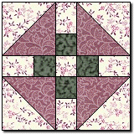 | Please abide by the Terms and Conditions of use! :o)

** Preparing the Pieces and Sewing the Block **

First cut the Color 1 2-1/2" x 14" strip into four 2-1/2" x 3-1/2" rectangles....

Next cut the Color 3 2-1/2" x 10" strip into four 2-1/2" squares...

 | 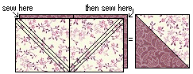 | Now speed piece the half squares by stacking the Color 1 and Color 2 5-7/8" x 11-3/4" strips right sides together. On the back of the top strip lightly mark the diagonals and the 5-7/8" square line, and sew a scant 1/4" above and below the diagonal lines. Cut apart on the marked diagonals, and on the square line. Press seam allowances towards the darker fabric. This will give you four half squares. Trim these back to measure 5-1/2" if needed...

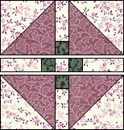 |  | Next sew a Color 3 2-1/2" square to one end of each Color 1 2-1/2" x 3-1/2" rectangle...

 | 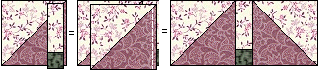 | Sew one of the rectangle strips to the right side of a large half square, referring to the diagram at left for orientation of the pieces. Add another half square to the other side of the rectangle strip. Press seam allowances towards the center strip. Make two of these units...

Now sew the extra Color 1 2-1/2" square between the last two rectangle units. Press seam allowances towards the outer rectangles...

Piece the block in the order shown at left, alternating pressing directions as you add rows.

 | 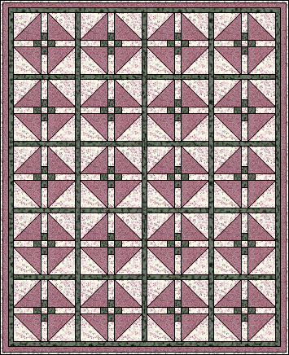 | Here's a simple quilt, with sashing around the blocks, two thin borders strips, and a narrow binding...  Happy Quilting!!  Marcia :o)

** Supplies List **

 | Color 1 | Color 1 needs: one 2-1/2" x 14" strip AND one 5-7/8" x 11-3/4" strip AND one 2-1/2" square

 | Color 2 | Color 2 needs: one 5-7/8" x 11-3/4" strip

 | Color 3 | Color 3 needs: one 2-1/2" x 10" strip

To the Patterns or The Quilter's Cache

 | May 4 2000 Marcia Hohn |  | Page 1

 | Traditional Block | pattern from http://www.quilterscache.com
EVENTS 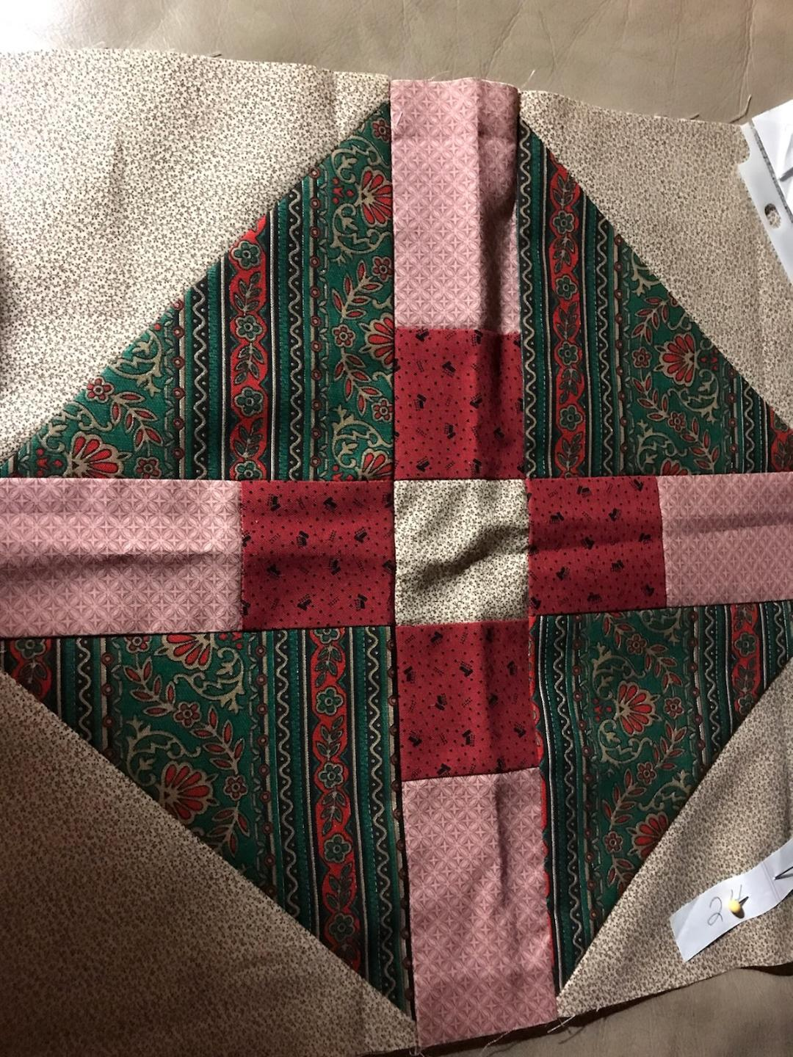
World Quilt Florida January 31st-February 2nd 2019
The Tampa Convention Center
333 South Franklin Street, Tampa FL 33602
String Purse Class February 6th, 2019
Guild Class will be held at St Gabe’s at 9:00am
Vero Beach Sunbonnet Sue
Local Quilt Show Feb 7, 8 and 9th 2019
Original Sewing and Quilt Expo March 14, 15 & 16 2019
Lakeland FL
Sewingexpo.com 800.699.6309
Trenton Bus Trip March 16th 2019
SCQG BUS TRIP!! Sharon Hollenback has arranged the trip to Trenton, Florida, (near Gainesville) on March 16, 2019’ for the one day only Trenton Museum, Historical Quilt Walk, Quilt Shop and Antique Shop. We have a Mears bus leaving from Titusville Home Depot promptly at 7:30 a.m. No Charge to members or $5 for non-members. It is a 3 hour bus trip with one stop. There are plenty of places to eat at the Trenton Quilt show. Eat on your own, either restaurant or food trucks. Leave Trenton at 3:30 p.m. and arrive Titusville at 6:30 p.m. Sign up sheet will be at February General Meeting.
  - Gainesville Tree City Quilters May 3rd and 4th 2019

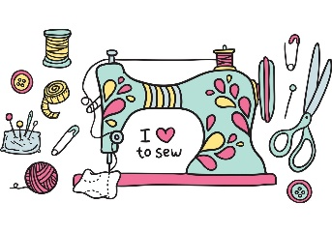
February Class 2/6/19

String Purse
Material Needed for String Purse

2 pcs of coordinating fabric at least 25 " x 16"
40" of coordinating cording

Reminders
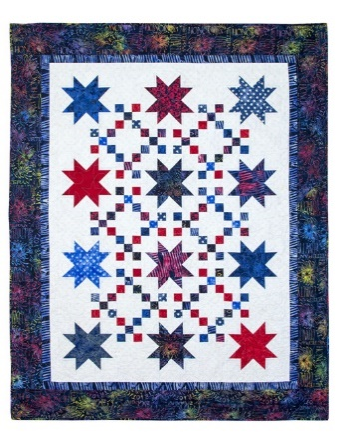
November and January Block of the Month are due February 20th, 2019

Looking for a volunteer to donate Raffle Quilts

Aging Matters needs Patriotic Quilts that are 40x40

We need volunteer speakers

We need volunteers for class projects.

For you to access the private part of our website where the roster will be available, you need to contact Jessica Gaudi, our Webmaster, as we do not hand this information out to the public.
jessicasanimals@aol.com

Food Volunteers for February’s Meeting:
Katie Martin, Sherrianne Larson, Ellen Herring and Cora Postlethwait
February Tip-
Looking for a Quilting App for your Phone???

Robert Kaufman Quilt Calculator

Thank you, Jeanette Kidd, for sharing!
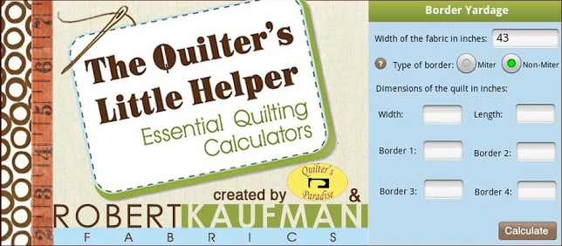
This app calculates yardage for:
Batting & backing
Piece count
Piece to yardage
Binding
Border
Square in a square
Set in & corner triangles
Available on
  - As well as the website: http://www.robertkaufman.com/quilting-calculators/

  - Contact Us

Editor: Katie Martin Phone 513-293-1639 Email Kiki989515@aol.com
Guild Mailing Address P.O. Box 2996 Titusville, FL 32781-2996

