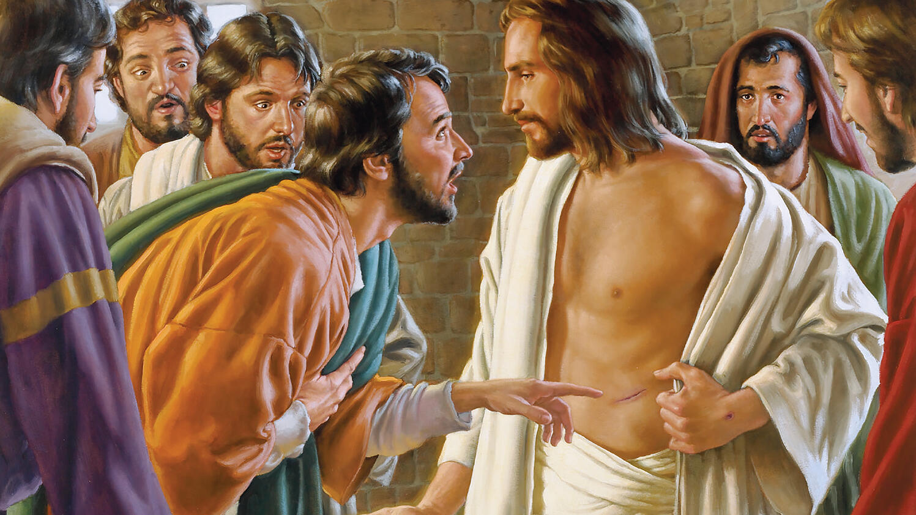
May 1, 2022

3rd Sunday in Easter

Carson City United Methodist Church

10:30 am

Greeting/Announcements

Call to Worship

L: Blessed are those who hear the word of God and obey it.
P: Blessed are those who hunger and thirst for righteousness, for they will be filled.
L: Blessed is the one who trusts in the Lord, whose confidence is in him.
P: Blessed are the merciful, for they will be shown mercy.
L: “Blessed are you when people insult you, persecute you and falsely say all kinds of evil against you because of your belief in Jesus Christ.
P: Blessed are those who are persecuted because of righteousness, for theirs is the kingdom of heaven.
L: blessed are those who have not seen and yet have believe.
P: For just as Abram’s belief in God was credited to him as righteousness, so will God credit our belief in Jesus Christ as righteousness to us.
*Hymn: I Come with Joy UMH 617

Opening Prayer: (unison) (from Patrick of Ireland)
We bind ourselves today to the power of God to hold and lead us, God’s eye to watch over us, God’s might to protect us, God’s ear to hear our needs, the wisdom of God to teach us, God’s hand to guide us, the word of God to give us speech, God’s heavenly host to be our guard. Praise to the Lord of our salvation, salvation is of Christ the Lord. AMEN
Contemporary Song: You Saved the Day (Phillips, Craig & Dean)

Offering

Doxology UMH 95

Offertory Prayer

Sharing of our Joys and Concerns

Call to Prayer: Turn Your Eyes Upon Jesus UMH 349

Pastoral Prayer

COMMUNION

Gospel Reading: JOHN 20:24-29

Old Testament: PSALM 103:17
Epistle Lesson: 1 PETER 1:8
Worship War Zone Song: Everywhere I go

Children’s Church

MESSAGE

*Hymn: Sent Forth by God’s Blessing UMH 664

Benediction

CCUMC – Announcements & Upcoming Events:
==========================================
As a courtesy to others please silence
or shut off cellphones
==========================================
United Women of Faith (UWF, formerly UMW): Salad Potluck, Mon, May 9th, 5:30 pm. Everyone is welcome to come learn about the Lutheran Quilt Project and what UWF is all about. Bring own table service and a salad to share. Drinks provided. For questions, call WalthaGaye at 989-640-0238.
==========================================
Native American Ministries Sunday, May 1:
Native American Ministries Sunday is one of six churchwide Special Sundays with offerings of The United Methodist Church. Native American Ministries Sunday serves to remind United Methodists of the gifts and contributions made by Native Americans to our society. The special offering supports Native American outreach within annual conferences and across the United States and provides seminary scholarships for Native Americans. To donate make checks payable to CCUMC or via credit/debit card at: ResourceUMC.org/SSgive
There are also card handouts located throughout the Church.
==========================================
National Day of Prayer: Is Thursday, May 5th. There is a Prayer gathering being held at the old city hall at 7:00 pm. Everyone is welcome to attend.
The theme for the 2022 National Day of Prayer is a call to praise in prayer, ‘EXALT THE LORD, WHO HAS ESTABLISHED US’ based on Colossians 2:6-7 NIV
⁶ Therefore, as you have received Christ Jesus the Lord, so walk in Him, ⁷ having been firmly rooted and now being built up in Him and established in your faith, just as you were instructed, and overflowing with gratitude.
For more information, or to donate, go to https://www.nationaldayofprayer.org/
==========================================
VBS meeting: Tues, May 10 @ 6:00 pm.

LAST DAY REMINDERS BEFORE FOR SUMMER

====================================
Euchre:
Last game for summer is Sat, May 7th
====================================
Cool Hour & Children’s Church:
Last day for these two is Sun, May 15th,
which will also be Celebration Sunday.
====================================
ARK:
Last meeting is Wed, May 18th
====================================
Women’s Group:
Last meeting is Sun, May 29th
====================================

Serving & Supporting Sunday Worship
Audio/Video: Pat Monroe
Children’s Ministry Audio/Video: Colin Fitzpatrick

Joys, Concerns & Prayer Request
For those battling cancers:
Jim Dunlap, Carolyn Nykerk, Ray Seaman,
Dillan Abell, Andrew Hogan,
Amorena Newman-Wojciakowski

For all who needs support, guidance or has health concerns.

Monthly Giving
4/3 $2314.04 4/10 $2158.30
4/17 $1704.76 4/24 $7282.15

Nursery Schedule
5/1 & 5/8 Maryann Severson 5/15 Chris Benjamin
5/22 Jenna Benjamin 5/29 Alex Krantz

Lighting of Candles

Passing of Collections Plate

Children’s Church
5/1 Roberta Kile

Our Church in Ministry This Week
Sun: Women’s Group 6:30-8 pm
Mon: PT Class 6:30-8 pm
Tue & Thu: COA Meal @ Noon

Coloring Page

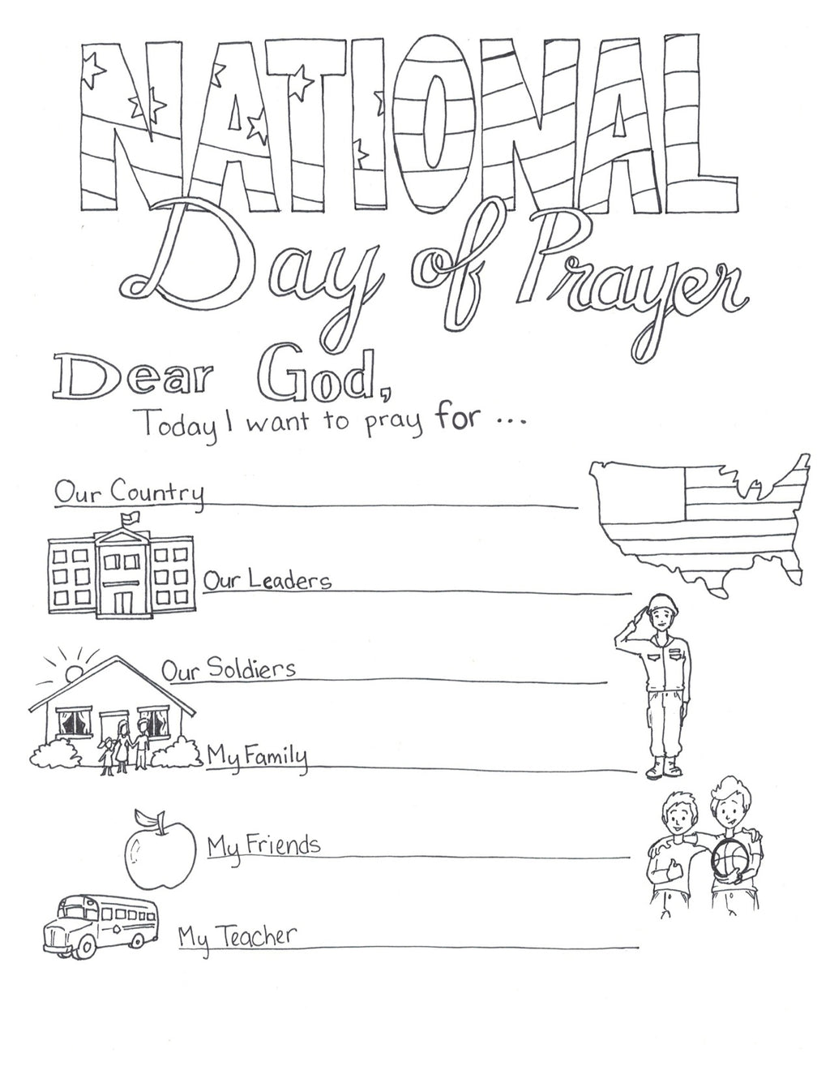

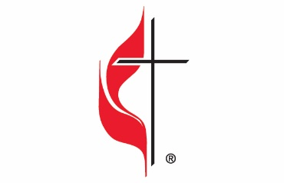

Carson City United Methodist Church
Location: 119 East Elm St., Carson City, MI
Mail: PO Box 298, Carson City, MI 48811
Phone: 989-584-3797 Email: carsoncityumc@gmail.com
Website: carsoncityumc.com
Sunday Worship Service: 10:30 am
Office Hours: Monday-Thursday, 9:00 am-12:00 pm
After hours by appointment
Pastor: Ian McDonald 906-322-5318
Secretary: Bonnie Seaman 989-763-1674

Weekly Sunday Bulletin now available on our website
@ www.carsoncityumc.com

“Father, thank You for Your promise to hear me when I pray, regardless of where I may be”

