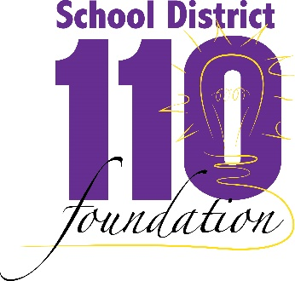

District 110 Foundation
Scholarship for Public Service

This scholarship will be awarded to the senior who best exemplifies a spirit of public service and commitment to community through volunteering efforts. These public service efforts should be in addition to the requirements of the National Honor Society, Future Leaders of America or other school organizations.

NOTE: This application must be typed in order to be considered.

Name:

Address:

Telephone:

- List your public service involvement in chronological order. Include a brief description of each service and your level of participation. (Do not include paid positions)
- What are your educational and career goals for the future?
- Briefly describe the value of your public service work and the personal changes you have experienced.
- List three references who know of you and your accomplishments. The School District 110 Foundation may contact one or more references.

References | Name | Position | Telephone
School

Community

Other

Return application to Waconia High School Guidance Office

