REGULAR MEETING
NOVEMBER 19, 2014

A Regular Meeting of the Town Board of the Town of Hampton, County of Washington and the State of New York was held at the Town Hall, 2629 State Route 22A, Hampton, New York on the 19th day of November, 2014.

PRESENT: David K. O’Brien----------Supervisor
Tamme Taran---------------Councilwoman
David Jensen----------------Councilman
Donald Sady----------------Councilman
Andrea Sweeney-----------Councilwoman-absent
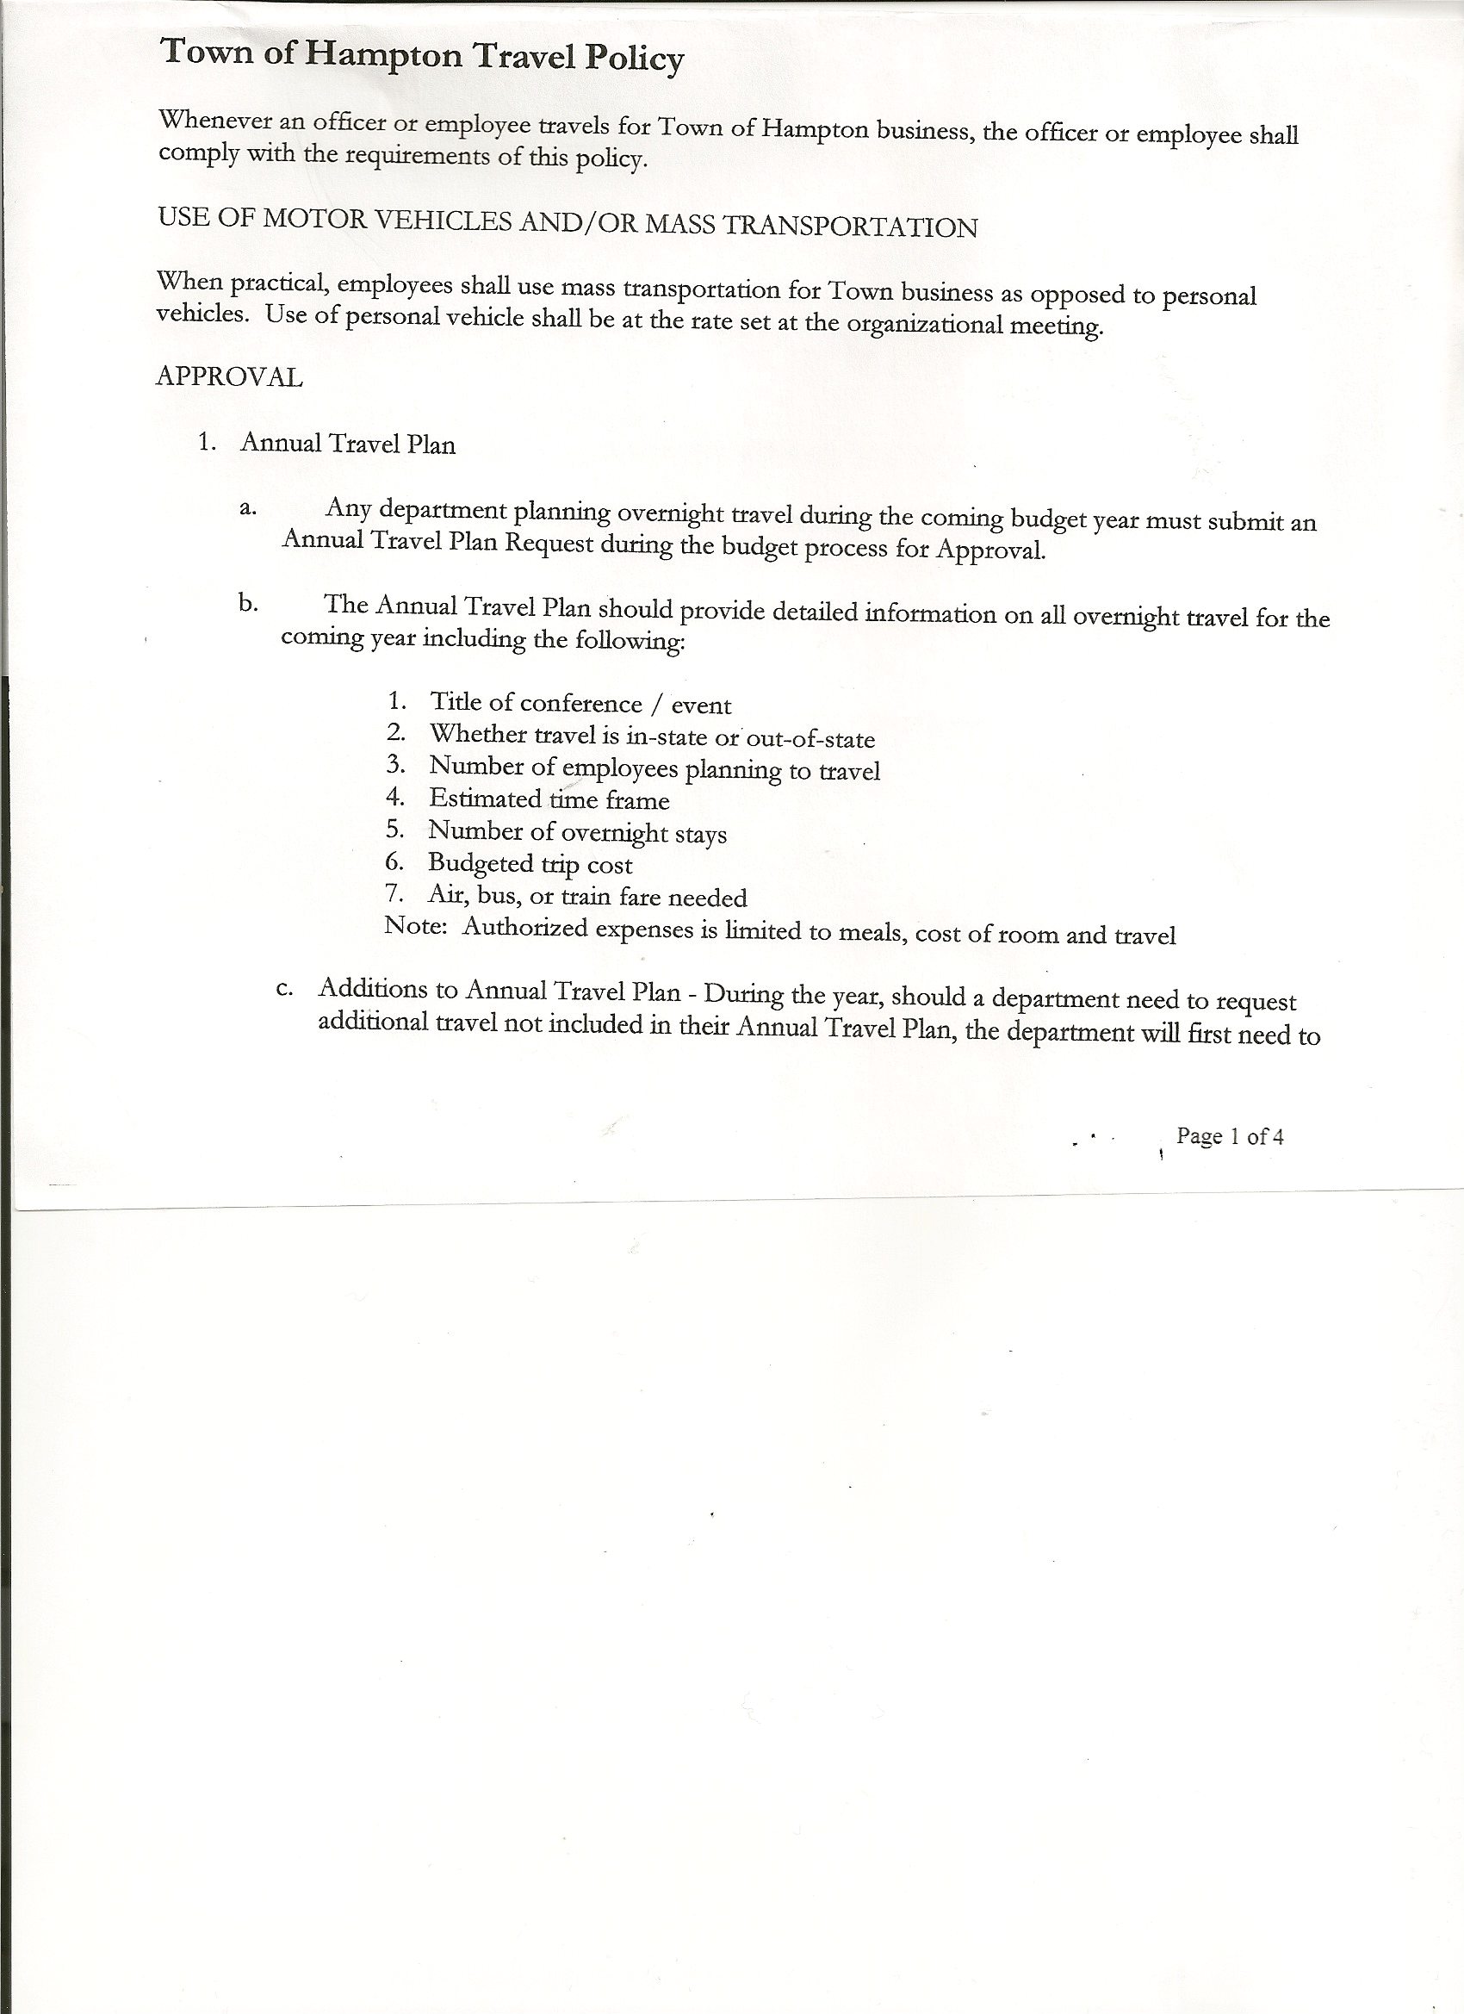 Rebecca Jones--------------Town Clerk
Camilla Shaw---------------Tax Collector/Deputy Town Clerk
Herbert Sady, Jr.------------Highway Superintendent

Planning Board Member(s): Bonnie Hawley, Chair and Frank Baker

Also present: See attached list

The meeting was called to order by Supervisor O’Brien at 7:30pm followed by the Pledge of Allegiance. Location of Fire Exits were given.

Supervisor O’Brien asked for a moment of silence in memory of Walter Gysel, Mirror Lake.

RESOLUTION NO. 96-2014
APPROVAL OF THE MINUTES
On a motion of Councilwoman Taran, seconded by Councilman Jensen, the following resolution was
ADOPTED: Ayes 4 O’Brien, Taran, Jensen, Sady
Nays 0
Absent 1 Sweeney
RESOLVED that the Public Hearing/Regular Town Board Minutes for October 15th, 2014 are approved.

Planning Board Report…Bonnie Hawley, Chair
- Continuing to work on mobile home campground law
- Vacancies on the Planning Board…Joe Panoushek will be resigning at the November meeting and Heather Spaulding-Gale will be resigning at the end of December 2014. Alternate member Dianne Sofia will fill one of the vacancies, still need one more plus an alternate.
- Next Planning Board Meeting will be Tuesday, November 25th, 2014 at 7:00pm at the Town Hall

Larry Carman, Dog Control Officer submitted his report, which was read by Supervisor O’Brien, copy of report is attached for 10/11 – 11/16/2014. In addition, Supervisor O’Brien picked up two dogs on County Route 18, they were taken to our shelter service in Greenwich, both have been adopted.

Camilla Shaw, Tax Collector….no activity, zero balance.

TOWN BOARD MEETING
NOVEMBER 19, 2014 PAGE 2

Herbert Sady, Jr., Highway Superintendent gave his report: (a copy is attached)
- On October 16th, Nathan Saxton gave his official notice of resignation effective October 27th, 2014
- Hired two (2) new employees…George Palmer @ $11.50/hour and Tyler McClure @14.00/hour, positions are pending a drug test and physical
- New chain in the 2000 International and rebuilding the spinner, seals were leaking and shaft was worn from the sand inside of it and wasn’t cleaned out.

RESOLUTION NO. 97-2014
APPROVAL OF SUPERVISOR’S MONTHLY REPORT
On a motion of Councilman Sady, seconded by Councilwoman Taran, the following resolution was ADOPTED Ayes 4 O’Brien, Taran, Jensen, Sady
Nays 0
Absent 1 Sweeney
RESOLVED that the Supervisor’s Monthly report be accepted as submitted for OCTOBER 2014.
09/30/14 10/31/14
ACCOUNT BALANCE RECEIPTS DISBURSEMENTS BALANCE
General Fund $ 111447.39 $ 4768.06 $ 54181.33 $ 62034.12
Highway Fund $ 32355.86 $ 49309.61 $ 12976.24 $ 68689.23
Equipment Reserve $ 85131.09 $ 7.23 $ 0.00 $ 85138.32
Fire #1 $ 15992.50 $ 3.54 $ 0.00 $ 15996.04
Fire #2 $ 2362.00 $ 0.00 $ 0.00 $ 2362.00
Totals $ 247288.84 $ 54088.44 $ 67157.57 $ 234219.71

All Board Members present signed Supervisor’s Report.

County News….Budget up for adoption on Friday, November 21st, with a 2.85% increase. New Highway Superintendent, Steve Haskins has been hired.

Received a letter from Mary Ellen Hill-Pierce,(copy of which is attached) she’s going to be retiring, but would like to continue to be Hampton’s Town Assessor, in order to do that she needs to resign effective December 31st, 2014 and be reappointed after January 1st, 2015.

RESOLUTION NO. 98-2014
RESIGNATION OF MARY ELLEN HILL-PIERCE AS TOWN ASSESSOR
On a motion of Councilwoman Taran, seconded by Councilman Jensen, the following resolution was ADOPTED Ayes 4 O’Brien, Taran, Jensen, Sady
Nays 0
Absent 1 Sweeney
RESOLVED to accept the resignation of Mary Ellen Hill-Pierce as Town Assessor, effective December 31, 2014 for retirement purposes.

TOWN BOARD MEETING
NOVEMBER 19, 2014 PAGE 3

Employee Handbook….modeled after Hartford’s Handbook, was handed out to Town Board Members for their review and will discuss at December meeting.
Drug and Alcohol Testing Policy was also handed out for Town Board members to review.

June West, resident of Greenfield Lane asked how many times a year are employees required to be tested? Highway Superintendent Sady responded…four (4) times a year needed to be drug tested according to DOT (Department of Transportation).

Doran Pratt, resident of Hills Pond Road commented that the employees should have been tested prior to being hired.

DISCUSSION REGARDING CEMETERIES IN TOWN…..a lot of stones are broken and/or tipped over, Supervisor O’Brien would like to work on repairing them, he has spoken with Senator Little about funds that maybe available.

Fire Department Contracts have been received back from both Hampton Volunteer Fire Company and Town of Fair Haven, VT.

Received Financial Statement from Fair Haven Rescue Squad.

RECORDS VAULT that was built downstairs….discussed storage and access. Will continue to work on a solution for access.

COUNCIL/PUBLIC COMMENTS:
Supervisor O’Brien stated many changes have taken place…the Comptroller’s Office was pleased with the Town Board’s decision to update the existing policies and to add new policies, as recommended. It was also noted that the Personnel and Clerk records were in order and Supervisor O’Brien added a Thank You to Personnel Officer, Kim Perry and Town Clerk, Rebecca Jones for a job well done.

Resident Leonard Reed commented that information should be shared with the townspeople and not held back…for i.e. information on highway employee resignation.

Resident Doran Pratt inquired about the return of his wood…Highway Superintendent Sady responded that the wood would be returned.

The Town Clerk’s report for October 2014 was submitted to the Board. The Town Clerk had Board Members review and sign bank reconciliation statements for the Town Clerk Account and Special Town Clerk Account dated October 31st, 2014.

TOWN BOARD MEETING
NOVEMBER 19, 2014 PAGE 4

RESOLUTION NO. 99 -2014

AUDIT OF CLAIMS
On a motion of Councilwoman Taran, seconded by Councilman Sady the following resolution was ADOPTED Ayes 4 O’Brien, Taran, Jensen, Sady
Nays 0
Absent 1 Sweeney
RESOLVED that the bills have been reviewed by the Town Board and are authorized for payment in the following amounts.
General Fund No. 147 through No. 162 $ 10453.87
Highway Fund No. 120 through No. 132 $ 11102.29
Total both funds $ 21556.16

On a motion of Councilwoman Taran, seconded by Councilman Sady, the meeting adjourned at 9:10pm. All in favor Aye.

Respectfully submitted,

Rebecca S. Jones, RMC
Town Clerk

