Andrew R. Reitnauer
President, NYIAI
NYIAIPresident@gmail.com

Dear Prospective Vendor,

The New York Division of the International Association for Identification is one of the association’s longest standing divisions. New York is home to many of the nation’s premier forensic laboratories and practitioners. In 2014, the Division’s relaunch was a very successful campaign, highlighted by the annual educational conference in Syracuse. In total, we had approximately 80 participants, both students and practitioners, in attendance. Our support and participation of our vendor supporters was a key to our success at the event, and the feedback and suggestions from you are a kay to our evolvement and continued success again this year.

Currently, our conference is scheduled to return to the Crowne Plaza from Friday, October 9 through Sunday, October 11, 2015. We are currently planning for all social events and vendor exhibit times to be on Friday and Saturday, with Sunday acting as an additional day for class sessions only. We will have a number of sponsorship opportunities for your consideration. Below I have outlined the various opportunities at the conference. Our vendor room will be in close proximity to all rooms being used during the duration of the conference, and this room will be made available to you all day Friday and Saturday.

Our vendor area tables will remain at $250 this year, and you are able to set up and maintain your area all day Friday and Saturday. Registration for a table may be done online. All participating vendors will also have their company logos placed on our webpage again this year in addition to a full page ad in the conference brochure. If you have an additional interest in sponsoring one of our events, please contact me directly.

On Friday, October 9, we are planning to open the conference with a breakfast meeting starting at 7:00am, with the meeting being held from 8:00-9:00am. We will have a poster designating the sponsorship present at the breakfast table. ($500 sponsorship)

On Friday evening, our classes will be ending at approximately 4:30pm. At 5:00, we are planning a cocktail social. ($1,500 sponsorship). During the social, we will also have on display photographic exhibits from the students of Syracuse University taken during their forensic coursework. If someone chooses to sponsor this event the sponsor will be given:
- A waiver of the $250 registration fee for the vendor area table
- A one hour block during the conference to give a presentation
- The Division will supply cocktail napkins with the sponsoring vendor’s logo at the event.

Saturday morning, we will be offering a continental breakfast prior to the start of our class sessions at 8:00AM, the breakfast will be available from 7:00AM-9:00AM. We will have a poster designating the sponsorship present at the breakfast table. ($500 Sponsorship)

Between 11:00AM-Noon we are planning a formal conference break in the vendor area. Anyone sponsoring this break will have a poster designating sponsorship, along with a specialized ad within the conference brochure. ($500 Sponsorship)

On Saturday evening following the afternoon class sessions, we will be holding our annual meeting immediately followed by the conference banquet. All participating vendors will also be given one admission to the banquet. The costs for the banquet will be $2,500. Any sponsor of the banquet will also have:
- Their registration fee waived for the vendor area for 2015 and 2016
- A full page ad in the four issues of the 2016 NYIAI Newsletters
- A one hour block during the conference to give a presentation
- Company posters placed within the room designating sponsorship.

We will also be accepting any door prize donations from any sponsors. Anyone offering a door prize will also be included in the registration booklet and have their company logo listed on our website.

On behalf of the New York Division of the IAI, we thank you for your consideration and support of the mission of the NYIAI. Without your continued support, we would not be able to continue to advance the field of forensic science within this state.

Sincerely,
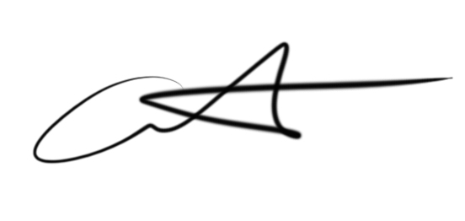
Andrew R. Reitnauer MSFE, CLPE, CLE, CSLE, CSCSA, CPO , F.F.S.
President, New York Division of the International Association for Identification

