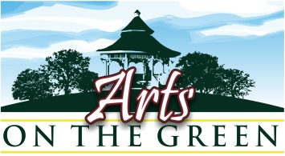
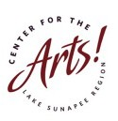

2015 Registration Form for Accepted Juried Artists
Registration Form and Payment must be received no later than April 15th to reserve space
and be included in publicity for the show (postcards, posters press releases, and ads)

Mail Registration Form and check to: Center for the Arts AOG – PO Box 872 – New London, NH 03257
OR Email Registration Form to aog@centerfortheartsnh.org AND
Pay with PayPal online at http://www.centerfortheartsnh.org/arts-on-the-green.html

$100 / $90 for CFA Members 2015 Artist membership is $25.
To also become a 2015 CFA member at this time please submit $115

Name _________

E-mail_______________________________________________Phone________________

Website __________

Mailing Address__________________________________________________________

zip

I will display: Fine Arts_______ what medium?______________________________________
Fine Crafts_____ what medium?______________________________________

- If you would like your artwork to be considered for Publicity purposes please email 3 images to aog@centerfortheartsnh.org labeled with your name and title of artwork by April 15th.

- If you would like to donate a piece of art for the AOG Raffle please indicate here: size, media, and title_________________________________________________________________________

- Please drop off donated Artwork to the CFA Info booth no later than 8:30.

- Clearly Label all Artwork on the back as indicated above

- No payments will be refunded for any reason after April 15th .

I have read, understand and agree to all of the statements in this application, and will not hold the Center for the Arts or any of its constituents liable for any injury or loss to me while participating at this event.

Signature: Date

Questions? Contact aog@centerfortheartsnh.org chk #_________ or Paypal________

