

2021
Doubles Open

Some close matches in Round one of our Doubles Open with Keith Pinel & Graeme Follain just edging Brian Harris & Paul Le Moine 10-9 and Cassie & Jean Stewart beat Neil Selby & Ross Payne 13 – 11.

Keith Boleat & Vanessa Nash also won 13 – 11 against Branden De La Haye & Tim Jackson but there were big wins for James Rondel & Matt Pinel over newcomers Adam Bellamy & Sam Smith 13 – 2. A similar score as Geoffroy Buffetrille & Matt Buesnel beat Sam Collin & Zack Morgan 13 – 1 and Andrew Bellamy & Callum Stewart beat Barry & Nicky MainDonald 13 -1.

Round 2 saw Laurent Pellaton & Toby Northern lose 13 – 6 to Geoffroy & Matt and Andrew & Callum to Christine Eccles & Paul Waters 12 – 9.

James & Matt also lost to Alan Lahiffe & Matt Scholefield and Gary Cowburn & Wendy Ritzema beat cassie 7 Jean 10 – 9. Brian & Paul suffered a surprising 13 – 1 defeat to Kevin Daly & Chris Fennel.

Round 3 saw Laurent & Toby just get the win 11 – 10 over Keith Boleat & Vanessa Nash with Andrew & Callum just beating Brandon & Tim 13 – 11.

Graeme & Keith beat Geoffroy & Matt 13 – 11 in a big win and Neil & Ross moved into contention with a 13 – 3 win over Kevin & Chris. Barry & Nicky won their first match against Adam & Sam 11 – 8 and Matt Hutchings & Mo De Gruchy came back from suffering a 13 – 0 loss in round 2 to Bob Morel & Colin Sutherland to win 13 – 0 in round 3 against Sam & Zack.

Round 4 saw friends and newcomers play each other as Adam & Sam beat Zack & Sam 13 – 9 for bragging rights.

Laurent & Toby’s chances were dealt a big blow as they lost 13 – 1 to Andrew & Callum. Kat Stewart & Paul Bell won their second match with a 13 – 11 win over Branden & Tim to give them a chance of progressing.

Neil & Ross lost to James & Matt 12 – 9 which was the same score as Bob & Colin lost to Brian & Paul.

In the final round Alan & Matt beat Andrew & Callum with the latter finishing top of the teams with three wins 15 BHN to claim 4th place with Alan & Matt finishing top as the only team with five wins from five.

Graeme & Keith finished second with a 12 – 10 win over Gary & Wendy who also qualified in 5th.

Laurent & Toby beat Kat & Paul 13 – 11 to also make the top 8 in 8th at the expense of their opponents. Christine & Paul beat Cassie & Jean 13 – 11 also taking 6th place as some really close matches determined the final eight.

Final Rankings

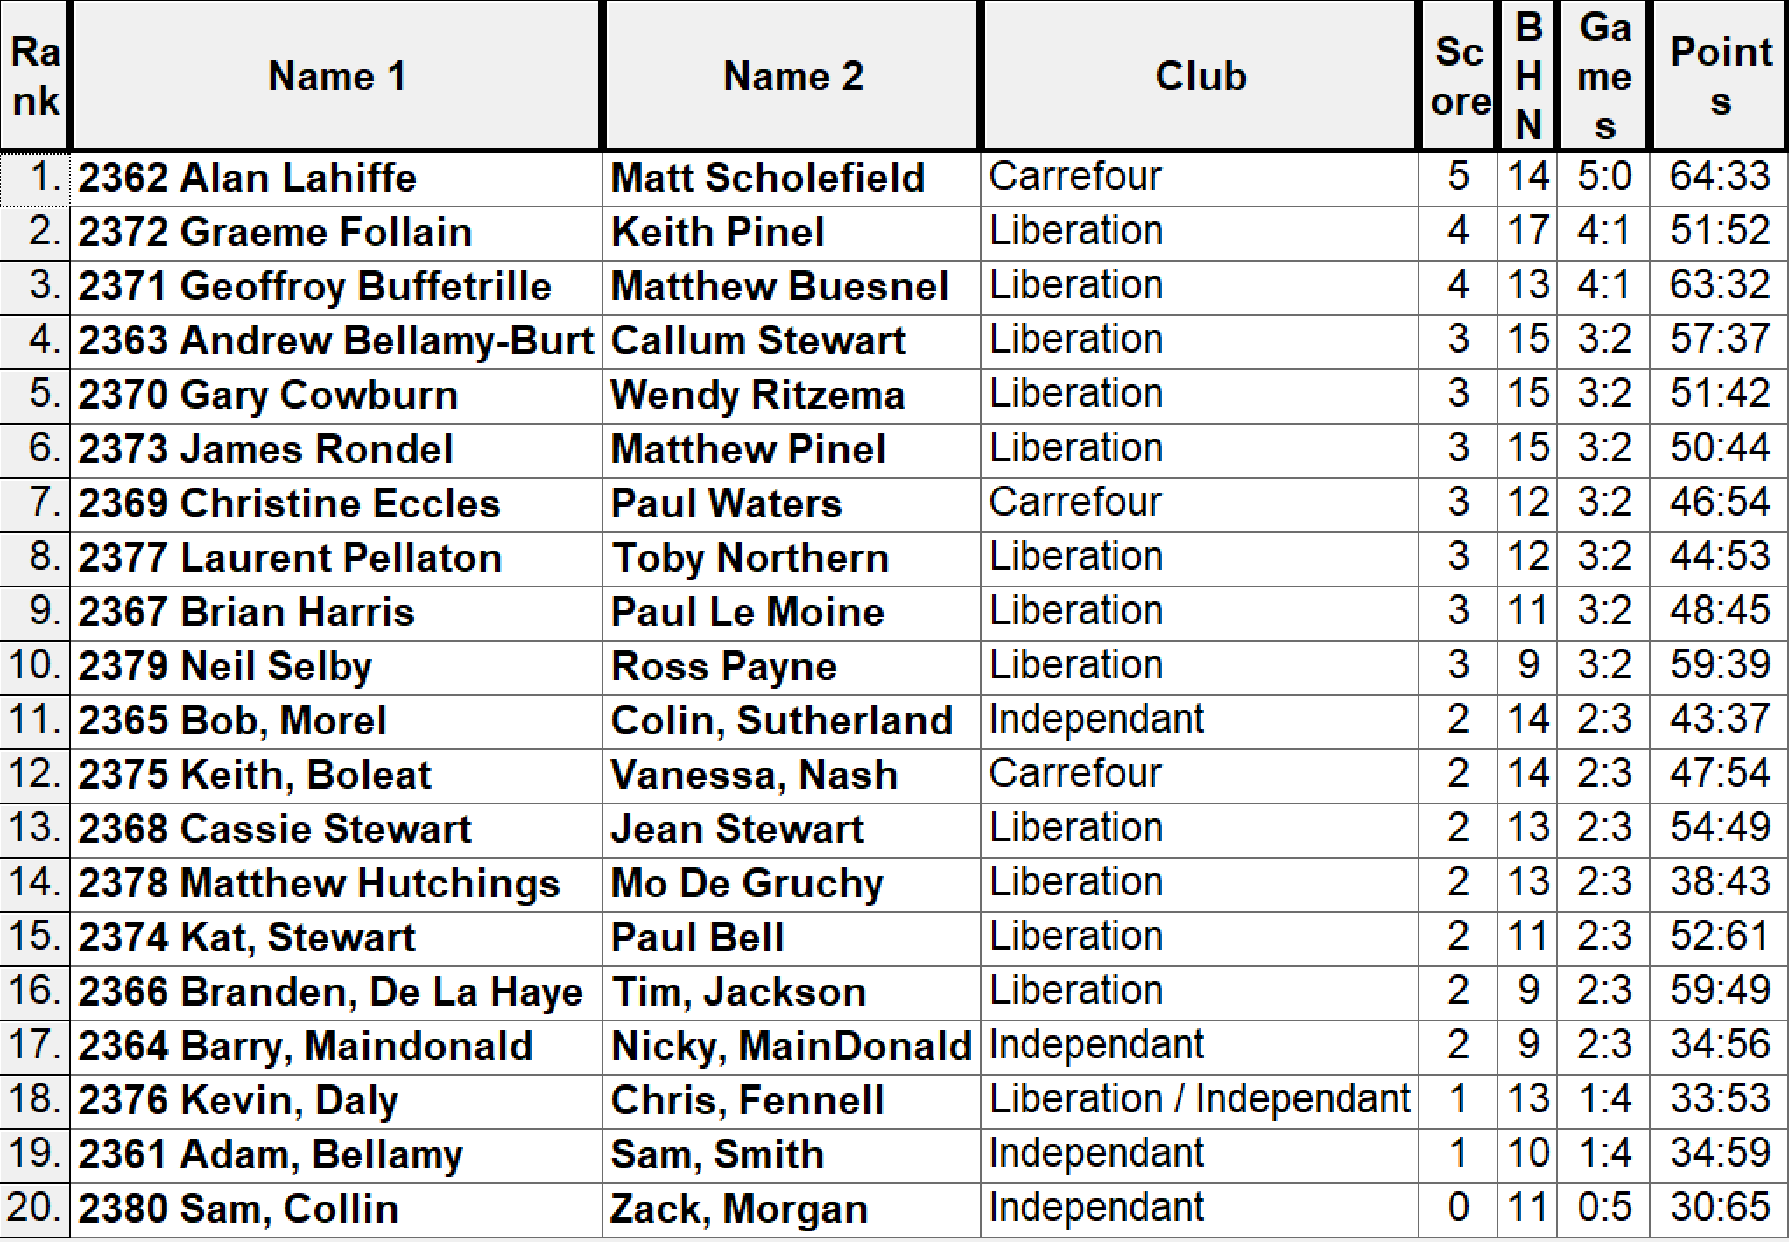

Quarter-Finals

Ranked 1st Ranked 8th

Alan Lahiffe & Matt Scholefield v Laurent Pellaton & Toby Northern

Ranked 2nd Ranked 7th

Graeme Follain & Keith Pinel v Christine Eccles & Paul Waters

Ranked 3rd Ranked 6th

Matt Buesnel & Geoffroy Buffetrille v James Rondel & Matt Pinel

Ranked 4th Ranked 5th

Andrew Bellamy-Burt & Callum Stewart v Gary Cowburn & Wendy Ritzema

Well the Swiss system curse struck yet again as Laurent & Toby hit top gear for the first time in the competition winning comfortably 13 – 5 over Alan & Matt as the top ranked team went out.

Well it didn’t stop there as the ranked two team also went out as Graeme & Keith could not get in the game against Christine & Paul who ran out comfortable winners.

Geoffroy & Matt made it back-to-back wins over James & Matt having already beat them 13 – 2 in round 5 winning again, albeit a bit closer 13 – 6. It wasn’t as close as Andrew & Callum v Gary & Wendy with the latter 10 – 7 up and holding saw Gary disastrously decide to shoot with his last boule giving 2 points away before Andrew & Callum gained a win that should not have been.

Semi-Finals

Ranked 4th Ranked 8th

Andrew Bellamy-Burt & Callum Stewart v Laurent Pellaton & Toby Northern

Ranked 3rd Ranked 7th

Matt Buesnel & Geoffroy Buffetrille v Christine Eccles & Paul Waters

Andrew & Callum had already beaten Laurent & Toby 13 – 1 in round 4 but this was much closer at 7 – 7 but three mis fires from Laurent let them in and they didn’t score another point as Andrew & Callum made another final.

Geoffroy & Matt played Christine & Paul who were playing well, but the final was just a step two far as Geoffroy & Matt took the match 13 – 8.

Christine & Paul ended the tournament in style taking third place over Laurent & Toby 13 – 8.

The final started off well for Andrew & Callum taking an early 5 – 1 lead but Geoffroy & Matt who had lost the club doubles Cup final to Andrew & Callum were not going to let in happen twice as they fought back to win 13 – 9.

WINNERS

Geoffroy Buffetrille & Matt Buesnel

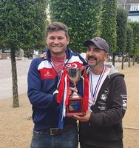

Great seeing new players taking part, enjoying the sport and of course doing really well.

Special thanks to James Rondel, Matt Pinel and Matt Buesnel and everyone else helped on the day.

Kind Regards

Toby Northern

Chairman

Liberation Petanque Club

