Texas History with Mr. Brown Name ____________________ Period _____
Ch 11 An Independent Texas p.236 -255
Chapter 11 Picture Search
Directions: Use the pictures, maps, graphs, and their captions to find the following information.

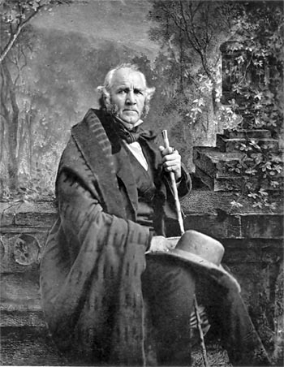
1) Who was the overwhelming winner of the election of 1836 that became the first elected President of Texas? _________________________________________________________________________
2) How many present day states hold land once occupied by the republic of Texas? ________
3) Whose calling card appears on page 239? _____________________________________________
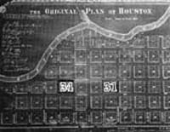
4) What is the name of the city that the Allen brothers started? _____________________
5) _________________________________ money was issued in the amounts of 1, 2, 3, 5, 10, 20, 50, 100, and 500.
6) What was Felix Huston’s profession prior to the Texas Revolution? ________________
7) Houston made a treaty with which Native tribe living in East Texas? ___________________________________
8) Who was elected president of the republic of Texas in 1838? ____________________________________________
9) Chief ____________________ negotiated and signed a treaty with Sam Houston in 1836?
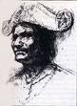
10) The Santa Fe Trail connects Santa Fe with what other city? ______________________________
11) While on a hunting trip Lamar found the location for the new capital of Texas at what city? __________________________
12) The Texas State Capitol building was completed in what year? __________________________
13) At one point ___________________________________ were worth only about 2 cents to the American dollar.
14) ____________________________________ was the secretary of state of Texas in 1845.
15) In what year did Sam Houston ask congress to put up Texas’s 2nd naval fleet for auction? _______________
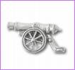
16) What was the name of the prison that the Mier Expedition Captives were held? ________________________
17) The Mier Expecition captives were forced to draw ___________________ from a mug to determine who would be executed.
18) Who fired a cannon to sound the alarm when the Texas rangers were trying to tae the Texas Archives from Austin to Washington-on-the-Brazos? _____________________________________________________________
19) Dr. Anson Jones arrived in Texas in 1833 and established a successful medical practice in _________________.

