REGULAR MEETING

MARCH 18, 2021

The Regular Meeting of the Town Board of the Town of Hampton, County of Washington and the State of New York was held at the Town Hall, 2629 State Route 22A, Hampton, New York, also via Zoom and live streaming on the You Tube Channel for “Town of Hampton New York”  on the 18th day of March 2021.

Due to the Corona Virus, occupancy inside the Town Hall is limited at this time. Supervisor O’Brien did provide a link to join the meeting via Zoom.

PRESENT: David K. O’Brien------------Supervisor

Donald Sady-----------------Councilman

Tamme Taran----------------Councilwoman

Andrea Sweeney------------Councilwoman – via Zoom

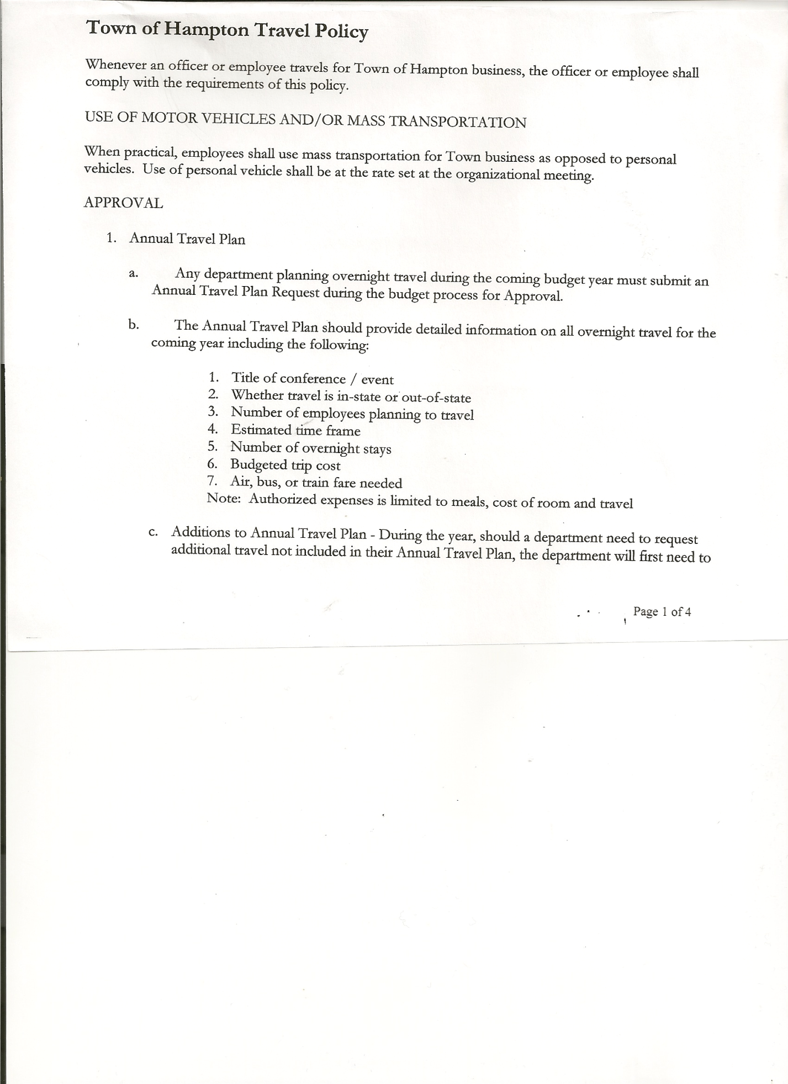 Michael Pietryka------------Councilman

Rebecca Jones---------------Town Clerk

Camilla Shaw----------------Tax Collector/Deputy Town Clerk

Herbert Sady, Jr.-------------Highway Superintendent – via Zoom

Planning Board Member(s): via Zoom… Bonnie Hawley, Chair; and Matthew Pratt

Others present at the Town Hall: John Mashak and Artie Pratt

Others present via Zoom: Travis Dean and Washington County Highway Association members:

Jim Buckley (Cambridge); Brian Rockway (Fort Edward); Floyd Pratt (Hebron);

Mike Graham (Kingsbury); Louie Pratt (Whitehall) and Chris Rieben (White Creek)

The Regular Meeting was called to order by Supervisor O’Brien at 7:33pm, followed by the Pledge of Allegiance. Location of Fire Exits were given. Quorum of board members present.

Supervisor O’Brien asked for a moment of silence in memory of Bette Willard and Joseph Mackey.

Vicki Hayner, Town Assessor presented an update on the recent property revaluation. The notices have been mailed to property owners. The average increase is 12%. A 10%-14% increase will not be much of a difference in taxes. 14%-20% or more will see a raise in taxes. Less than 10% increase will see a decrease in taxes. She did get to most every property in town. Some are inaccessible for her to reach in her vehicle.

Vicki gave the times she will be available by phone if someone wishes to discuss the valuation with her. The Tentative Roll will be available May 1st. If after talking with Vicki, someone is not satisfied, they can go to the May 27th Board of Assessment Review or if they would prefer to not speak with Vicki, they can go directly to the Board of Assessment Review. Everything is explained in the letter sent to each property owner.

The reevaluation was done to try to get back to the 100% evaluation rate. It gives the residents the most value for their exemptions.

Councilwoman Sweeney asked when the assessments will be available to be seen. It is hopeful they will be posted on the town website by the weekend.

TOWN BOARD MEETING

MARCH 18, 2021 PAGE 2

Members of the Washington County Highway Superintendents Association were also in attendance by Zoom. Supervisor O’Brien opened with an overview of why Hampton is having a vote to let the residents choose whether to go to an Appointed Highway Superintendent rather than an Elected Highway Superintendent.

Supervisor O’Brien added Hampton is looking to changes to put more money into roads. There is a limited pool of candidates in town. It is nothing against the Highway Association or previous Highway Superintendents.

Since Hampton has the lowest assessed value in the County at about $68M in value, and the next lowest is $140M, Hampton does not have the resources to operate as other larger towns do. The Highway Superintendents in attendance were asked how many people their towns employed. All of them had more workers and a full time Superintendent.

Mike Graham the Kingsbury Highway Superintendent, Vice President of the Washington Highway Association and is on the Executive Committee of the New York State Highway Superintendents Association spoke on behalf of the Washington County Highway Superintendents Association in support of keeping the elected position for the Town of Hampton.

**RESOLUTION NO. 28-2021**

**APPROVAL OF THE MINUTES**

On a motion of Councilwoman Taran, seconded by Councilman Pietryka, the following resolution was ADOPTED:

By Roll Call Vote: Supervisor O’Brien AYE

Councilman Sady AYE

Councilwoman Sweeney AYE

Councilman Pietryka AYE

Councilwoman Taran AYE

RESOLVED, that the Regular Town Board Minutes for February 18th, 2021 are approved.

Larry Carman, Dog Control Officer submitted his report, which was read by Supervisor O’Brien, copy of report is attached.

Camilla Shaw, Tax Collector gave her report – there are about 107 unpaid parcels at this time. Submitted February 2021 report to the Board. Also submitted Bank Statement to the Board for review and signatures.

Bonnie Hawley, Chair gave Planning Board Report… They met on Wednesday, March 10, 2021 via Zoom. They are waiting for the grant results. Copy of report is attached.

Herbert Sady, Jr., Highway Superintendent submitted his report, copy of which, is attached.

Jim Brown was hired today for the Highway position.

**SUPERVISOR’S REPORT/ COUNTY UPDATES/ COMMUNICATIONS**

The stimulus funds for $100,000 that the town is expected to receive is restricted to only COVID related items. So far about $2,000 can be claimed for Zoom meeting related items. There is a window of 24 months to look at and submit use of monies. Senator Schumer is being asked for clarifications.

TOWN BOARD MEETING

MARCH 18, 2021 PAGE 3

**RESOLUTION NO. 29 -2021**

**APPROVAL OF SUPERVISOR’S MONTHLY REPORT**

On a motion of Councilman Sady, seconded by Councilwoman Taran, the following resolution was ADOPTED:

By Roll Call Vote: Supervisor O’Brien AYE

Councilman Sady AYE

Councilwoman Sweeney AYE

Councilman Pietryka AYE

Councilwoman Taran AYE

RESOLVED that, the Supervisor’s Monthlyreport be accepted as submitted for **FEBRUARY**

1/31/21 2/28/21

ACCOUNT BALANCE RECEIPTS DISBURSEMENTS BALANCE

General Fund $ 240,559.78 $ 162,470.84 $ 330,094.81 $ 72,935.81

Highway Fund $ 36,171.30 $ 264,585.71 $ 13,461.91 $ 287,295.10

Equipment Reserve $ 54,900.35 $ 2.11 $ 0.00 $ 54,902.46

Fire #1 $ 0.00 $ 43,297.00 $ 0.00 $ 43,297.00

Fire #2 $ 0.00 $ 10,200.00 $ 0.00 $ 10,200.00

Cemetery $ 1,743.18 $ .36 $ 0.00 $ 1,743.54

Totals $333,374.61 $480,556.02 $ 343,556.72 $470,373.91

All Board Members present signed Supervisor’s Report.

**OLD BUSINESS**

The Special Election, which is be held for the voters to decide whether to keep the Highway Superintendent Position Elected or change to an Appointed position, will be on April 20, 2021 from 12-7p.m. There was a discussion about what the wage should be for Election Inspectors for an 8-hour shift including time to set up and count absentee ballots.

There will be 2 inspectors, already booked by Town Clerk:

Leonard Reed or Elaine Leddick ( Republican)

Scott Lenihan (Democrat)

**RESOLUTION NO. 30-2021**

**SPECIAL ELECTION – WAGE FOR ELECTION WORKERS**

On a motion of Councilman Pietryka, seconded by Councilwoman Sweeney, the following resolution was ADOPTED:

By Roll Call Vote: Supervisor O’Brien AYE

Councilman Sady AYE

Councilwoman Sweeney AYE

Councilman Pietryka AYE

Councilwoman Taran AYE

RESOLVED that, the wage for the election inspectors will be $13 per hour.

Following a discussion regarding residency requirements for the Highway Superintendent position the following resolution was introduced

**RESOLUTION NO. 31-2021**

Introduced by Councilman Donald Sady

who moved its adoption

Seconded by Councilman Michael Pietryka

**RESOLUTION ADOPTING** **LOCAL LAW AUTHORIZING THE POSITION OF SUPERINTENDENT OF HIGHWAYS OF THE TOWN OF HAMPTON TO RESIDE OUTSIDE THE CORPORATE LIMITS OF THE TOWN OF HAMPTON, WASHINGTON COUNTY, NEW YORK**

TOWN BOARD MEETING

MARCH 18, 2021 PAGE 4

**WHEREAS,** the Town Board (the “Town Board”) of the Town of Hampton (the “Town”) has seen an inability to obtain residents of the Town of Hampton as candidates for the office of superintendent of highways of the Town of Hampton and wishes to permit and authorize any individual to hold the office of superintendent of highways of the Town of Hampton who resides within the corporate limits of the Town, or within the corporate limits of a town within Washington County, New York that immediately adjoins the corporate limits of the Town; and

**WHEREAS**, in order to permit same, the Town Board must consider a proposed local law authorizing any individual to hold the office of superintendent of highways of the Town of Hampton who resides within the corporate limits of the Town, or within the corporate limits of a town within Washington County, New York that immediately adjoins the corporate limits of the Town; and

**WHEREAS,**  a proposed local law authorizing same has been drafted and is attached hereto; and

**WHEREAS**, the Town Board wishes to hold a public hearing concerning the proposed local law authorizing any individual to hold the office of superintendent of highways of the Town of Hampton who resides within the corporate limits of the Town, or within the corporate limits of a town within Washington County, New York that immediately adjoins the corporate limits of the Town.

**NOW, THEREFORE BE IT**

**RESOLVED,** that the proposed local law authorizing any individual to hold the office of superintendent of highways of the Town of Hampton who resides within the corporate limits of the Town, or within the corporate limits of a town within Washington County, New York that immediately adjoins the corporate limits of the Town, is hereby accepted for introduction to the Town Board; and be it further

**RESOLVED**, that a public hearing shall be scheduled for the consideration of this proposed local law to be held by the Town Board April 15, 2021 at 7:00 pm at the Town offices; and be it further

**RESOLVED**, that the Town Clerk is direct to post and publish a notice of said public hearing in the *Granville Sentinel and the Whitehall Times* at least five (5) days before the hearing.

**RESOLVED**, that this resolution shall take effect immediately.

DATED: March 18, 2021 Supervisor O’Brien AYE

Councilman Sady AYE

Councilwoman Sweeney AYE

Councilman Pietryka AYE

Councilwoman Taran AYE

TOWN BOARD MEETING

MARCH 18, 2021 PAGE 5

**RESOLUTION NO. 32-2021**

**LOCAL LAW “1” OF 2021 CHANGED TO LOCAL LAW “A” OF 2021**

On a motion of Councilman Sady, seconded by Councilwoman Taran, the following resolution was ADOPTED:

By Roll Call Vote: Supervisor O’Brien AYE

Councilman Sady AYE

Councilwoman Sweeney AYE

Councilman Pietryka AYE

Councilwoman Taran AYE

RESOLVED, that Local Law “1” of 2021 will be referred to as Local Law “A” of 2021. (This is because of the mandatory referendum regarding Local Law “A” of 2021)

**PUBLIC COMMENTS/COUNCIL COMMENTS**

Matt Pratt asked about the cemetery mowing being contracted out. There are only 3-4 (with the Miller Cemetery-which is being done by Travis Dean) that the highway crew has been mowing. The money comes out of the general fund. Supervisor O’Brien has been checking into the cost of contracting them out. Also information on transferring the Miller Cemetery to the Adventist Church is being looking into.

The Town Clerk’s report for February 2021 was submitted to the Board. The Town Clerk had Board Members review and sign bank reconciliation statements for the Town Clerk Account and Special Clerk Account dated February 28, 2021.

**RESOLUTION NO. 33 -2021**

**AUDIT OF CLAIMS**

On a motion of Councilman Sady, seconded by Councilwoman Taran the following resolution was ADOPTED:

By Roll Call Vote: Supervisor O’Brien AYE

Councilman Sady AYE

Councilwoman Sweeney AYE

Councilman Pietryka AYE

Councilwoman Taran AYE

RESOLVED that the bills have been reviewed by the Town Board and are authorized for payment in the following amounts.

General Fund No. 27 through No. 43 $ 9,061.24

Highway Fund No. 28 through No. 38 $ 10,912.07

Total both funds $ 19,973.31

**RESOLUTION NO. 34-2021**

**MEETING ADJOURNED**

On a motion of Councilwoman Taran, seconded by Councilman Pietryka, the following resolution was ADOPTED:

By Roll Call Vote: Supervisor O’Brien AYE

Councilman Sady AYE

Councilwoman Sweeney AYE

Councilman Pietryka AYE

Councilwoman Taran AYE

RESOLVED that the meeting adjourned at 8:26pm.

Respectfully submitted,

Rebecca S. Jones, RMC

Town Clerk