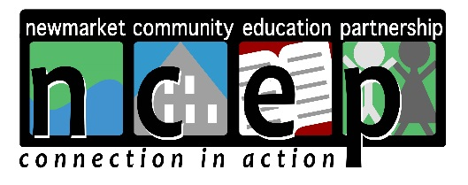

NCEP GRANT APPLICATION

NCEP’s Board looks forward to considering your grant application. To ensure proper review, please carefully follow the instructions listed below. Grants received after the stated deadlines or grants that are missing requested information cannot be considered. Please visit www.ncepconnects.com for grant-writing assistance. Thank you in advance for your understanding.

NCEP offers two (2) grant cycles each year. Grants must be received by the following deadlines:
- February 15
- September 15

Steps for successful submission:
- Prepare cover sheet.
- Complete grant application. See important note below.
- Make five (5) copies of the cover sheet and application.
- Mail copies to:
Newmarket Community Education Partnership
P.O. Box 536
Newmarket, NH 03857

IMPORTANT NOTE ABOUT NEWMARKET JR./SR. HIGH SCHOOL GRANTS:
School grants require review and pre-authorization to ensure they meet school gifting policies. Pre-authorization must be obtained from both school and district administration. Please make sure to work in enough approval time to ensure grant deadlines are met. How to:
- Complete grant application submission instructions step 1 and 2.
- Provide grant scope and details to school principal; obtain approval (email is fine).
- Provide grant scope and details to the school district (email is fine), or drop a copy of the grant off at the district office; obtain approval.
- Continue with step 3 and 4.

Responsibilities of Grantee and Grantor:
Organizations that receive grant money from NCEP must use the grant funds only for the purposes of which the grant was made. All grantees must provide a final written report at the end of their project; evaluating the project and an accounting of how grant funds were used (available on website). NCEP has the authority to withhold and/or recover grants funds in case funds are, or appear to be, misused. Any unused grant funds shall be returned to NCEP after a two-year period has lapsed.

Questions:
- Please visit our website www.ncepconnects.org, or email: ncepconnects@gmail.com
NCEP GRANT APPLICATION
COVER SHEET

Grant deadline: | February 15 or September 15
Grant request name:
(i.e. “iPads for 3rd Grade,” “8th Grade Trip,” “Supplies for Cooking Club,” etc.)
Brief description of grant request (one paragraph):
Name of organization:

Address:

Pre-authorization:  School district grants require pre-approvals. | Approvals in place? Please indicate date:  Principal: _____________  School District: ____________
Contact person for application:

Contact phone number:

Contact email:

Tax ID:

Funding: | Project total: $_________________  Amount requested: $______________  Are you seeking other funding from other sources as well? ______ If yes, please explain:
Number of children/ youth grant will impact:

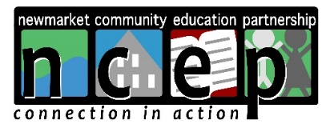
NCEP GRANT APPLICATION

Part I – Project Description
Describe the project. What are the goals and objectives? Who will the project serve (how many children and/or youth). Provide a timeline for implementation. Validate grant request amount by providing copies of receipts, quotes, etc.

Part II – Rationale
How does this grant serve NCEP’s mission?

Part III – Staffing
Who are the key personnel? List names/titles and their roles.

Part IV – Evaluation
How will progress be monitored, and success measured?

