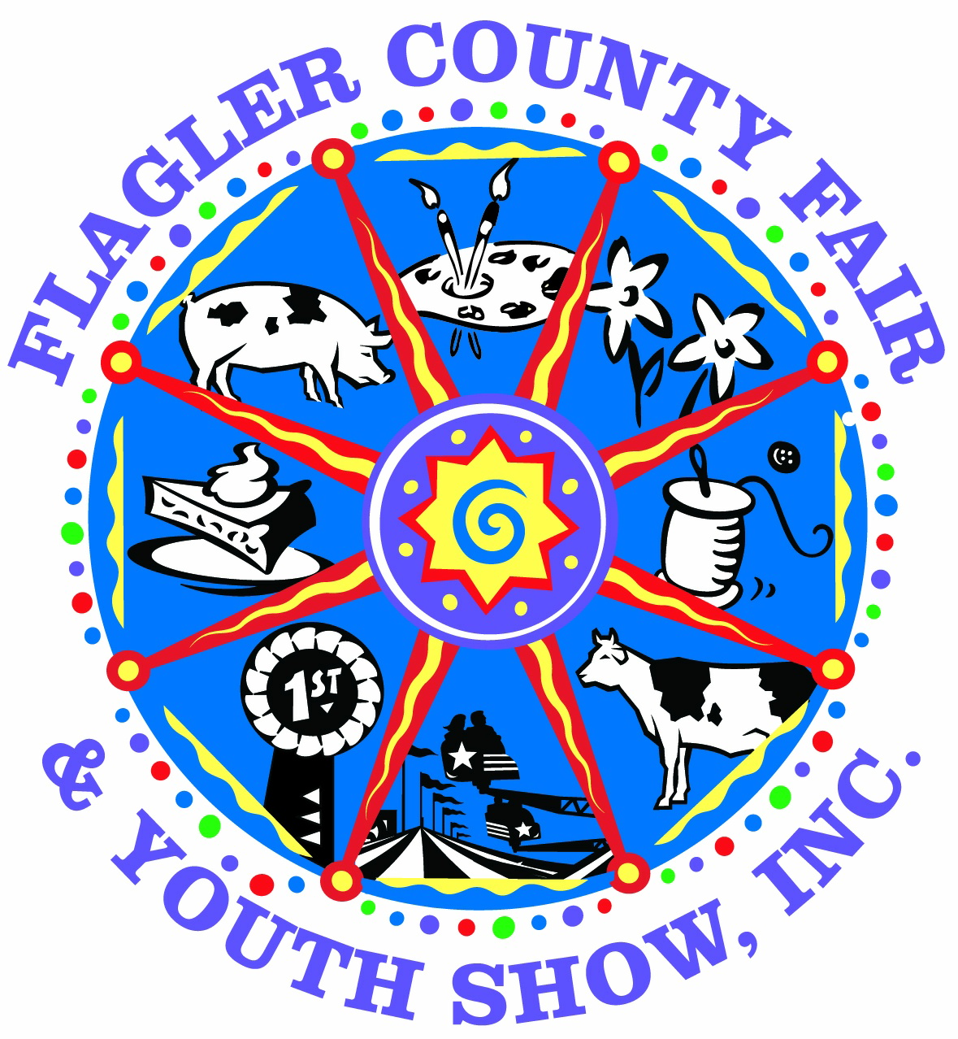

Shoebox Float Contest
THEME: “Fresh From Florida”

Float must be made of cardboard shoebox no larger than 13"X 9". Decorations on the box should not exceed 14 1/2" tall. NO EXCEPTIONS! All judging will be final and based on age specific completion of project. Points will be deducted if float does not meet the guidelines based on the age of the exhibitor making it.

Allowable materials: Papier-mâché, cloth, foil, fringe, petal paper, etc. Non-perishable items may be used for float (macaroni, spaghetti, etc.) Let your imagination soar.

Non-allowable materials: No perishable food items; no motorized toys; do not put wheels on float or mount float on truck body. Do not put shoebox on a piece of cardboard larger than the shoebox.

Please include name, telephone number and Date of Birth on underside of the float
- Only one applicant per float and must be a 4H or FFA member
- All entries will remain on display at the fair
- Drop Off: Monday April 5th from 1pm to 6pm in the Cattleman’s hall
- Pickup: Once judging and ribbons are complete.
- Judging: Tuesday April 6th

Age Divisions: As of September 1, 2020
Cloverbud (Ages 5-7)
Junior (Ages 8 to 10)
Intermediate (Ages 11 to 13)
Senior (Ages 14 to 18)

Judging Criteria: *Originality *Neatness *Craftsmanship and Age specific
Prizes: Per Age Division
1st Place – Blue Ribbon & $10.00 Cash Reward
2nd Place – Red Ribbon & $5.00 Cash Reward
3rd Place – White Ribbon & $3.00 Cash Reward
“Overall” Best of Show – Rosette & $25.00 Cash Reward

Contacts for this Competition:
Penny Buckles – Fair President (386) 931-6597
Ennasea Coute – (386) 627-4122
Email: flaglerctyfair@bellsouth.net or ennasea.coute@yahoo.com
Website: www.flaglercountyfair.com

