Paul Bunyan Rendezvous by Mike Moran
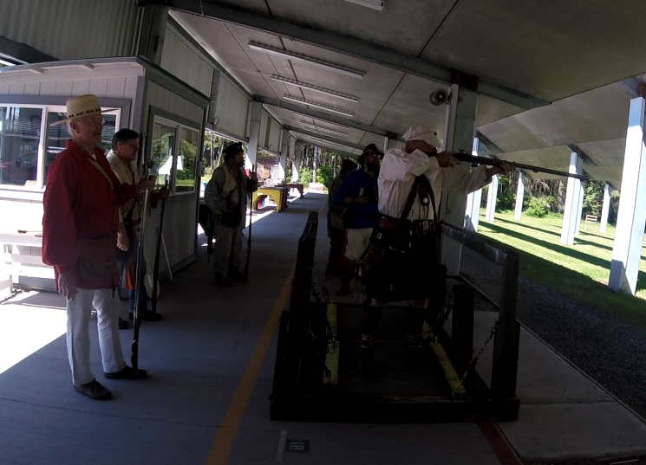
It was hot. The kind of hot that makes grown men contemplate wearing breechclouts. Luckily, most men stuck to their buckskin pants (literally and figuratively) and there were no fashion faux pas among the participants. Other than the afternoon heat, there was very little to complain about at the Paul Bunyan 42nd Annual Rendezvous held in Puyallup over Memorial Day weekend.
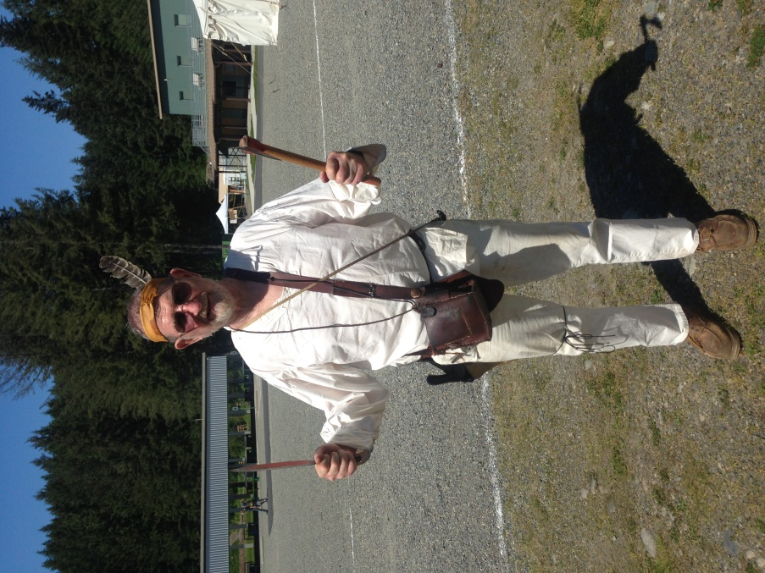
After the opening ceremony and flag raising, the competition got started. For those who had been here numerous times, there were a few new surprises thrown in. The first change on the rifle trail was having to shoot one of the targets from a rocking chair, which everyone seemed to enjoy. Next change up was the 150 yard elk, which was shot offhand from a moving bridge. Then the powder horn silhouette was shot before a lead ball dropped in a six foot tall spiraling piece of flexible conduit had a chance to drop out the bottom into a coffee can. For the last target on the rifle trail, a string with two half pound weights was hung over the end of the rifle barrel. For the most part, the feedback on these new targets were that they were challenging and fun. We can’t publish some of the other comments.
Doug Kitchens fires from the moving bridge
The pistol trail had a new target as well, where you had to sit in one outhouse and shoot through the crescent cut out of the other outhouse door, without hitting the door itself. To make sure, there was a steel plate behind the opening with a flag that would waive if it was hit correctly. Thank Mark Curtis for that one. The Hawk and Knife trail were pretty straight forward, with most targets allowing you to choose your preferred weapon. With the changes to the rifle, pistol, and hawk & knife events, it made the outcome of the aggregate scores difficult to predict.
Our traders were set up on trader’s row having made the 1,000 mile trek up the Missouri River from St. Louis, or in some cases all the way from Bremerton. So much of the rendezvous history is based on the accomplishments of these diehard suppliers, and it is great to see the tradition lives on.
The archers showed their hunting skills on the course that Jim Haeckel set up. For the juniors, the top three arrow slingers were Josiah Goode, Jarod Barth, and Leila Smith. The top archer for the adults was Tony Woore, followed by Bad Wind, Squatting Hawk, and Glenn Borg.
Frank Ponceroff ready for the hawk & knife trail
The novelty shoots are always fun. Bill Sick ran the stake shoot and candle shoot on Saturday evening. The team of Derek and Kyle Sotelo, Tony Woore, and Tony Plante shot their 4”x4” stake in half first. Mike Holeman, Tom Litts, and Bob Tresch were the finalists in the candle shoot. On Sunday, the team of Wally McKendry and Doug Kitchens took top honors in the Chicken Shoot. The Trade Gun shoot on Monday morning had Allen Tresch, Will Ulry, and Joe Nevius in 1st, 2nd, and 3rd place. And although technically not a shooting event (depending on your definition of shooting), Tony Plante won the apple pie contest at the council fire. He also received his new mountain name, “Running Bare”.
Karla Hillberg shows off her new chicken
It was a great event, no one got hurt, and the weather didn’t get the better of us. Once again the Paul Bunyan Plainsmen put on a helluva rendezvous. Here’s looking forward to next year’s event.
Aggregate Scores:

Top Mountain Man Top Mountain Woman Top Mountain Junior
1. Allen Tresch 1. Maureen Reily 1. Jarod Barth
2. Gene Trobaugh 2. Dana Atchison 2. Jack Knight
2. Clark Sherwood 3. Barbara Sherwood 3. Aiden Sachman
3. Caleb Smith

