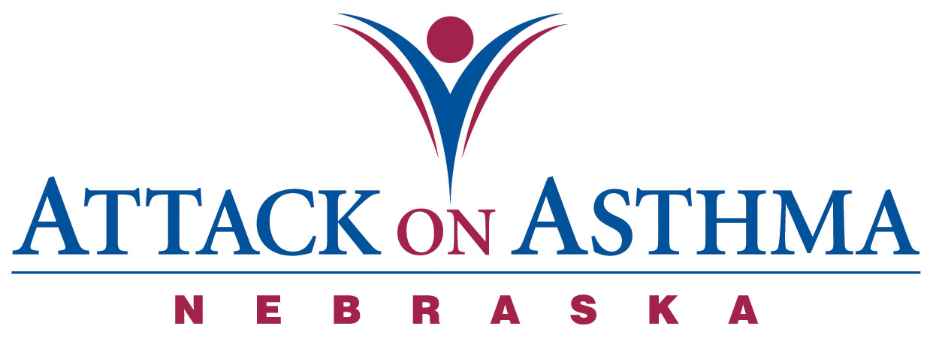

Characteristics of Individuals and Protocol Use in Nebraska Schools
2009-10

Data was voluntarily reported to Attack On Asthma Nebraska (AOAN) during and following the 2009-2010 school year. During this period of time there were 34 reported incidents of the Emergency Response to Life-Threatening Asthma or Systemic Allergic Reaction (Anaphylaxis) protocol being implemented. Schools submit data using a standardized form.

- Over half the incidents occurred during the months of August, September, October, November (53%).

- Protocol administration was split almost evenly between male (56%) and females (46%).

- More Elementary school students (41%) were administered the protocol than Middle School (35%) and High School (21%) students. There was one staff incident (3%) reported.

- The greatest percentage of incidents was reported in conjunction with activity; PE class and recess (53%). Classroom (29%) incidents as a location followed. There was also one incident (3%) reported in conjunction with cleaning solutions and one incident (3%) reported in association with secondhand smoke.

- The majority of the incidents were with an individual with a history of asthma (79%). Six individuals reported no history of either asthma or anaphylaxis (18%) and only one individual reported a history of anaphylaxis (3%).

- Over three-quarters (88%) received epinephrine as a correct usage of the protocol.

- Of the six individuals with no history of asthma, four (67%) returned to school with an action plan.

- Out of seventeen individuals with a history of asthma and no action plan on file, five individuals (29%) returned to school with an action plan after protocol administration.

- Of the twenty-seven individuals with a history of asthma, only ten (37%) had an action plan on file.

- The one individual with a history of anaphylaxis did not have an action plan on file at school, but did return with an action plan (100%).

- No one required the administration of CPR.

- There were four incidents (12%) in which only albuterol was administered.

- Emergency Medical Services (EMS) was summoned 94% of the time. Of the two incidents which EMS was not summoned, one incident (50%) was treated with albuterol only.

- Twenty-six individuals (76%) were transported to a medical facility via the Emergency Medical System. Eight individuals (24%) were transported to a physician’s office or medical facility by a parent or were signed off by a parent.

- Eleven school districts reported the 34 incidents.

- There was one school district which reported two incidents with the same individual.

- Each school district had access to or has a school nurse.

NOTE: Action plans on file at school may or may not include prescribed medication(s).

