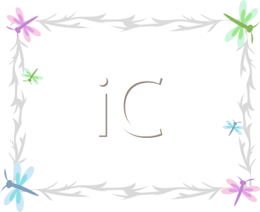ite

**Dragonfly**

3 years to 4 years

Our program offers a variety of activities that both stimulate learning and socializing as they make the transition from toddler to active and independent children. The young preschool class introduces more classroom structure with a fun learning environment. This is the year you will see children start playing with each other more. The curriculum consists of numbers, letters, shapes, colors, social skills, large motor development and fine motor development with an introduction to handwriting.