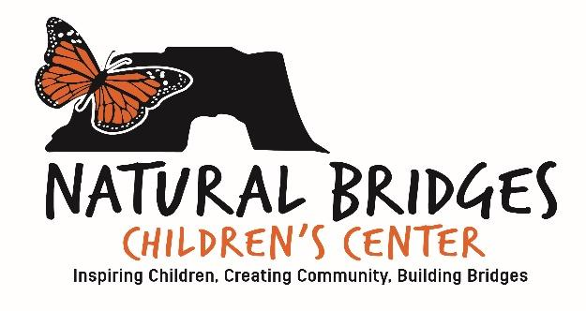
Office Use Only

Received:___________

Check #: ___________

H:____ Yr.:________

M:____ Yr..:________

S:_____ F:_________

Notified:____________

Natural Bridges Children’s Center
Enrollment Application

NBCC is a 5 day a week program. Your child needs to be 2 years of age by September 1st for eligibility in our toddler room (2-3.5 years) and 3.5 by September 1st to be eligible in our Pre-K/TK room (3.5-5 years). Receipt of this application along with an attached family photo and $150 non-refundable application fee ensures a spot in the NBCC wait-pool. A tour and meet and greet is also required.

Date __________________

Child’s Legal Full Name:_____________________________________________________________________

Male: ____ Female: ____ Age: ____ Date of Birth: _________________2 Years Old by September 1st 20____

Applying for the HONU Toddler Room (2-3.5 years) beginning year: 23/24 ____ 24/25 ____ 25/26 ____

Applying for the MONARCH Pre-K/TK Room (3.5-5) beginning year: 23/24 ____ 24/25 ____ 25/26 ____

4/5 Day Schedule Preference & Summer Camp

¾ Day M-Th (8:30-2:45) Fri (8:30-1:00) - _________
¾ Day M-Th (8:30-2:45) - _________
½ Day M-Th (8:30-12:45) - _________
Extended Day M-Th (8:30-4:15) Fri (8:30-1:00) - _________
6 Week Summer Camp M-F (9:00-2:00) - _________

Natural Bridges Children's Center 255 Swift St. Santa Cruz, Ca. 95060 Phone 831.429.NBCC (6222)
Family Information

Parent/Guardian Name 1:________________________________________________________________________

Home Address 1:___________________________________ City _________________ State: _____ Zip: _______

Parent/Guardian Name 2:________________________________________________________________________

Home Address 2:___________________________________ City _________________ State: _____ Zip: _______

Parent/Guardian 1: | Parent/Guardian 2:
Relationship to Child: | Relationship to Child:
Occupation: | Occupation:
Employer: | Employer:
Cell Phone: | Cell Phone
Email: | Email:

Sibling Information

Sibling Name:__________________________________________________________________________________

Age:_______________ School:____________________________________________________________________

Sibling Name:__________________________________________________________________________________

Age:_______________ School:____________________________________________________________________

Official inclusion to the waitpool requires a one-time non-refundable $150.00 application fee.
Upon notification that a spot is available, there is a 48 hour response period. Upon acceptance into the program, an enrollment agreement contract will be offered and an annual non-refundable $750.00 enrollment fee will be required.

____________________________________________________________ _____________________________
Parent Signature Date

____________________________________________________________
Print Name

**Please attach a family photo to the back of this application**

Inspiring Children ~ Creating Community ~ Building Bridges

Natural Bridges Children's Center 255 Swift St. Santa Cruz, Ca. 95060 Phone 831.429.NBCC (6222)

