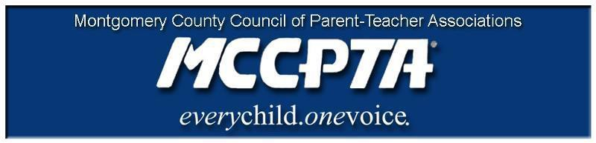

DELEGATES’ ASSEMBLY MEETING AGENDA
Thursday, November 19, 2020
Meeting Held on Zoom

7:00 pm Call to Order

- Welcome; Approval of Agenda & October 2020 Minutes

7:10 pm ParentVUE/Synergy/Canvas Discussion

Mr. Peter Cevenini, Associate Superintendent, Chief of Engagement, Innovation and Operations
Dr. Kara Trenkamp, Director, Department of Technology Integration and Support

7:40 pm Updates

- MDPTA/National PTA – Updates
- MCPS Survey
- SSL

7:30 pm New Business

- Adoption of MCCPTA Bylaws
- Nominating Committee
- MCPS Return to School Buildings Metrics

8:20 pm Old Business

8:25 pm Officer Reports

- All reports in the November 2020 OneDrive Folder – https://mccpta-my.sharepoint.com/:f:/g/personal/office_mccpta_org/EsOhuHUeKuRMnIKSXAT3ExUBtu-GvlVWVDq_HqPgmKEebg?e=Dxh4Oi

8:40 pm Committee Updates & Announcements

- Membership
- Committee Reports - https://mccpta-my.sharepoint.com/:f:/g/personal/office_mccpta_org/EtmDF2DwO61OjubSAOL7SMABoYLQnz6RXBp-pzB2l6YrqA?e=eKU7Rl

9:00 pm Motion to Adjourn

Dates:

- December 9, 2020 – BOD Meeting, 7 pm on Zoom, registration link will be sent via email
- January 11, 2021 – BOE Operating Budget Hearing
- January 13, 2021 – BOD Meeting, 7 pm on Zoom, registration link will be sent via email
- January 19, 2021 – BOE Operating Budget Hearing
- January 26, 2021 – Delegates Assembly Meeting, 7 pm on Zoom, registration link will be sent via email

