Room types
Jacuzzi Junior Suite (preblocked rooms)

King bed, large 2 person jacuzzi, gharden view
Approx 405 sq feet

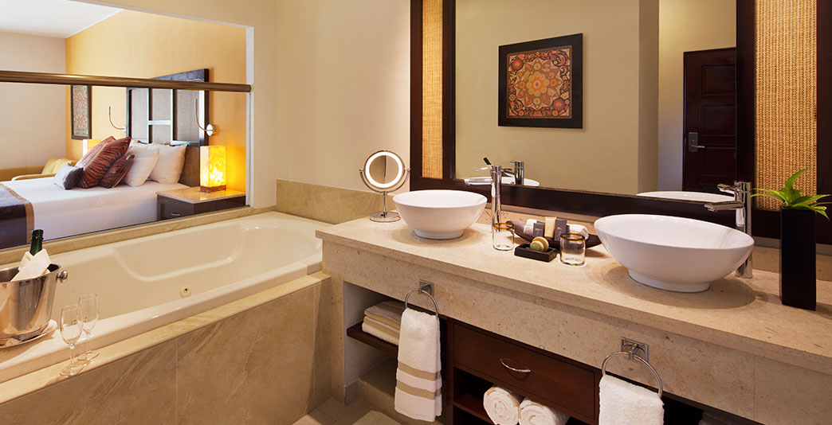

Honeymoon Suite
King bed, separate living/bedroom areas, jacuzzi, “Aguas del Amor” outdoor shower, garden/pool views
Approx 588 sq feet

Mi Hotelito Beachfront Suite
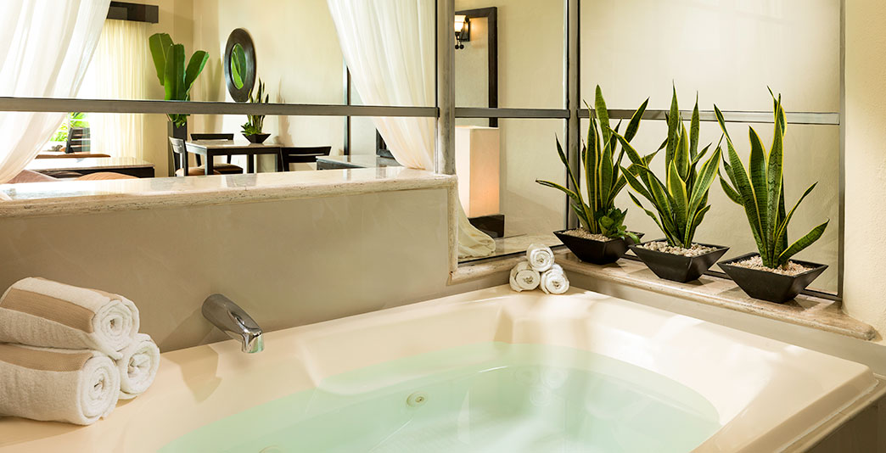
King bed, large terrace, steps from Maroma Beach (no jacuzzi)
Approx 276 sq feet

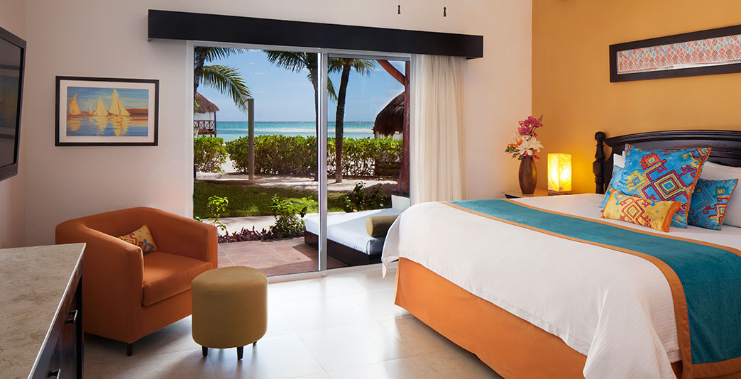

Page 2
Maroma Room types

Infinity pool jacuzzi suite ** Sold out these travel dates **

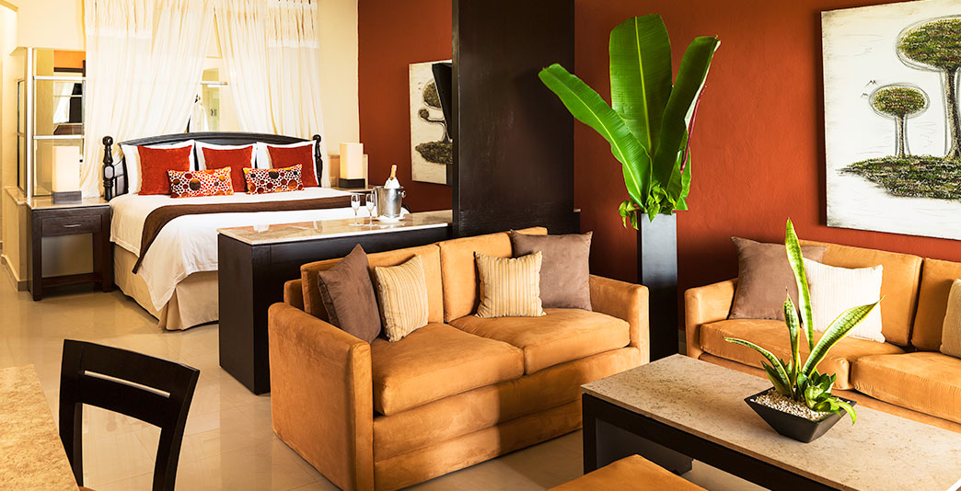

Swim-up Jacuzzi Suite **very limited availability **
Ground floor rooms with direct access to the pool form the suite’s patio
King bed, jacuzzi, garden/pool views
Approx 588 sq ft

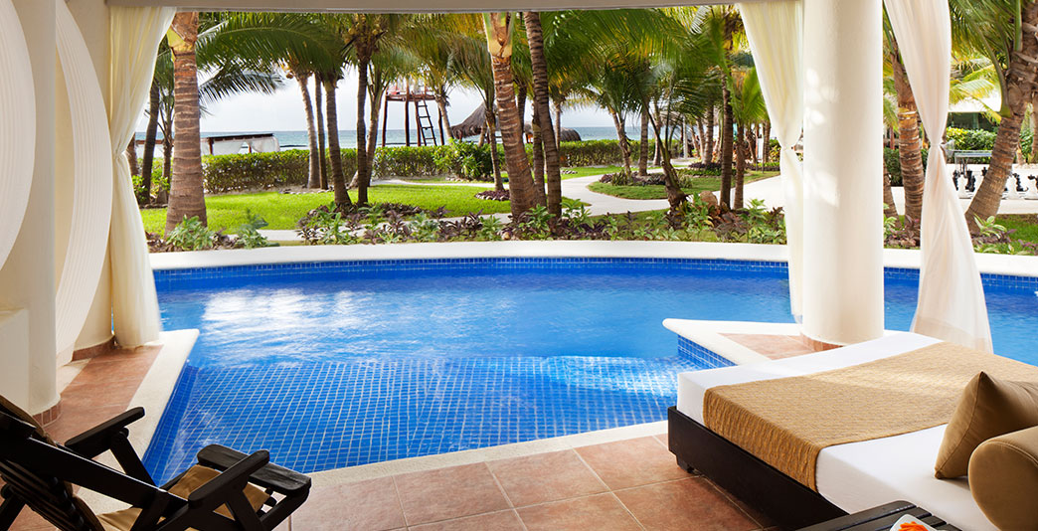

Palafitos- over water bungalows

Located on the exclusive Palafito Pier
King bed, extra large jacuzzi, glass floor panels in living area & bedroom, oversized patio with infinity pool, butler series 24/7, exclusive Palafito Restaurant. Ocean views
Approx 811 sq ft

