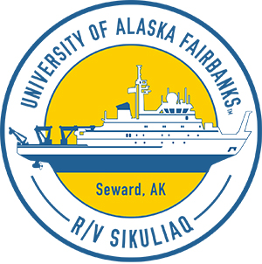Stratified Ocean Dynamics of the Arctic Ocean

Jen MacKinnon (Sikuliaq chief scientist,[jmackinnon@ucsd.edu](mailto:jmackinnon@ucsd.edu)), University of California San Diego; and Craig Lee (Steering Group Chair)

## Research questions

* What is the subsurface distribution of heat in the Beaufort Sea?
* What physical subduction, stirring and mixing processes control that distribution?
* How do any of those processes change near the coast, or near the ice edge?

## Why we should care

Our goal is to understand the processes controlling the distribution of heat and salt in the Beaufort Sea, and in particular the role of turbulent mixing in setting those distributions. This information will help us make sense of a changing climate. The Beaufort Gyre (BG) is historically home to some of the oldest and thickest ice in the Arctic, but is now remarkably ice free in summer.

## What we will measure

We will measure ocean temperature, salinity, currents, and turbulent mixing.

## General 2018 cruise plan

We plan to depart Nome September 2 and transit to Barrow Canyon to deploy one mooring and spend a day or two surveying ocean temperature near the mooring. Then we will transit north to sample the region denoted by green shaded box in our cruise track. Sampling will likely be concentrated near the ice edge. We will arrive back in Nome on September 30.

### Timeline

**August 29:** Mobilize in Nome

**September 2:** Depart Nome

**September 5:** Deploy mooring in Barrow canyon (TBD)

**September 6–27:** Surveys

**September 30:** Arrive Nome

**October 1–2:** Demobilize in Nome

### Cruise track

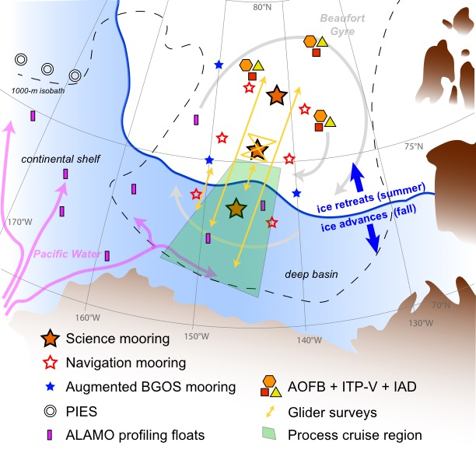

## Daily science updates and additional information

We would welcome a community observer, should someone wish to join the cruise. Operational plans, including the proposed Barrow Canyon mooring, can be flexible to minimize impact on nearby communities. We will be posting daily blog updates for our cruise (<https://www.mod.ucsd.edu/)>. Please contact Jen MacKinnon at [jmackinnon@ucsd.edu](mailto:jmackinnon@ucsd.edu) if you would like to receive a daily email or fax during our cruise.