St. Joseph’s Polish Society Inc. Autumn/Winter 2018
THE FALCON
395 South Main St, Colchester, CT (860)-537-2550 stjoespolishclub@aol.com

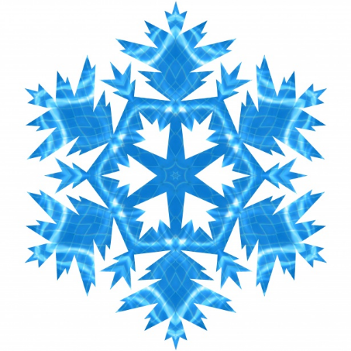
Message from the President
I hope everyone had a great summer even though it was a rainy one. We have had some really great events this year. Thank you to all who came to support our club at these events. I would like to thank all our members that have volunteered during the year. Without our volunteers we would not be as successful as we are. Unfortunately, it is the same people over and over again. This is a great opportunity for all our members to show their support of their club. We have a lot of up coming events such as the members Christmas party, New Years Eve party and hall rentals, so if you could give us some of your time, even just once a month would help.
I would like to thank the members that do all the cooking on the grill for the functions we have had this year. I hope they continue as they do a great job. In addition, I want to especially thank Ed Taronto and his team for the renovation to the club’s bar. A lot of time and effort went into this project. Everyone is so complimentary on how great the place looks. Ed would like to thank all that came in to help him with this project.
The 15th annual scholarship golf tournament was a great success again this year. I would like to thank the committee and the people that helped put this event together. Everyone that participated in the tournament had nothing but high praise for the event and all had a great time. Thank you again and we look forward to another successful year!!!
With regret the Board of Directors and I have accepted the resignation of Linda Griezka and want to thank her for all the work she did over the years booking the hall and writing the newsletter. Melissa Perry will now be booking the hall and writing the newsletter. You can contact her at 860-334-4170.
Welcome to our new members: David and Laurie Gregoire, Kate Quattropani, Rochelle Grenier and Elizabeth Salie.

Members Only Christmas Party

Saturday, December 8, 2018
COST: $10.00 members; $20.00 member’s guest- 1 guest per member
6:00 pm - Cocktail Hour 7:00 pm - Buffet Dinner
Sign-up at the bar Payment is due at sign-up

Super Bowl Party

Sunday, February 3, 2019
COST: $15.00 members/non-members
FREE to pool participants who played a minimum of 10 weeks
OPEN TO THE PUBLIC
Sign-up at bar
Payment is due at sign-up

New Year’s Eve Party
Monday, Dec. 31st, 2018
Featuring The Locomotives
Cocktail Hour/Dinner/Music & dancing/Champagne toast at Midnight
$25 per person
please see a bartender to purchase your tickets in advance

Check the club’s website for more information as it becomes available stjoespolishclub.com

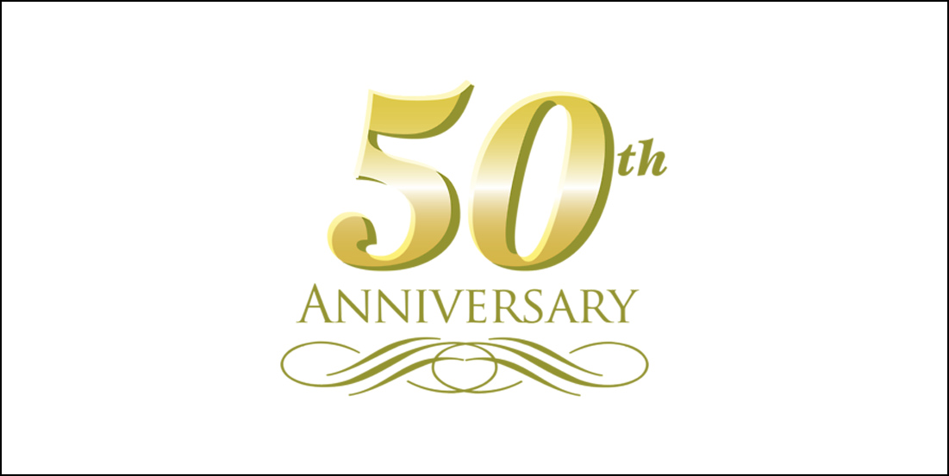
On November 3rd, St. Joseph’s Polish Club honored Dennis Polisky and Rich Bernier for 50 years in the Polka industry. There were 120 guests with Dick Pillar and Bob Sawicki as Masters of Ceremony sharing memories of Dennis and Rich’s past accomplishments. Everyone enjoyed a sit-down dinner and Polka dancing to the music of Dennis and The Maetros men. Congratulations to Dennis and Rich from all of us at St. Joe’s.

Christmas Polka/Dinner Dance
Sunday, December 16, 2018
TIME: 1:00 pm to 6:00 pm
1:00 pm - Cocktail Hour/Free Snacks/Entertainment
Dave Goclowski - Accordion Christmas Music
2:00 pm - Dinner and dancing
Dennis Polisky and the Maestro’s Men
COST: $25.00 per person
Raffles, Prizes, Santa Claus, Christmas Carols, and Kolendy Sing-Along

2019 POLKA DANCE SCHEDULE
Saturday, January 12th Joe Milardo and the Musical Cavaliers
Saturday, February 16th Dennis Polisky and the Maestro’s Men
Saturday, March 16th Eddie Forman Orchestra
Saturday, April 13th Joe Milardo and the Musical Cavaliers
Saturday, May 18 Dennis Polisky and the Maestro’s Men

Saturday, Sept. TBD OCTOBERFEST – Dennis Polisky & the Maestro’s Men &

Country Polka Musicians

Saturday, October 19th Eddie Forman Orchestra
Saturday, November 9th Lennie Golumka & Chicago Push
Saturday, December 15th St. Joe’s Christmas Party with Dennis Polisky & the
Maestro’s Men

The Falcon newsletter is a quarterly publication of information and news about St. Joseph’s Polish Society, Inc. Questions or comments can be directed to Melissa Perry, Editor, at melissaperry89@yahoo.com
MEMBERS: If you have recently moved, please update your home address by sending an email to stjoespolishclub@aol.com. Email addresses are always welcome!
St. Joseph’s Polish Society, Inc.
395 South Main Street
Colchester, CT 06415

