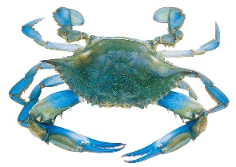
Leonardtown Lions
Crab Festival and Car Show

Saturday, 10 June 2023, 11 am to 7 pm
St. Mary’s County Fairground, Leonardtown, Md.
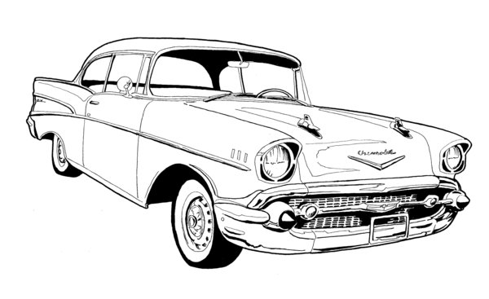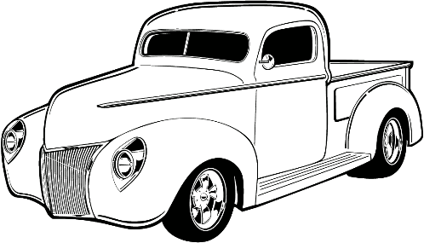
Dash Plates for first 35 cars
Trophies for 1st, 2nd, and 3rd place cars
Plaques for next 15 best cars
Proceeds benefit Leonardtown Lions Club Charitable Foundation

Car show will be from 11 am until 4 pm. Registration closes at 11 am.

For more information, contact Mike Payne at 240-298-7179 or email payneml@md.metrocast.net
Registration Fee is $20 at the gate and pre-registration is $15. Includes admission fee for driver.
Pre-registration form and check must be received by June 3, 2023.

Name: Club Affiliation:
Address: Vehicle Make:
City/State/Zip: Model:
Phone Number: Year:
Email Address:

Liability: In acceptance to the right to participate, I hereby release the Leonardtown Lions Club, Inc. and everyone connected with management or presentation of this event from any and all known and unknown liabilities that may be suffered by my party (myself, my property, and those persons accompanying me to this event). I further will ensure that my party will observe and obey all safety and traffic regulations, fire ordinances, and will maintain conduct befitting a representative of the Street Rodding Sport. I am aware that said management will do all in its power to safeguard the persons and property involved in this event and to cooperate with participants/spectators to ensure a successful event.
Signature:

Make Checks payable and mail to: Leonardtown Lions Club Crab Festival, PO Box 363, Leonardtown, Md. 20650

