William Thomas Moore (1830- 1922)
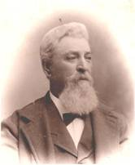
One of Arcola’s prairie stories was told by a pioneer born on September 5th, 1830 in Park County, Indiana.

William Thomas Moore, called “Squire Moore,” told his story in 1916 to an Arcola Record-Herald reporter. It was included in a special edition of the newspaper, celebrating 50 years of publication. The editors repeated the story in 1922 as part of Moore’s obituary.

Moore came to the Okaw River (now Kaskaskia) in the spring of 1834, at age 4. His young, Indiana parents, Jacob Moore (1799-1860) and Amanda Rice Moore (1806-1863) were the first settlers in the area. Other pioneer families included the Campbell family and John and Margaret Louthan. They saw the growth of the little town of Bagdad nearby and watched it disappear in 1855 when many residents moved three miles east to the Illinois Central Railroad thereby creating the town of Arcola.
William Thomas Moore, about 65, in 1895. Picture courtesy of Brenda Black Watson
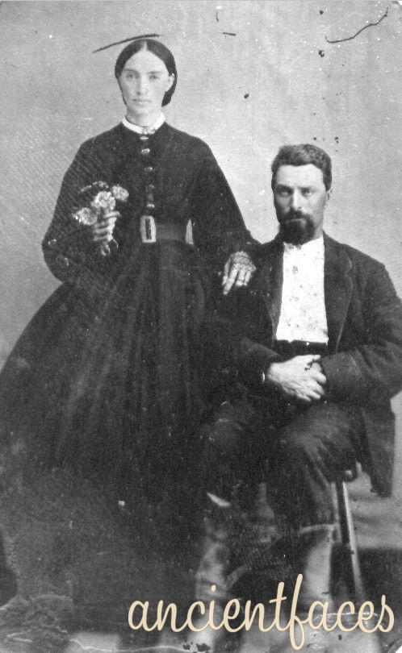
Margaret Elizabeth Louthan Moore and William Thomas Moore, Photo 1870. See. Ancient Faces, Vintage Photos, http://www.ancientfaces.com/research/photo/352650
Others settled along the river to the north, creating the town of Bourbon. These pioneers included George Dehart and his sons, Samuel and Lucas, and Isaac Gruelle, the progenitor of Johnny Gruelle, the creator of the Raggedy Ann stories and doll.

By 1837 pioneers had built the “Hermitage,” a roadside Inn that also served as a post office (1837-1864), near the Moore family home. There is some discrepancy about its exact location, but, most likely, as a travelers’ inn, it was located on the “Springfield Road,” the road one mile south of Chesterville that ran from Terre Haute, Indiana to Springfield, IL. By 1840, John and Margaret Louthan owned the Inn. After Margaret died in 1844, John remarried to Sarah Haines in 1846. William Moore especially liked the “Hermitage” because there he discovered Margaret, the youngest child of John and Margaret Louthan’s 12 children. Moore married her in 1856. They moved one-half mile north of the Springfield road, just east of the river, to a house called “Woodland.” It was built precisely on the same spot where William’s father, Jacob, built their first log cabin.

Squire Bill said that his father’s first home, like most pioneer homes, was a log cabin. It was built of round logs. The family lived in it without a floor until late that fall because they could not spare the time during the summer. They were busy with the essential work of planting crops, building fence, and cutting wood for the winter. “The chimney was built of wood, plastered with mud…. The house consisted of one room, a sort of combination kitchen, dining room, living room, bedroom, reception hall and parlor all rolled into one.”

According to Squire Bill, as the family expanded, they built a “hewed-log” house just a few rods south of the round log house. Later, after dismantling the original log cabin, they constructed a third house on the same, exact spot. That house was “Woodland.”

Mr. Moore explained how life was different in the early prairie days. First, land was cheap. Over a span of years from 1835 to 1853, Jacob Moore bought about 1,600 acres of land. For most of it he paid $1.25 per acre. Game was plentiful. The woodland along the river abounded in deer. The prairie supported wild turkey and prairie chickens (now extinct) that were so thick that an average hunter could easily kill five or six before dinner. The Okaw (Kaskaskia) River also supplied a quantity of fish.

Until local mills were constructed, getting flour for bread, salt, sugar, and other “groceries” required extended trips to distant towns. Moore explained that they drove to Terre Haute, Indiana to get their groceries. We “…got a barrel of salt, a barrel of sugar, a barrel of whiskey,” he explained. He said that the whiskey wasn’t the “forty-rod kind with so many fights per gallon, [as] it is now.” It sold for 8 and 12 ½ cents per gallon with no government tax. The Moore family, like most prairie pioneers, bought the few essentials that they could not raise or produce on the farm. Each trip had to be carefully planned. The purchases would have to last for several months.

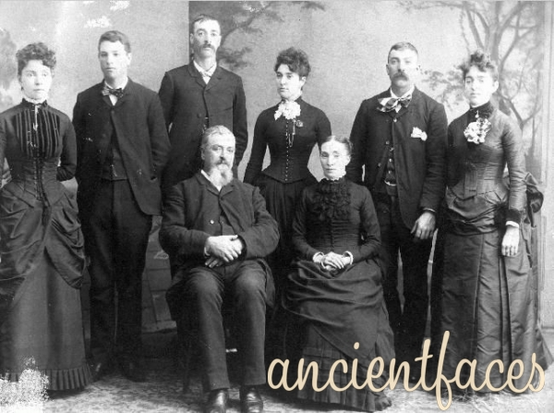
Moore explained other prairie details. “Why, I can remember when there wasn’t a house nor a tree from the timber along the Okaw until you got over to the timber of the Embarrass near Oakland,” he said. “You see in those days everybody settled at the edge of the timber so they would have timber to build their houses, make their fences and sheds and could find plenty of game nearby. We farmed the prairie land immediately adjoining and used that farther back for grazing.”

“We took our corn and wheat to a mill at Charleston to be ground for our own needs. We took our wool down there to be carded and then mother wove the cloth for our clothes on a loom that father had made her. Yes and we raised flax too. We cut it and let it lie on the ground until it began to rot and then we would take it and gather out the finer portion and spin the thread that mother used to sew with.”
Family picture (1895) of Squire Moore, Margaret Louthan and their children. Arcola, IL area. Uncertain of order or date. Kids standing L to R: Sarah M., Charles A., C. Ferdinand (tall), Laura C., Wm. Henry, Alice B. Source: Brenda Black Watson, and Ancient Faces, Vintage Photos, http://www.ancientfaces.com/research/photo/355354/squire-wm-t-moore-il-family-photo

Moore also told how the roles of women were different. They were busy. They did a great deal of hand labor work. But they didn’t have any “clubs or societies.” Instead they had visitors. When visitors came they stayed awhile. And people were glad to have the company.

Like others, the Moore family made cash income from selling cattle and hogs. It was common for hogs to grow wild in the timber living on what was called “mast,” or the abundance of persimmons, crabapples, nuts, paw paws, wild grapes, wild plums, mushrooms, “greens,” berries of several kinds that grew there.

“We didn’t have any grain markets near here in the early days.” Moore explained. “We fed cattle and hogs. Buyers came through and bought our hogs but we usually drove our cattle to Chicago. I remember one time raking up 150 or 200 head of cattle and we drove them through and sold them at four cents a pound and made good money on them too. It took sixteen or seventeen days to get them to market that trip.”

“Corn was pretty cheap in those days and you could fatten cattle without much expense….” He added, “We did most of the work with oxen then, but it was all right because we didn’t know much about faster or better ways.” “…After the Central was built [The Illinois Central Railroad] I remember seeing thousands of bushels of corn hauled into Arcola and thrown out on the ground and piled up just like so much hay, until it could be shelled out with a horse-power corn sheller and shipped to the city market.”

After William married Margaret, he became a justice of the peace and married a couple at Woodland Home in 1866. Soon he married many local couples on the lawn, in the barn and even on horseback.
Squire William and Margaret lived in that house until her death in 1907. The Woodland house was still standing in 1993; but it was razed and replaced by 2000.

The Moores celebrated their golden wedding anniversary in 1906. Margaret died in 1907. Sometime later, Squire William moved into Arcola on Main Street, where he died in 1922, aged 92. His funeral was conducted by Rev. A. G. Hinkle of the Presbyterian Church which Moore had joined on October 17, 1920 at the age of 90. His marriage to Margaret Elizabeth Louthan produced seven children, six of whom grew to adults, four of whom were living at the time of his death. Miss Sarah and Henry, of Arcola, Mrs. Laura Black of Oakland and Clarence Fred Moore, of San Diego, California. He was also survived by one brother, George W. Moore and two sisters, Mrs. Elizabeth Scott (the grandmother of Miss Modesta Scott, long-time American history teacher at Arcola High School) and Mrs. Sarah Chandler. Mr. Moore had been a member of the Arcola Masonic Lodge for fifty years.

Arcola Record-Herald, Obituary of William Thomas Moore, June 15, 1922, p. 1.
Others place this date at 1833. But William would have been only 3 years old then. Either William was wrong about his age then the move was made; or the later historian was wrong about the 1833 date. See Tom Fetters, “Thomas Fetters’ Family History of the Louthan family,” quoted in Black-Howe Family, Roots Web, Ancestry.com. "The Hermitage" had been built as a coach stop and inn on the Springfield Road which ran from Terre Haute, Indiana and Springfield, Illinois. It later became a post office known locally as "The Hermitage" and the last proprietors were John and Sarah Louthan. Jacob Moore had been the first to settle in the area in 1833 [This is probably the wrong date. Other sources say 1834 and William Moore, born in 1830, said he was 4 when they arrived] and he built a cabin two miles west of the future site of Arcola, Illinois. His son, William T. Moore, met John and Margaret's daughter, Margaret Louthan, at The Hermitage and married her in 1856. They lived a half-mile north of Springfield Road at Woodland Home which still stands in 1993.”
Some people had settled in what was to become the Bourbon community. See: Gresham, John. Historical and Biographical Record of Douglas County, Illinois. Logansport, IN: Wilson, Humphreys & Co., 1900, p. 279, “Jacob Moore, the pioneer of the family of Moores in the county, was a native of Kentucky. His wife, Amanda Rice, was also born in Kentucky. They came to Douglas county in the spring of 1834. In the same year he purchased from Sigler Lester forty acres of land, and afterward added about two thousand more. He died in 1860, and his wife in 1863. They had ten children: The eldest of whom, William T. Moore, was born in Park county, Indiana, September 5, 1830. “
See Find-a-Grave, http://www.findagrave.com/cgi-bin/fg.cgi?page=gr&GSsr=41&GScid=2234366&GRid=30848842&CScn=Bagdad+Cemetery&CScntry=4&CSst=16& referring to the tombstone of John Louthan and to the Campbell-Bagdad cemetery, located on the Springfield Road, 1 mile south of Chesterville, IL and just east of the bridge that crosses the Kaskaskia.
Isaac Gurelle and Malden Jones owned one of the first stores in Bourbon, IL. Niles, Henry C., History of Douglas County, IL, Bourbon Township, F. A. Battey & Co, Publishers, 1884, Township Histories, Reproduced from the Originals and contributed by Larry M. Burmeister,© May 2004, p. 277.
“Arcola claims Mr. R.B. Gruelle, a well-known Indian artist and member of the ‘Hoosier Group,’ began his career in Arcola. His talents increased with time. He was well known for portraits of ladies and gentlemen, including one of the portraits of Judge Gallagher of Decatur. He was the father of Johnny Gruelle who wrote the Raggedy Ann and Raggedy Andy stories and invented the famous dolls. Niles, H. C. , History Of Douglas County, Il, Garrett Township.F.A. Battey & Co., Publishers, 1884. Township Histories By H.C. Niles Reproduced From The Originals And Contributed To Illinois Trails By Larry M. Burmeister, ©May, 2004, p. 223. http://www.iltrails.org/douglas/garretttwphistory.html.
Arcola Record-Herald, Obituary of William Thomas Moore, June 15, 1922, p. 1, Moore says that the “Hermitage” was “a few miles south of the Springfield road on the hill”; Forte, Jim, Postal History, Post Offices, http://www.postalhistory.com/postoffices.asp?task=display&state=IL&county=Coles&searchtext=&pagenum=2; Fannings Illustrated Gazetteer of the United States, New York: Published by Ensign, Bridgman, and Fanning, 156 William St., 1854, p. 155. “Hermitage, p. o. Coles County, IL 77 ms E of Springfield; from W 702 ms. “ ] Bailey, J. C. W. Illinois state gazetteer and business directory, for the years 1864-5, http://www.ebooksread.com/authors-eng/jcw-bailey/illinois-state-gazetteer-and-business-directory-for-the-years-1864-5--lia/page-64-illinois-state-gazetteer-and-business-directory-for-the-years-1864-5--lia.shtml “Hermitage, A post office in the township of Bourbon, in the western part of Douglas county. “ For information that the Hermitage was an Inn on the Springfield road, see John L. Louthan, “Find a Grave,” http://www.findagrave.com/cgi-bin/fg.cgi?page=gr&GRid=30848842,: "The Hermitage" had been built as a coach stop and inn on the Springfield Road which ran from Terre Haute, Indiana and Springfield, Illinois. It later became a post office known locally as "The Hermitage" and the last proprietors were John and Sarah Louthan.
John L. Louthan (Find a Grave—Fetters) http://www.findagrave.com/cgi-bin/fg.cgi?page=gr&GRid=30848842 who indicated that the Louthans moved to Illinois in 1838 with 11 children; Watson, Brenda Black, “Squire William T Moore & Margaret E. Louthan 1881 Family Bible,” Douglas County, IL Family Bibles, http://genealogytrails.com/ill/douglas/bibles.html, p. 1, states that Margaret (John & Margaret’s daughter) was the last of 12 children. Photo of Margaret Elizabeth Louthan Moore is on Ancestry.com, http://trees.ancestry.com/tree/17316352/person/492960271/photo/6a7fef05-b188-42df-9f70-b97a9ccee5fa?src=search .
Brenda Black Watson, “Squire William T Moore & Margaret E. Louthan 1881 Family Bible,” Douglas County, IL Family Bibles, http://genealogytrails.com/ill/douglas/bibles.html, p. 1, “They lived a half-mile north of Springfield Road at Woodland Home which still stands in 1993. (Source: Tom Fetters).”
Illinois Public Domain Land Tract Sales, Illinois State Archives, http://www.ilsos.gov/isa/landSalesSearch.do. Purchases All in Douglas County; Townships 14, 15, and 16, Ranges 7,8 East, 3rd Meridian. 5/30/1853= 160 A. @ 2.50/ A 400 4/22/1835= 41.07 A @ 1.25 $51.34 8/2/1836= 40 A @ 1.25 $50. 8/2/1836 = 160 A @ 1.25, $200 5/23/1839= 71.02 A@ 1.25, $88.78 5/23/1839= 80 A @ 1.25, $100. 5/23/1839= 40 A @ 1.25, $50 7/22/1837= 81.52 A @ 1.25, $101.90 7/22/1837= 80 A @ 1.25, $100 6/6/1837= 80.82 A @ 1.25, $101.03 12/13/1841= 80 A @ 1.25, $100 10/05/1852= 160 A @ 0.00 Warrant Deed. Total of 1,074.43 Acres for $1,343.05
For an account of how the chickens thickly populated the prairie see the excellent account of Captain William N. Blane written during his excursion into Illinois in 1822-13. Blane, Capt. William N. ,An Excursion through the United States and Canada During the Years 1822-23 by an English Gentleman, London: Baldwin, Craddock, and Joy, 1824, pp. 173-17; See also the description by Niles in which he cites the introduction of the first “scatter guns” into the Bourbon community. Niles, Henry C., History of Douglas County, IL, Bourbon Township, F. A. Battey & Co, Publishers, 1884, Township Histories, Reproduced from the Originals and contributed by Larry M. Burmeister,© May 2004, p. 278. On page 279, Niles writes: ““In 1859 to 1865, these birds were often so thick in the air as to almost darken it, and when half grown, in about July and August, walking across almost any field would insure a good bag to an indifferent marksman. In after years, as the birds became used to being killed, a good dog, a good gun, and a good shot were absolutely required to give any sport. Al Woody, John Russell and Isaac Jewell, of Tuscola, became sure shots. In a very few years longer, the prairie chicken in this region will only be seen in the mind's eye; he is nearly gone.”
Early pioneers were expected to house travelers and provide them with a meal. Not all stays were friendly. For an excellent account of these encounters see, Tillson, Christina Holmes, A Woman’s Story of Pioneer Illinois, Milo Milton Quaife, Chicago: R. R. Donnelly and Sons Company, 1919, pp. 54-65.
Boggess, Arthur Clinton, The Settlement of Illinois, 1778-1830, Chicago: Chicago Historical Society’s Collection, Vol. V, 1908, p. 122. “….persimmons, crabapples, nuts, pawpaws, wild grapes, wild plums, fish, mushrooms, “greens,” berries of several kinds, and other palatable natural products known to the Illinois frontiersman, were to be had in most, if not all, of the localities then settled. Hogs fattened on the mast. Log houses could be built without nails.” See also: Boggess, pp. 133-134 explaining how farmers started swine herds. Also, Harding, Benjamin, A Tour through the Western country Published for the use of Emigrants. London: British Library, Historical Print Edition, 1819, p. 6.
Brenda Black Watson, Black – Howe Family, Roots Web, Ancestry.com, http://wc.rootsweb.ancestry.com/cgi-bin/igm.cgi?op=GET&db=brendablack&id=I278&style=TABLE
Arcola Record-Herald, Obituary of William Thomas Moore, June 15, 1922, p. 1.

