How to Order the Bitterroot Buckaroos Badge

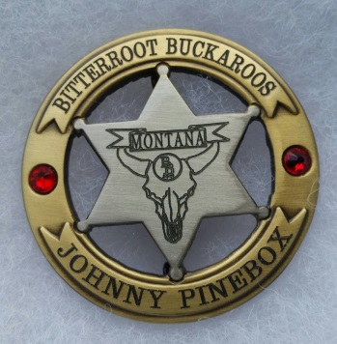
Look over the options for the badge covered on the following two pages and decide what you want.

Once you have made your decisions call or email Cindy and tell her you want the Bitterroot Buckaroos badge. Our logo will be placed in the center of the badge.

Cindy Sutton
800-564-6164
800-488-1316 fax
cindy@piecesofhistory.com
She will arrange payment for the badge and email you a mockup for approval.
If you would like to see larger images you can check out the web site for Pieces of History. Look under “Western Badges” and then “custom” to see the options. www.piecesofhistory.com For some reason you can not order from the web site and get the club logo in the center. You must do that by emailing Cindy.

The mock up they will send you for approval does not do the actual badge justice, but be sure to check the spelling and make sure the crystals and center graphic are correct.
The crystals will break and chip so treat them kindly.
