Summer Camp weekly Chinese Themes
Week 1  6/15-19 | Chinese Tea Ceremony | 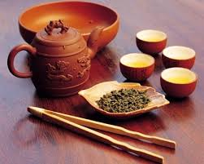
Week 2  6/22-26 | Chinese Music Concert | 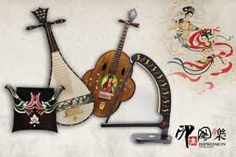
Week 3  6/29-7/2 | Fun Chinese Sports
Week 4  7/6-10 | Chinese Fashion Show | 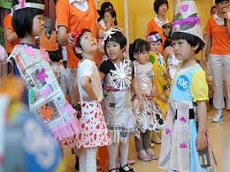
Week 5  7/13-17 | Chinese Mythical Legends | 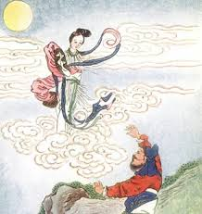
Week 6  7/20-24 | The Arts of War | 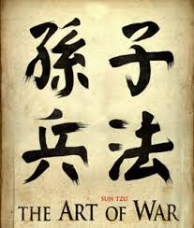
Week 7  7/27-31 | Weird Chinese Custom
Week 8  8/3-7 | Wacky Chinese Food | 