Where are you located? Our General Conference Office is located in Cayce, West Columbia SC. USA.

U.S.A. Map
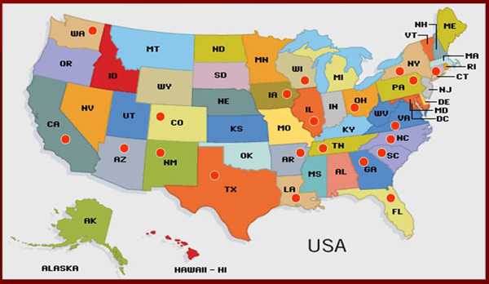
Red dots indicate where EPC GCEPC LEPC ministries are located.

World Map
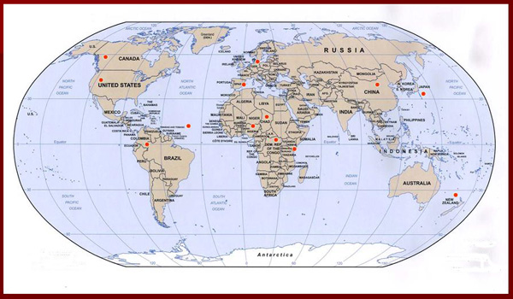

Please contact us to verify rostered clergy at generalconference@lutheranepc.com.

