Today’s lesson was on Biology, specifically the Water Cycle. The girls knew a lot of information on the water cycle and so the lessons added onto their background knowledge of the topic. Along with the 3 terms they already knew, they learned more about transpiration and runoff. The girls created models of the water cycle using cotton balls in representation of clouds!
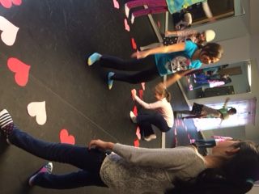
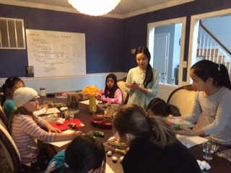
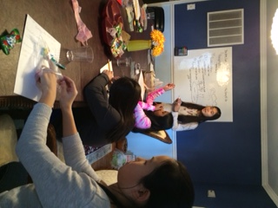
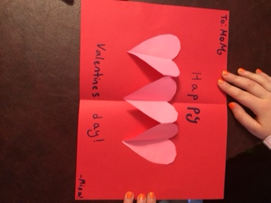
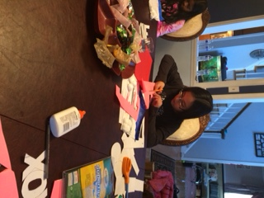
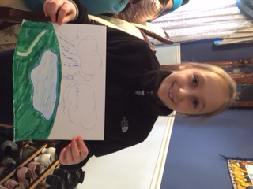
Since it is so close to Valentine’s Day, the girls also played some valentines themed games and created some valentines cards! As an activity, they played musical chairs, heart-themed, and whenever they stopped on a specific card, they got to do a small fun activity! They also made cute little valentines cards that popped out when they opened using different folding techniques.

