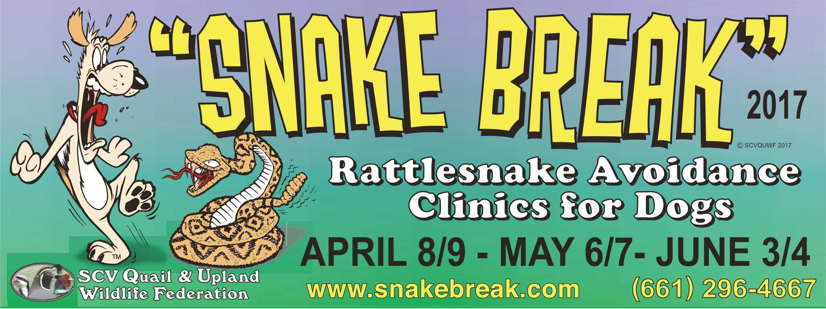
CREDIT CARD NUMBER:
CARD HOLDER NAME:
Billing Address:
EXP. DATE:
3 digit code (back of card)
Signature:
Preferred Time: Choice #1 Choice #2 Choice #3 Choice #4
Print Clearly
Dog Owners Name: Dog’s Name:
Address: City: Zip: Phone: Work:
Email Address:
Dog(s) Type :
Snake Break T-Shirts Now Available Sizes: M-XL: $ 15.00 2XL/3XL: $ 18.00 SMALL MEDIUM LARGE X-LARGE 2XL 3XL: T-Shirt Total: $
Quail & Upland Wildlife Federation Annual Membership - General Membership: $ 40.00
General Membership - Snake Break patrons get $ 5.00 off (per dog), Priority appointment times, Membership Patch and Snake Avoidance Class proceeds will go into local wildlife habitat projects & local Youth Educational / Conservation programs.
MAY 6
MAY 7
JUNE 3
JUNE 4
CASH (no COD’s)
CHECK (make payable to SCVQUWF)
Revised 02/01/2017
Information Only: Call (661) 296-4667or Email: dogclinics@scvquwf.com / www.SnakeBreak.com / www.SnakeAvoidanceClass.com
Mail Registration Form To: SCVQUWF, P.O. Box 802738, Santa Clarita, California 91380 - Email Registration Form: dogclinics@scvquwf.com Payments are Non-Refundable for “No-Shows”. A $ 25.00 charge will be added to any returned checks or cancelled credit card payments.
DATES: April 8 & 9 - May 6 & 7 - June 3 & 4
TIME: 7:00 AM to 5:00 PM at specific intervals.
PLACE: Mint Canyon Community School (utility field)
16400 Sierra Highway, Canyon Country, Ca 91351
COST: $ 75.00 Per Dog
The training sessions will be done by appointment only! Register early, space is limited and we will sell out!
Minimum of 35 dogs per monthly session to hold clinic. SCVQUWF reserves to right to schedule dogs to the
earliest available time and/or refer dog to next available date if requested class date & time is unavailable.
APRIL 8
APRIL 9

$ 75.00  Per Dog | X
Per Dog Total
Membership Total
T-Shirts Total
Grand Total

