

**2016**

**Liberation Singles Open**

The 2016 Liberation Singles Open was for the third year running maxed out at 32 entries which is the perfect number for the Swiss system used.

Round 1 saw holder Andrew Bellamy-Burt lose to Neil Selby 13 – 12 to dent his chances of retaining his title. Another loss 13 – 12 was Matt Pinel to Island Singles runner up Mathew Scholefield and the Island champion Matt Buesnel started off with an easy win 13 – 03 over Delphine De La Mare from Guernsey.

There was two 13 – 01 wins with Geoffroy Buffetrille beating James Rondel and more surprisingly (just the scoreline) Michel Morel beat Alan Lahiffe, but there was one 13 – 0 win as Keith Boleat hand out a certificate to Colin Myers.

Round 2 saw another certificate handed out as Seb Renaud beat Joe Richardson who was playing his first ever matches. Ian Foster got just 2 points more than Joe losing to Toby Northern 13 – 02 and Andrew Bellamy-Burt lost 13 – 12 again! This time to Brian Harris virtually ending his title defence.

Brandon Ogier from Guernsey beat Mat Scholefield 13 – 11 in a close match, but the surprise one was Neil Selby losing 13 – 10 to David Le Gresley who was playing in his first Liberation tournament.

Round 3 saw the pressure start to mount as the matches got tougher for those winning. Brandon won again 13 – 12 against Michel Morel and Matt Buesnel beat his Island Triples champion team mate Ross Payne 13 – 05. Callum Stewart one member of the European Triples team lost his third straight match this time to Penny Foster.

Round 4 saw Island Singles champion Matt Buesnel lose 13 – 12 to Keith Boleat and another 13 – 12 was a loss for Neil Selby against Seb Renaud. Ross Payne lost to Michel Morel and David Le Gresley 01 – 13 to Matt Pinel.

The final Round of the Swiss system (5) saw Keith Boleat be the only person to win all five matches with a 13 - 10 win over Brandon Ogier who finished third overall. Geoffroy Buffetrille beat Matt Pinel to go through to the quarter finals at the expense of Matt.

Michel Morel beat Paul Le Moine to finish second in the rankings with Matt Buesnel taking fourth place beating Chris Romeril who finished seventh. Toby Northern beat Alan Lahiffe 13 – 4 to take fifth place and end Alan’s hopes of reaching the knockout stage.

There was however a tie for the last quarter final place with Paul Le Moine and Stephen Leathem, therefore a 3 end play-off was played. Paul won 3 points on the first end but Stephen came back well to win the play-off.

Keith Boleat continued his fine run of form ending Stephen’s run in the competition in a Carrefour Petanque Club quarter final to make the Semi finals for the first time. Michel Morel lost to Chris Romeril (who was the first ever Liberation Singles champion in 2012) in another all Carrefour Petanque Club quarter final.

Matt Buesnel played an outstanding match against Toby Northern handing the Island Number 1 ranked player a thrashing 13 – 04. This wasn’t as big a win as it was for Geoffroy Buffetrille who beat Brandon Ogier 13 – 01.

The Semi Finals saw Keith play Matt, and having already beat him in Round 4 of the Swiss System Keith would have been confident of reaching the final. It was again a close match, but a combination Matt’s experience of the terrains, his confidence and form saw him make the final.

Geoffroy showed great composure in his semi final against Chris Romeril who struggled with the terrain to make it an All Liberation Petanque Club final.

The final was a game of thirds as Matt quickly took a 5 – 0 lead, before Geoffroy started to out place Matt on every end, with Matt seemingly reluctant to fire Geoffroy moved 11 – 5 up. It must have been a combination of the pressure of getting so close to winning and Matt giving everything he had as it ended up at 12 – 12 and this was a result of Matt only picking up one point on the end before when he really should have won it.

But he needn’t have worried as a brilliant comeback from 11 – 5 down ended in in Matt winning his second singles title in as many weeks. Keith Boleat took 3rd place with a win over Chris Romeril.

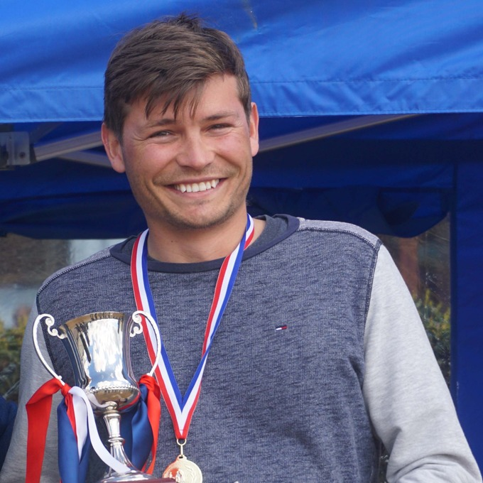

See below SWISS RESULTS

|  |  |  |  |  |  |  |
| --- | --- | --- | --- | --- | --- | --- |
| RANK | PLAYER NAME | CLUB | WINS | BHN | GAMES | POINTS |
| 1 | 267 Keith Boleat | Carrefour | 5 | 15 | 5:0 | 65:35 |
| 2 | 268 Michel Morel | Carrefour | 4 | 16 | 4:1 | 64:38 |
| 3 | 258 Brandon Ogier | Guernsey | 4 | 15 | 4:1 | 62:55 |
| 4 | 246 Matthew Buesnel | Liberation | 4 | 14 | 4:1 | 64:35 |
| 5 | 245 Toby Northern | Liberation | 4 | 14 | 4:1 | 61:36 |
| 6 | 242 Geoffroy Buffetrille | Liberation | 4 | 12 | 4:1 | 64:38 |
| 7 | 263 Chris Romeril | Carrefour | 3 | 15 | 3:2 | 59:45 |
| 8 | 260 Stephen Leathem | Carrefour | 3 | 14 | 3:2 | 55:46 |
| 9 | 243 Paul Le Moine | Liberation | 3 | 14 | 3:2 | 55:46 |
| 10 | 244 Ross Payne | Liberation | 3 | 14 | 3:2 | 53:47 |
| 11 | 249 Alan Lahiffe | Carrefour | 3 | 14 | 3:2 | 44:42 |
| 12 | 261 James Mold | Liberation | 3 | 12 | 3:2 | 56:50 |
| 13 | 237 Brian Harris | Liberation | 3 | 12 | 3:2 | 55:56 |
| 14 | 264 David Le Gresley | Carrefour | 3 | 12 | 3:2 | 44:54 |
| 15 | 251 Matt Pinel | Liberation | 3 | 11 | 3:2 | 59:39 |
| 16 | 250 Andrew Bellamy-Burt | Liberation | 3 | 10 | 3:2 | 63:54 |
| 17 | 259 Matthew Scholefield | Carrefour | 2 | 14 | 2:3 | 55:58 |
| 18 | 253 Colin Myers | Liberation | 2 | 14 | 2:3 | 44:54 |
| 19 | 240 Neil Selby | Carrefour | 2 | 13 | 2:3 | 58:58 |
| 20 | 256 Andrew Limbrick | Liberation | 2 | 13 | 2:3 | 48:51 |
| 21 | 266 Ellis Turmel | Liberation | 2 | 12 | 2:3 | 47:60 |
| 22 | 247 Ian Foster | Liberation | 2 | 11 | 2:3 | 42:47 |
| 23 | 239 Delphine De La Mare | Guernsey | 2 | 11 | 2:3 | 44:51 |
| 24 | 254 Tony Lagadu | Carrefour | 2 | 11 | 2:3 | 51:60 |
| 25 | 262 Jamie Saville | Liberation | 2 | 10 | 2:3 | 43:60 |
| 26 | 238 Seb Renaud | Guernsey | 2 | 9 | 2:3 | 53:51 |
| 27 | 255 Lorna Limbrick | Liberation | 1 | 15 | 1:4 | 45:64 |
| 28 | 257 Ian Black | Liberation | 1 | 12 | 1:4 | 41:64 |
| 29 | 248 Penny Foster | Jersey PC | 1 | 12 | 1:4 | 31:62 |
| 30 | 265 James Rondel | Jersey PC | 1 | 11 | 1:4 | 36:52 |
| 31 | 252 Callum Stewart | Liberation | 1 | 9 | 1:4 | 51:56 |
| 32 | 241 Joseph Richardson | Liberation | 0 | 9 | 0:5 | 17:65 |

# Club email address - [liberationpc@gmail.com](mailto:liberationpc@gmail.com)

# Club Website - [www.liberationpetanque.co.uk](http://www.liberationpetanque.co.uk)

# Kind Regards

# Ross Payne

# Report Editor

# Liberation Petanque Club

# SPONSORED BY

# 135a1bd6338e1b589a50cdec98bd84d1?AccessKeyId=C6E923731F1A482DD910&disposition=0&alloworigin=1