The Social Thinking Methodolo The Social Thinking Methodology builds: gy builds:

**The Social Thinking Methodology Builds:**

social competencies • social self-awareness • perspective taking • self-regulation • executive functioning • social skills • social emotional understanding • organizational systems

**February 17, 2020**

**272 Terhune Ave.**

**Passaic NJ 07055**

**8:30AM - 3:00PM**

**6 Contact Hours**

**Presented by:**

**Nancy Clements, MA, CCC-SLP** is a speech-language pathologist and Executive Director of Social Thinking® Boston, the East Coast sister clinic to Social Thinking Stevens Creek and Social Thinking Santa Clara in California. She is also the Director of the East Coast Social Thinking Clinical Training Program. She provides intervention to social learners spanning all ages and presents across the United States, Canada and internationally.



**The Social Thinking Methodology builds:**

**• social competencies • social self-awareness • perspective taking • self-regulation • executive functioning • social skills • social emotional understanding • organizational systems**

The speaker for this event is from the Social Thinking’s Training and Speaker’s Collaborative (STTSC). Social Thinking is not a sponsor of this event.

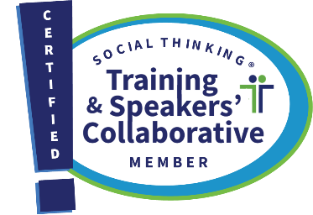

**Please contact Therapy Funplace at 201-777-0473 or** [**office@therapyfunplace.com**](mailto:office@therapyfunplace.com) **for information about continuing education credits for SW’s SLP’s and audiologists.**

**Please email Therapy Funplace with any complaints/grievances and for any accommodations for disability.**

**No refunds will be issued. Registrant may send another attendee in their place if approved by Therapy Funplace in advance.**

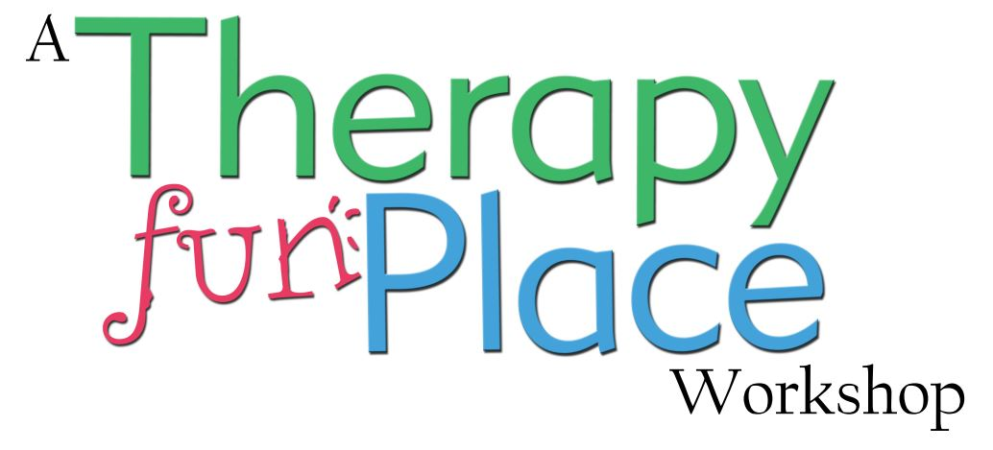

**Implementing Social Thinking Concepts and Vocabulary: A Day to Develop Team Creativity**

Learn more than 20 Social Thinking strategies and three core treatment* frameworks to guide students, clients, and patients to better attend, interpret, problem solve, and respond to social information. Help individuals 1) observe and respond to situations based on the context and determine the “expected” behaviors of each situation, 2) learn core Social Thinking Vocabulary and concepts to encourage social-communicative competence, and 3) discover strategies for teaching self-regulation, executive functioning, emotional understanding, and theory of mind/perspective taking. Work in teams to develop lesson plans to implement new strategies in the home, clinic, or classroom the very next day. People love this hands-on, engaging course!

*\*Treatment refers to using conceptual and strategy-based frameworks to help individuals improve their social skills and competencies.*

**COURSE LEVEL: INTERMEDIATE**

Participants will be able to:

1. Describe why the context or situation is key for figuring out social expectations and related social skills.
2. Describe the core steps of Social Behavior Mapping to help teach social responsibility.
3. Define at least five Social Thinking Vocabulary concepts.
4. Describe how Social Thinking Vocabulary concepts facilitate generalization across settings.
5. Describe the difference between sharing an imagination and a singular imagination and their relationship to conversations and reading comprehension.