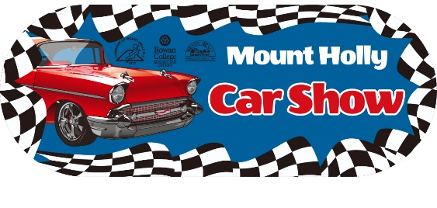
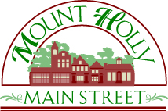

Dear Potential Sponsor,

Get your brand in front of 2,000+ future customers!

You are invited to become a valued sponsor for the best family-friendly car show in Burlington County. Join us for the 17th Annual Mount Holly Car Show on Saturday, June 1st, 2019.

In its 17th year, the car show will draw crowds of regional visitors to fill the town for a full day of viewing custom cars, trucks, hotrods, military vehicles and other incredible pieces of mechanical art and history. The event features classic music, activities, food, shopping and more in historic downtown Mount Holly, NJ.

Don’t miss this opportunity to connect YOUR business with potential customers at this unique and popular event.

Thank you in advance for your consideration. Please contact us with any questions.

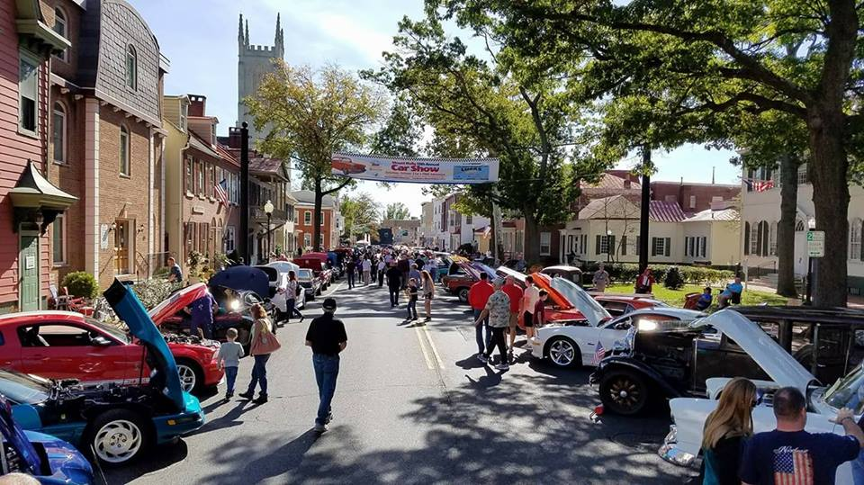
Most sincerely,

Robert V. Drapala
Mount Holly Car Show Committee Chairman
Ph: 609-346-2416
Email: msmhnj@gmail.com
www.MainStreetMountHolly.org
PO Box 747, Mount Holly, NJ 08060

Proceeds from the event benefit Main Street Mount Holly, a volunteer-driven nonprofit organization, whose mission is to protect, promote and enhance our historic downtown. Main Street Mount Holly is a NJ 501c3 registered organization so your donation is tax deductible (EIN 04-3668475).

