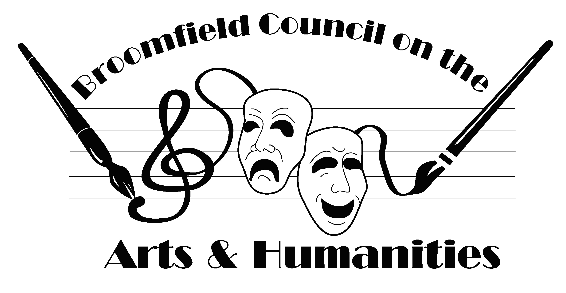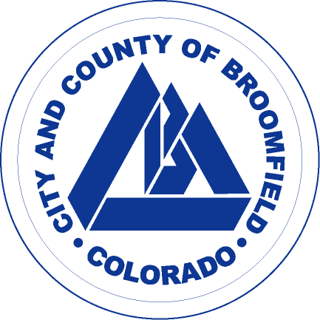

2019 Broomfield Days Poster Contest
Call for Entries

Entry Rules

Artwork size: 16x20 inches
Allowed mediums: Water media, pastel, oil, acrylic, or mixed media. No fluorescent
colors, computer generated or photography.
Entry Fee: $10 per piece of artwork for BCAH members & $15 per piece
of artwork for non-members. You may submit up to 3 entries.
Awards: Cash awards for 1st and 2nd places. 1st place entry will be printed as official Broomfield Days Poster.

All artwork must be original, framed, and ready to hang (wire) in a gallery.
Open to all artists aged 16 years and older.
There is no theme for this year’s contest.

Mail entry forms and fees to: BCAH
P.O. Box 681
Broomfield, CO 80038

Important Contest Deadlines

Friday, July 6, 2017 Last day to submit entry form and fee; due by mail, email or dropped off to BCAH (envelopes with July 7 postmark will be accepted)

Wednesday, July 12- Delivery of artwork to the Brunner Farmhouse
Friday, July 14, 2017 located at 640 Main St. (NE corner of Main & Midway); office hours: 9-2:30 p.m. M-Th & 9-12 p.m. Fri.

Thursday, July 27, 2017 Reception with all artists and guests for the announcement of the winners; 6-7 p.m.

Saturday, September 16, 2017 Broomfield Days at Midway Park

If you need to make alternate arrangements for the delivery of your artwork, please call 303-460-6800.
Please complete two copies per entry of the following form. Submit one form with payment. The other form should be cut and attached to the back of each piece submitted.

2019 Broomfield Days Poster Contest Entry Form

Entry form and fee are due or must be postmarked by July 5, 2017
Artwork must be delivered by July 14, 2017

Member: ___ Non-Member: ____ # of Entries: ______ Amount Enclosed*: ______
*Please make checks payable to: Broomfield Council on Arts and Humanities

Object __1__ of _____
Name:

Title of piece:

Address:

Phone:

Email:

Object _2_ of ____
Name:

Title of piece:

Phone:

Email:

Object _3_ of ____
Name:

Title of piece:

Phone:

Email:

