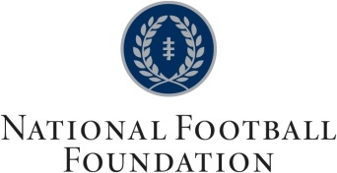
Jack Grinold Eastern Massachusetts Chapter

JACK DALY AWARD FOR ACADEMICS, CITIZENSHIP, AND FOOTBALL NOMINATION FORM

In honor of Jack Daly, a charter member of the Jack Grinold Eastern Massachusetts Chapter of the National Football Foundation, the Chapter will present annually an award to a college football player at an institution in the Chapter footprint based on academic performance, community service, and demonstrated football ability. Each of the three components of the award will be weighted equally in the selection of the winner. Collegiate student-athletes who have completed their junior and/or senior years of eligibility shall qualify for this award.

Nominee Name: ______________________________________ Institution:____________________

Hometown: __________________________________________ High School:____________________

Class year: Jr. Sr. (circle one) Academic Major(s):___________________________________

GPA: ____________ (4.0 scale) Academic Minor(s): ___________________________________
(Please include academic transcript)

Academic Honors Received:

Page 1 of 2

JACK DALY AWARD FOR ACADEMICS, CITIZENSHIP, AND FOOTBALL
NOMINATION FORM

page 2 of 2

Nominee Name: __________________________________ Institution:__________________________

Community Service Activities (please include all activities both on and off campus):
Please rank level of involvement: 1 – ongoing leadership position, 2 – single event leadership position,
3 – ongoing participant, 4 -single event participant

Football Career Statistics and Honors:

Feel free to add extra pages if necessary.
Please return the completed form to: Roger Crosley
20 Pond Drive
Manchester, NH 03013
or grinold.chapter@gmail.com

