Taking Technology into the Wilderness
(Provided by: HighCountryExplorations.com)

All technology should be assumed guilty until proven innocent.
—David Brower, prominent environmentalist and
founder of the Sierra Club Foundation

When I was a boy we learned what the land looked like, and we knew the rock cairns that the people had built on the land to find their way in storms and whiteouts, because we were a part of the land and we knew it because if we didn’t we would not live. Now these computers [GPSs] that the young people use to find their way—it makes them afraid of the land. . . . They make you afraid of what you should know.
—Inuit elder living in northern Canada, quoted from
Kevin Patterson, The Water In Between, p. 205

Technology is a way of organizing the universe so that man doesn't have to experience it.
—Max Frisch

Central Questions Addressed in This Article
What about taking and using high-tech gear in the wilderness? How should we define “high-tech” gear relative to wilderness travel? What high-tech gear will enhance and what will detract from my wilderness experiences? What about emergency communication devices like personal locator beacons and navigation devices like GPS units? What is my general philosophy regarding the use of modern technology in the wilderness?

Some Starting Assumptions
It is necessary to make several assumptions to deal effectively with the above questions.

- Assume that high quality wilderness experiences are desirable when backpacking.

- Consider that there is no such thing as a “pure” wilderness experience untainted by human technology. Airplanes and satellites fly over. Trail signs and maps involve some technology. Modern packs, tents, boots and clothing all involve lots of technology. Essential survival gear (e.g., LED light and topography map) usually involve some technology.

- Assume that technology can intrude on our wilderness experiences. Consider an extreme example of the person who takes a digital camera, a smart phone, a GPS and an iPod, all on the same trip. With all of these devices, it is unlikely he or she will have much time to sit quietly and absorb the sights and sounds and smells of nature. While most hikers do not fit this extreme example, many might to lesser degrees.

- Assume we are not practicing survivalist techniques or attempting to recreate a primitive wilderness style where we make most of our clothes and gear.

- Even though some have a problem with almost any item of modern technology applied to backpacking, assume that the primary issue here is with taking high- or higher-tech gear into the wilderness. Lower-tech products of modern technology (e.g., basic gear made from plastic or aluminum or nylon) are not generally at issue. Even though these lower-tech items may have been high-tech at one time, they are no longer.

Defining “High-Tech” Gear by Example
Assuming that high- or higher-tech gear is at the heart of this issue of technology and wilderness experiences, what is the best way to define this concept? It could be defined by making explicit many of the characteristics of high-tech gear: electronic, miniaturized, computerized, computer aided design, solar charged, complex in design, innovative, making use of the latest available technology. But defining “high-tech” in this way (i.e., by its qualities and characteristics) only goes so far. In this context, a better way to define “high tech” is by giving examples. Most will recognize the following high-tech items even if they can’t say exactly what they all have in common (if anything). Following this advice, here is a comprehensive list of the latest, greatest and highest tech gear often seen in the wilderness.

cellular phone
smart phone
satellite phone
GPS (Global Positioning System)
PLB (Personal Locator Beacon)
PDA (Personal Digital Assistant)
FRS (Family Radio Service)
GMRS (General Mobile Service Radio)
MP3 player (miniature digital audio and video device)
LED (Light Emitting Diode) hand light or head lamp
Chlorine dioxide based water treatment
Ultraviolet light based water purifier
prescription medications and wonder drugs
meal replacement powders and bars
vitamin and mineral supplements
performance fabrics (e.g., Goretex, eVent, silnylon, Cuben fiber, Spectra)
electronics embedded in clothing (e.g. heart rate monitor, heating panels)
solar chargers and photovoltaic fabrics
digital camera
digital tape recorder
digital AM, FM radio
digital altimeter, barometer, thermometer, chronometer, compass, etc.
alkaline and lithium batteries
titanium gear
carbon fiber gear
night vision goggles
footwear with gel pockets in the soles

The above comprehensive list focuses on high-tech gear often taken into the wilderness. Whether or not some items have been missed, I guarantee more will arrive on the scene in the near future relegating at least some of these devices to lower tech status or making them totally outdated.
To extend this “definition by example” a bit further with contrasting examples, check out the next section.

Examples of Low- and Mid-Tech Gear
Below is a comprehensive list of examples of low and mid-tech gear commonly taken into the backcountry. It is interesting to note that many of the items were considered high-tech when first available.

Oldest and lowest-tech
knife
wooden equipment
canvas gear
wool clothing
oilskin clothing
primitive fishing gear
printed journals and guide books
printed paper maps
eye glasses
oil stoves and lamps
candles
feathered sleeping quilt
whistle

Older low-tech
watch
pistol or rifle
caulked logger boots
triconi nailed climbing boots
aluminum and stainless steel gear
zippered clothing
molded insoles
customized orthotics
plastic gear
compass
waterproof matches
iodine and chlorine water treatment
tinted eyeglasses
toilet paper
non-prescription medications
chemical fuel stoves
chemical bug repellents
monocular/binoculars
mechanical camera
bush plane flight into remote wilderness

Modern mid-tech
topography map
mechanical altimeter
synthetic fabrics
synthetic insulations
Velcro (hook and loop) clothing
collapsible trekking pole
metal alloy gear
combination (multi) tool
fortified and modified trail foods
freeze-dried food
self-inflating mattress
portable water filters
Polaroid and transition lenses in eyewear
contact lenses
waterproof and breathable shell clothing
chemical hand and foot warmers
Lexan utensils
butane lighters
pressurized canister stoves
liquid fuel stoves
composite lightweight trail shoes and boots
alkaline batteries
incandescent bulb flashlights
hydration bladders

When seen as a whole, different levels of technology (i.e., low/mid/high tech) should be viewed as a continuum with no precise definitions possible.

Reader Participation: Use of High-Tech in the Backcountry
First, add items that belong in the “high-tech” list that are not now listed. Second, check off those items you currently take or would seriously consider taking into the backcountry. These could be items already owned, would like to own if affordable, or are willing to rent for specific trips.

Defining “High-Tech” by Specific Actions
To make my definition of high-tech-by-example even more comprehensive, consider the following specific actions while using higher-tech gear. Consider a person doing the following before or after coming back from a trip:

- using a cellular phone to make arrangements with party members

- using a computer to visit the Internet for specific tasks (e.g., researching a trip, purchasing hiking equipment)

- printing customized maps from a computerized mapping program

- using a photo enhancement or photo organization computer program to process pictures taken during a trip using a digital camera

- transcribing notes from a miniaturized recorder to write a journal, book or article based upon wilderness experiences

- using a computer to actually write a book or article about trips into the wilderness

- using computer aided equipment to design and manufacture outdoor gear

- using a high tech vehicle to get to and from trailheads

Even though the above examples are obviously much different from the earlier examples of high-tech gear, they should add another dimension to the philosophical questions addressed in this article.

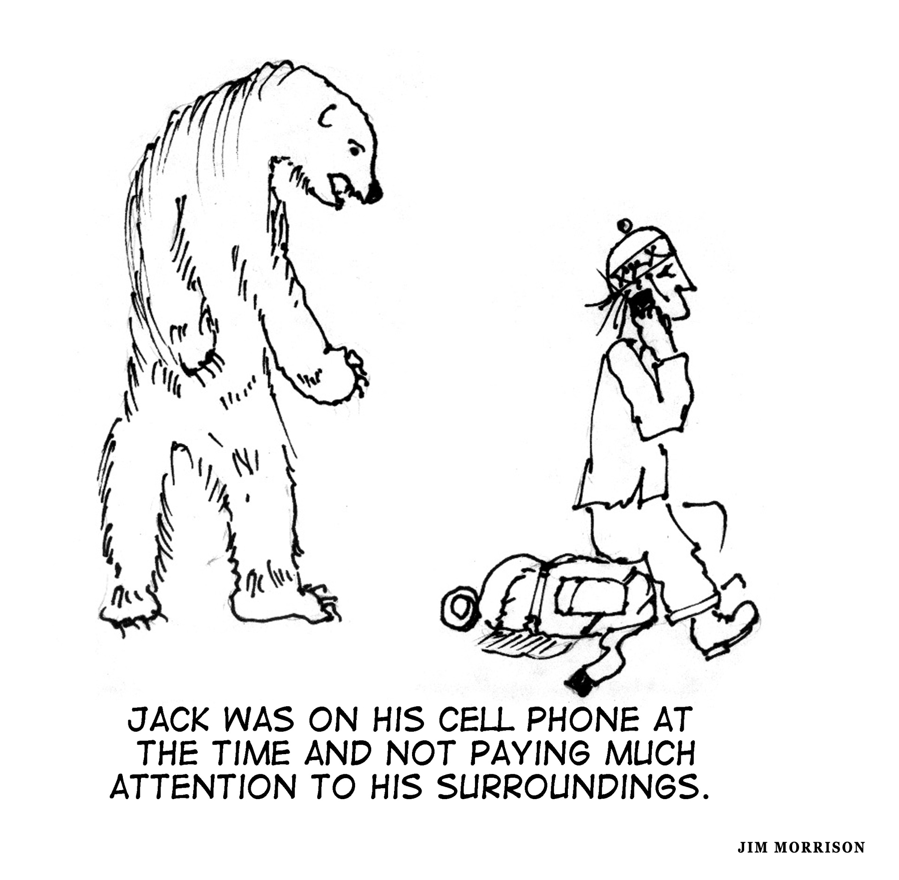
Philosophies of Technology in the Wilderness: Thumbnail Sketches
With the necessary preliminaries taken care of (i.e., questions, assumptions and definitions), let’s get to the heart of the matter: to objectively examine potential answers to issues posed at the beginning of the article. What follows are brief sketches (in the first person) that will provide us with a comprehensive list of philosophies on this subject. I attempt to state each without any personal judgments on my part. My conclusions and philosophies will come later.

Keep It Low-Tech: My goal when backpacking is to get as far from civilization and its technologies as possible. I like to keep it low key and low-tech. Therefore, I do not take any high-tech gear unless necessary for me to get out and enjoy the backcountry safely (e.g., prescription medications and batteries for my flashlight).

Primitivism: I pride myself in being able to survive and enjoy the backcountry without any high-tech gear. A few low-tech items like a knife, compass and matches are okay.

High-Tech Minimalism: I strongly believe in carrying a few high-tech gear items (e.g., stove, watch, headlamp), but keeping them to a minimum. When in doubt, leave it out.

Enhances My Wilderness Experiences: Anything that distracts me from Nature I leave at home. Anything that helps me enjoy Nature that much more, I take. Any gadget that keeps me from being totally present is left home. I shut out technology that will distract or isolate me from the sights and sounds of Nature. For example, all electronics designed for entertainment are out because they always get in the way.

Maintaining Basic Skills: If I regularly carry some high-tech stuff, I do lower-tech trips at least once a year to maintain my basic survival and navigation skills. It is important to remember how to do it "the old-fashioned way” (e.g., when the batteries fail).

Simplicity and Reliability: I go with the simplest version of selected gear items to minimize the chance the item will fail and become a nuisance. Examples of big potential nuisance items are inflating pads, zippers, trekking poles, and stoves. If a piece of higher-tech gear is light and simple to operate and highly reliable, it usually goes with me. For the in-between complexity and reliability items, I use my judgment regarding my ability to do field repair and maintenance. One unknown writer expressed it this way: “I've concluded that the more simple and convenient my routine ‘life-supporting’ activities are, the more they fade into the background of the trip. This leaves me more open to the experiences of the trip.”

Advanced Forms of Basic Activities: I take higher-tech gear into the wilderness if it provides a different approach to what has been done, pretty much, forever. Basic activities like walking, sleeping, cooking and carrying stuff are fair game for high-tech. For example, I take a tent—as my ancestors might have—only mine is made from waterproof, breathable, high-performance fabric with carbon fiber poles. If it is not a new approach to an old problem but a new kind of thing, it merits a high degree of skepticism. I have no problem with new technology when it is better than the old ways, especially if it is lighter weight and more durable and useful.

Being Comfortable: Being comfortable while enjoying nature is important. If higher technology will assist me in this, I am willing to compromise my wilderness experiences a bit (if there is a tradeoff). There will be times of discomfort, but not to the point that they intrude on my experiences of the wilderness (e.g., being cold, wet and miserable).

Dual Purpose Technology: Taking things that have more than one purpose is important. For example, the latest cell phone technology can not only call out in case of emergencies, but often includes a GPS to pinpoint my location. High-tech cell phones have an alarm function, take decent pictures and play my favorite tunes. The latest high-tech phones function as personal digital assistants (PDAs) with which I can take notes for the article I am currently writing. Dual purpose is my mantra.

Whatever Achieves My Goals: My primary goals when out in the wilderness are to travel light, be safe and have fun. I generally welcome technology that will lighten my load (e.g. lighter weight tent, bag, boots, clothing, etc.) or increase my safety (e.g., wicking and quick-drying synthetics, personal locator beacon, customized and detailed computer-generated maps). I use technology that will enable me to hike farther, linger longer and experience Nature a bit more.

Relative to Trip Objectives: The trip dictates the gear list. Some trips dictate more technology, some less, some none at all. A GPS, binoculars and altimeter can be quite useful for off-trail trips into new terrain. If I am going solo, a satellite phone or personal locator beacon can be a good emergency backup and will usually make my loved ones rest easier. If I am out to observe the wildlife, binoculars and a field guide are usually quite helpful. If I only want to get away for a few hours on an easy day hike, then little or no technology is usually the rule. In summary, it all depends upon the weight, volume and usefulness of specific gear for a specific trip.

Balance and Moderation: My philosophy of life is balance and moderation in everything. Some higher-tech gear can and does enhance my experiences. However, I try to balance it with lower-tech items. For example, if I take the latest model of an LED headlamp, I might balance it with other lower-tech navigation gear (i.e., only map and compass). If I take the lightest high-tech shelter (e.g., a catenary cut, silnylon tarp-tent with titanium pegs), I might avoid taking the latest high-performance and high-tech clothing (e.g., bicomponent and hybrid merino wool and polyester base layers). If I take a digital camera, I will resist taking any high-tech electronics for entertainment. It is so easy to get off balance with a bunch of high-tech gear. Balance and moderation! Balance and moderation!

Relative to Age, Culture and Political Background: Being modern and trying to fit into a high-tech culture seems relative to one’s age and cultural background. I am conservative and old school and do not like change for its own sake. I like to live simply; I have little interest in trying out the latest technologies. I am comfortable with the same outdoor gear I have found useful over the years. I often have to shop at garage sales and secondhand gear stores to replace worn out items. Living my basic values (which do not include technology) is my central focus. My getting out regularly in the wilderness and away from technology fits quite well with these values.

Confessions of a Technophile: In contrast to the above philosophy, I am the product of a high-tech oriented society. I love change and trying new things. I love gadgets and I like to have fun playing with them in the backcountry. Gadgets greatly enhance my fun. I am a confirmed gadget-oholic and technophile. I love to experiment with new gear. I essentially reject one of the starting assumptions given at the beginning of the article that quality wilderness experiences are more important than playing with my high-tech gadgets. I love to be out in the wild, but when there is a conflict, technology wins out every time.

Reader Participation: Acknowledging Philosophies about Technology and Wilderness Experiences
The above thumbnails are designed to assist in sorting out the central issues of this topic and coming to some conclusions. Do any thumbnail sketches jump out at you? Are there any that you reject out of hand? First, consider going back and circling the philosophies that come the closest to your own position. Second, if a preferred philosophy is too biased, distorted or incomplete, consider rewriting it. Third, if none captures your own thinking on this subject, consider writing out your individual philosophy about the ideal relationship of technology to quality wilderness experiences. Fourth, if your philosophy is complex and multifaceted, consider synthesizing the many ideas into one written essay.

Special Case: Emergency Communication Devices
I see the following devices as special cases of technology in the backcountry: cell phones, personal locator beacons, personal tracking devices, satellite phones. As emergency devices, they deserve their own analysis. Consequently, I have written an entire article on the subject: “Emergency Communication Devices Analyzed.” In that article, I take the position that there are many factors to consider when deciding whether or not to take these devices into the wilderness. Sometimes it is important not to carry such a device; sometimes it is important to carry two or more. In many cases, I conclude that it is your moral obligation to carry one or more of these emergency communication devices into the wilderness.

Author’s Philosophy of Technology Related to Wilderness Experiences
Without a doubt, being obsessed with any number of things while in the backcountry (e.g., use of technology, proper etiquette, techniques, safety, achieving specific goals, personalities, weather) will intrude on the quality of wilderness experiences. Going overboard on technology is only one manifestation of a larger problem. For example, taking and using several electronic devices (for emergencies, for navigation, for entertainment) will almost always intrude. The best solution, for the highest quality wilderness experience, is to keep these electronic devices in the bottom of the pack. When they come to the fore, temper use of them with restraint and moderation.
Having said this, other factors (other than use or non-use of high-tech gadgets) are much more important for producing quality wilderness experiences. Here is a summary of the more important elements:

- the distance and the length of time away from cities and the trailhead

- the amount of time spent traveling through previously unexplored areas

- the number of man-made improvements and signs of civilization

- the number of people in the party and their attentiveness to the wilderness environment

- the commitment to just being in the wilderness without always having to be doing something and achieving something

In addition, to maximize such wilderness experiences, I need to:

- spend weeks or months in pristine and isolated environments with minimal interruption by resupply

- spend time in environments not often frequented by others

- travel off-trail by myself or with a small, like minded party

- not have rigid agendas

Author’s Philosophy of Technology Related to Backpacking
Since the level of technology taken into the backcountry, by itself, has little to do with the quality of wilderness experiences (as expressed in the previous section), there is still an unanswered question: What is my chosen style regarding technology in the backcountry?
Two closely related philosophies sketched earlier in this article (“Whatever Achieves My Goals” and “Relative to Trip Objectives)” come the closest to stating my personal philosophy. More specifically, my primary goals on most backpacking trips are to travel lightly and safely and have fun. I welcome technology that will assist me in accomplishing these objectives. Selection of gear is relative to the specific objectives of specific trips. For example, I especially enjoy traveling off-trail into new terrain. With this type of trip, the following high-tech options are seriously considered: altimeter, GPS, printing customized maps from a computerized mapping program and doing Internet research to research and learn everything I can about an area. I generally go off-trail with others of similar minds, but if I go solo, I will usually take a personal locator beacon (PLB) or a satellite phone.

Final Thoughts
This article was fun to write because it enabled me to develop definite answers on a difficult, confusing and multi-layered subject. What about you? Did this article assist you in coming up with satisfying answers to the questions raised at the beginning? Did it clarify your position regarding potential conflicts of technology with wilderness experiences specifically and with backpacking generally? Or did it just reaffirm the philosophies you already had? Either way, I hope this article challenges some previously held assumptions and positions.

Additional Issues for Reflection
- What is the best way to define high-tech outdoor gear? By common characteristics? By examples? By dictionary definitions? By all of these? Is there one characteristic or element that defines most high-tech outdoor gear?

- On a broad scale of things, how has modern technology changed hiking and backpacking in North America over the past 50 years or so? Assuming that some of the changes are for the good and some not, what is your overriding judgment about goodness?

- Is there such a thing as a “pure” wilderness experience untainted by technology in some way? Would John Muir’s High Sierra travels or Grandma Gatewood’s Appalachian Trail experiences come close?

- When exploring this topic, should a distinction be made between emergency and other electronic devices (entertainment, navigation, cooking)?

- Is it important to make a distinction between natural materials and man-made materials? If so, how easy is it to distinguish between the two?

- Is it important to distinguish between homemade and machine-made outdoor gear, between gear manufactured in small cottage industries and mass-produced items?

- Is high-tech relative to the times and culture in which we live? Is the definition of high-tech constantly changing (a moving target)?

- Should the social and ethical issues associated with modern technology (e.g., pollution, mass consumerism, globalization, economic equality, world poverty) be factored into the equation when deciding about what technology to own and what to carry into the wilderness?

- Should higher-tech equipment (e.g., helicopters) be used in wilderness areas to maintain trails, build shelters and bridges and fight fires?

