STOP !
Before painting, please read all of the information below
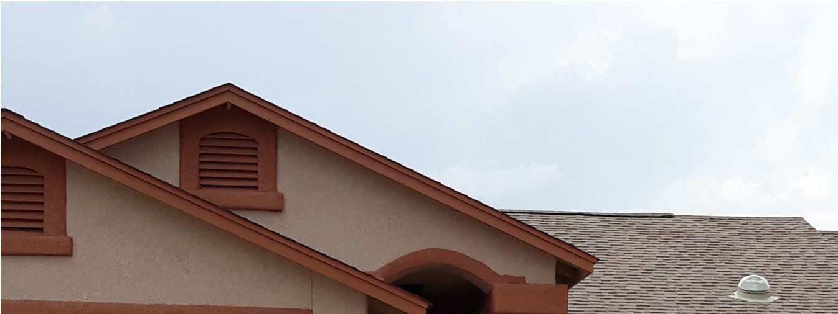
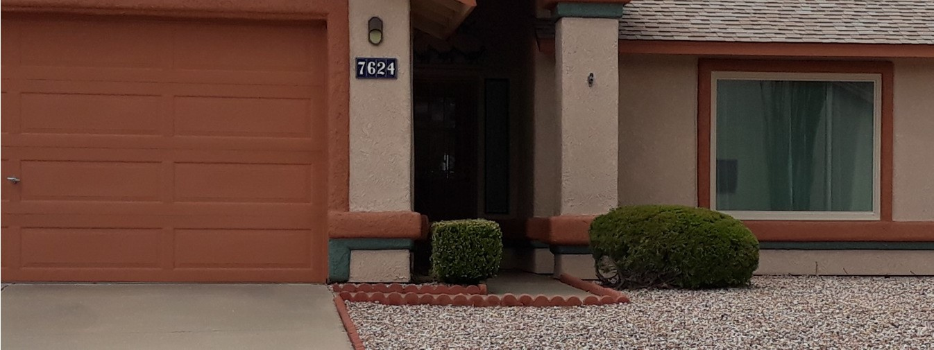

Fascia Color
Stucco Color
Large Bump Outs
Garage Door Color
Large Bump Outs Accent Color(Optional)
Small Bump Outs
Correct color scheme for your house can be viewed at Dunn-Edwards.com/colorark or RanchoAntiguaHOA.com
- Check the color of your roof. Is it blue/gray or Brown? Each roof color has its own set of color schemes.
- Select from one of the six color schemes (A,B,C,D,E,F from the Dunn-Edwards website ) depending on your roof color.
- Accent Colors from Schemes C,D,E & F can ONLY be used on small bump out areas. See diagram above.
- Garage doors must be painted a stucco color or fascia color.
- Front door and security doors are to be painted the same color as stucco or fascia.
Any deviation from original paint schemes MUST be approved by the Architectural Review Committee prior to painting, otherwise you may be required to re-paint all or part of your house. Prior to painting , ARC forms MUST be submitted with paint samples attached and areas described. if you have questions, please contact Lorna at 520-886-9877

