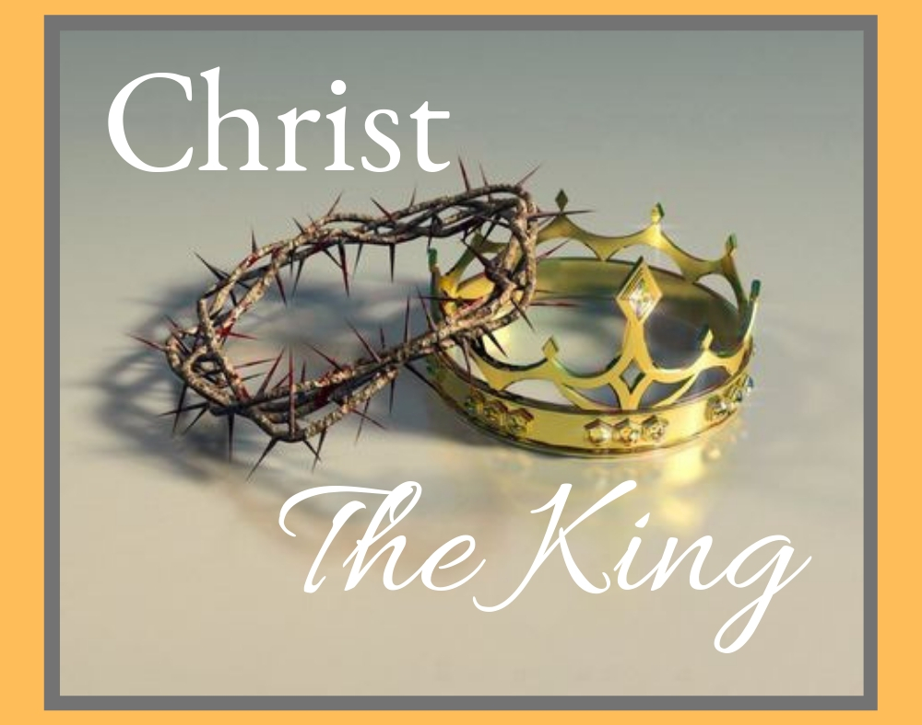

November 21, 2021
Reign of Christ/Christ the King

Carson City United Methodist Church

10:30 am
Prelude/Greeting
*Indicates stand as you are able

Call to Worship

L: Jesus can be trusted in all he promises. Jesus is faithful to his sheep.
P: Jesus holds us in the palm of his hand.

L: Everyone on the side of truth listens to Jesus.
P: Jesus has spoken the words of eternal life to us.
L: Today let us commit to letting Jesus reign in our hearts as Lord of Lords and King of Kings.
P: Come Lord Jesus, come and make our hearts a place for you to dwell.

*Hymn: We Gather Together UMH 131

Opening Prayer: (unison)
Heavenly Father, help us to love as Christ loved. Knowing our own weakness may we stand with all who stumble. Sharing in his suffering may we remember all who suffer. Rejoicing in his forgiveness, may we forgive all who sin against us. Oh God help us to as obedient to doing your will and following your ways, as Jesus was. We ask this in Jesus’s name who reigns in unity with you and the Holy Spirit, all glory and honor are yours eternal God now and forever. AMEN.

Contemporary Song: Good God Almighty (Crowder)

Offering

Doxology UMH 95

Offertory Prayer

Gospel Reading: JOHN 18:33-38

Old Testament: DANIEL 7:13-14
Epistle Lesson: REVELATION 17:12-14
Worship War Zone Song: Power Shuffle (VBS)

Children’s Church

THE MESSAGE

Contemporary Song: You Reign (Mercy Me)

Sharing of our Joys and Concerns

Call to Prayer: Give Thanks

Pastoral Prayer

*Hymn: Bringing in the Sheaves UMH

Benediction

CCUMC – Announcements & Upcoming Events:
========================================
COA Lunch: Are cancelled until further notified.
========================================
Nov 24th: there is no ARK & Office is closed.
========================================
It’s time to “Fill-the-Pew” for IM 3rd Meal on Sun Nov 21. The following are items needed for this project.
~Cheerios ~Fruit cups
~Fruit juice boxes – 100% fruit juice
~P-nut butter ~Skittles ~Mini pretzels
~Jell or Jam (grape or strawberry)
~Lunch bags ~Square snack bags
Let’s all work together to “Fill-the-Pew!”
=========================================
Christmas Wreaths for sale: It is not too soon to think about decorating. CCUMC is selling evergreen wreaths on a 10” base with 2 pinecones and a red bow for $20.00. Contact CCUMC at 989-584-3797 to place an order. Proceeds go toward CCUMC mortgage. The more we sell, the greater the debt reduction. Deadline is Nov 21st. Money is due by deadline. Delivery to be announced.
========================================
Finance Budget Mtg: Tue Nov 23 @ 6:00 pm
AD Board/Finance Mtg: Wed Nov 24 @ 6:00 pm
========================================
Thanksgiving Meal: We would like to extend an invitation to EVERYONE to join us for our Free Annual Traditional Thanksgiving Dinner, Nov 25th, Noon-2pm @ CCUMC. If you would like to attend and need a ride, please call the Church office at 989-584-3797 by Tuesday, Nov 23rd. make the day special for others.
========================================
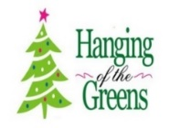
For those decorators or those that just love to get together for some fun and fellowship, decorating of the Sanctuary will be Nov 27th from 10:00 am to about Noon. As the saying goes, many hands make light work.
========================================
Join CCUMC at the following events on Dec 11th:

Holiday Craft/Vendor show 9 am – 2 pm in CCUMC Hall.
We would love more local crafts.
If you’re a crafter and would like a table,
please contact Dawn Wager at
989-833-8081, or text 989-285-2518, or email at dwnwager@gmail.com as soon as possible.

Snacks with Santa from 2:30 - 4:30 pm in CCUMC Hall
Come get some yummy snacks & meet & Greet Santa

M1CCU Holiday Parade - 5:00 pm Downtown Carson City
========================================
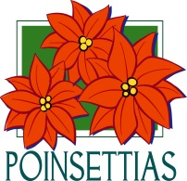
If you would like to purchase a poinsettia plant this Christmas Season in memory, or in honor of a loved one please fill out an order form, located on the Welcome Desk & by the table just before entering the Sanctuary. The poinsettias are $12.99 each. Please indicate how many plants you would like and what color. Put the amount due in the small envelopes & write poinsettia on it, and place both the sale sheet and envelope in the offering plate or turn order into the office. Orders will be placed Monday, December 10th. The plants will stay at the church until after the Christmas Eve service.

Serving and Supporting Sunday Worship Audio/Video: Pat Monroe
Children’s Ministry Audio/Video: Colin Fitzpatrick

Joys, Concerns & Prayer Request
For those battling cancers:
Beth Grienke, Jim Dunlap,
Carolyn Nykerk, Ray Seaman

For everyone who needs support,
guidance or has health concerns.

Monthly Giving
11/7 $4763.04 11/14 $1824.02

Nursery Schedule
11/21

Lighting of Candles

Passing of Collections Plate
11/21 Grant Wilson & Colton Butler

Children’s Church
11/21 Roberta Kile

Our Church in Ministry This Week

Sun 6:30-8 pm Women’s Group | Mon 6:30-8 pm  PT Class

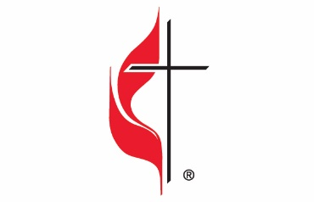

Carson City United Methodist Church
Location: 119 East Elm St., Carson City, MI
Mail: PO Box 298, Carson City, MI 48811
Phone: 989-584-3797 Email: carsoncityumc@gmail.com
Website: carsoncityumc.com
Office Hours: Monday-Thursday, 9:00 am-12:00 pm
After hours by appointment
Pastor: Ian McDonald 906-322-5318
Secretary: Bonnie Seaman 989-763-1674

Weekly Sunday Bulletin now available on our website
@ www.carsoncityumc.com

“Amazing God, please help me worship You
as I rejoice in who You are, what You’ve done,
and all You promise to do”

