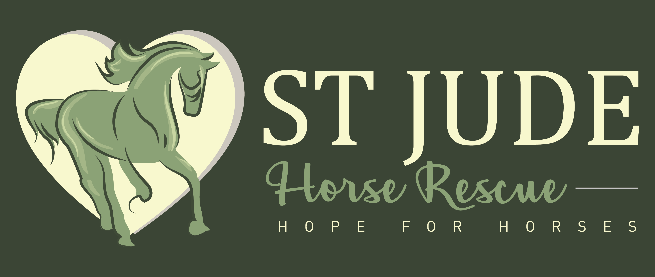

Release of Liability

This document waives important legal rights. Read it carefully before signing. Your
signature indicates you understand and agree to its terms.

This document is a release and waiver of liability, assumption of risk, and indemnity
agreement.
I,____________________________________________________, understand and agree
that equines, such as horses, ponies, donkeys and mules are unpredictable and that access
to equine facilities or activities is dangerous and poses inherent high risks to persons,
property, and other animals. I understand and agree that access to equine facilities or
activities are wholly voluntary and are done at my own risk. I understand and agree that
access to equine facilities or activities involves all inherent risks associated with the
dangers and conditions that are an integral part of equine facilities and activities,
including, but not limited to:

1. The tendency of equines to behave in ways that may damage property and injure, harm or even kill people or other animals.
2. The unpredictability of equine reactions to other animals or people, sounds,
sudden movements, smells, and unfamiliar objects.
3. Hazards related to footing, surface and subsurface conditions and variations in
terrain.
4. Hazards relating to features of trails including but not limited to bridges, tree
trunks and branches, vehicle barriers, and gates.
5. Collisions with other equines, persons, animals or objects.
6. The potential for other human participants to act in a negligent or unskilled
manner, such as failing to maintain control over a child, equine or other
animal or over a vehicle, equipment or tools.
7. Equines, because of their unpredictable nature and irrational behavior,
regardless of their training and past performance, without warning or any
apparent cause, may skid, stumble, fall, buck, rear, bite, kick, run, make
unpredictable movements, spook, jump obstacles, step on a person’s feet, push
or shove a person, etc.
8. Saddles or bridles or other tack or equipment may loosen, break or fail.

I understand this is only a partial list of risks. I am not relying on Lissette F. Hernandez,
St. Jude Horse Rescue, its Board Members, directors, advisors, staff,
volunteers, family members, horse owners, or other animal owners, agents or assigns to list all the inherent high risks that are a part of equine activities and services.

I understand that the roadways, private properties, trails and parks I ride on are used by
others who may pose hazardous to me. For instance, bicycles coming down hill around
blind corners, rattlesnakes, motorcycles, trucks, loose horses, cattle, dogs, etc. I accept
the inherent risks associated with trail riding as well as arena riding and the above named
activities.

In consideration of the privilege of participation in or attending or observing of equine
activities, or receiving equine services provided by Lissette F. Hernandez, St. Jude Horse Rescue, its Board Members, advisors, directors, staff and volunteers:

I agree that I expressly assume any and all risks of injury, death, or loss and I agree to
release and promise not to sue and I agree to indemnify, hold harmless and defend
Lissette F. Hernandez, St. Jude Horse Rescue, its Board Members, directors,
advisors, staff, volunteers, family members, horse owners or
other animal owners, agents or assigns for or from and against any loss, damages,
liability or injury however caused, resulting directly or indirectly from my participation
in or attending or observing equine activities or receiving equine services whether or not
such injury or loss resulted directly or indirectly from the negligent acts or omissions of
Lissette F. Hernandez, St. Jude Horse Rescue, its Board Members, directors,
advisors, staff or volunteers, family members, horse owners or
other animal owners, agents or assigns.

I enter into this contract voluntarily and understand and agree that unless I sign this
agreement I cannot participate in or attend or observe the equine activities or receive the
equine services provided by Lissette F. Hernandez, St. Jude Horse Rescue, its
Board Members, directors, advisors, staff, volunteers, family
members, horse owners or other animal owners, agents or assigns.

California state law governs this agreement. Any action under this agreement shall be
brought only in the courts of Riverside County, California.

If any portion of this agreement is found invalid, the balance of the agreement shall
continue in full legal force and effect.

I shall pay all costs and attorney’s fees from any legal proceedings that I may bring
contrary to this agreement that are resolved in favor of Lissette F. Hernandez, St. Jude Horse Rescue, its Board Members, directors, advisors, staff, volunteers, family members, horse owners or other animal owners, agents
or assigns.

I agree to abide by and follow any instructions given or rules established by Lissette F. Hernandez, St. Jude Horse Rescue, its Board Members, directors, advisors,
staff or volunteers.

I have been advised that I must wear an ASTM approved and SEI certified protective
helmet and proper foot wear while participating in equine activities.
I have been provided with appropriate safety information regarding helmet use.

I represent that I have no health or physical problems that will interfere with involvement
in equine activities or access to equine facilities.

I clearly understand the fairness and meaning of this agreement. I acknowledge that I
have been given sufficient time and opportunity to read this document and to ask any
questions concerning this matter.

I have read this document before signing it. I understand and agree it is a promise
not to sue and a release and waiver of liability and indemnity for all claims.

Name:____________________________________________________________________
Name and age of child, if minor:_______________________________________________
Address:__________________________________________________________________
City and Zip:_______________________________________________________________
E-mail:___________________________________________________________________
Telephone:_______________________________

Signature:_______________________________________ Date:________________

Emergency Contact Information:
____________________________________________________________________
____________________________________________________________________
Medical Insurance Provider: ____________________________________________________________________
____________________________________________________________________

(Please initial each page at the bottom to verify that you have read them.)

