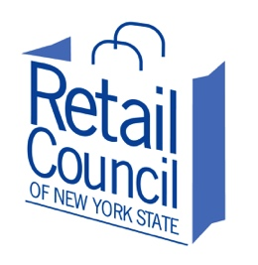
Retail Council of New York State
258 State Street
Albany, New York 12210-1992
(800) 442-3589 | (518) 465-3586
www.retailcouncilnys.com

Ted Potrikus
President and CEO

VIA E-MAIL

June 3, 2016

Alphonso David, Esq.
Counsel to the Governor
Executive Chamber
State Capitol
Albany, New York 12225

Re: A.6503-A (Cusick)

Dear Mr. David:

I write today to urge Governor Cuomo’s approval of the captioned legislation, which in certain cases would grant jurisdiction and venue for a pattern of organized retail crime incidences transpiring over a number of contiguous jurisdictions.

The legislation is a vital step forward in the battle against organized retail crime and, indeed, defines “organized retail theft crime” with specificity. Colloquially, ‘organized retail crime’ (ORC) comprises a variety of retail crimes, including theft of merchandise, receipt fraud, gift card fraud, ticket switching, and other forms of fraud by organized groups of professional shoplifters (a.k.a. “boosters”). ORC differs fundamentally from shoplifting in that amateur shoplifters tend to steal for personal consumption.

The captioned legislation does not target amateur shoplifters. Groups, gangs, and sometimes individuals are engaged in illegally obtaining retail merchandise through both theft and fraud in substantial quantities as part of a criminal enterprise. These crime rings generally consist of boosters, who methodically steal merchandise from retail stores, and fence operators, who convert the product to cash or drugs as part of the criminal enterprise. Sophisticated criminals switch UPC bar codes on merchandise. Others use stolen or cloned credit cards to obtain merchandise. Some produce fictitious sales receipts to “return” stolen product to retail stores.

Letter to Alphonso David re: A.6503-A • Page Two of Two • June 3, 2016

ORC groups tend to target several retailers in one day, moving from county to county and state to state stealing and reselling merchandise. They steal thousands of dollars worth of merchandise at a time, with the intent to resell it for profit, buy drugs, or fund other illegal activities. Fences send their boosters off to work with specific “fence sheets” – a shopping list of the items most desired at the time on the black market – with the products tending toward items easily concealed, valuable, and highly sought. They run the gamut from diabetic test strips, premium razor blades, face creams, and smoking cessation products to printer cartridges, name-brand power tools, laundry detergents, and designer clothing.

Estimates of retail losses to ORC activity nationally are as high as $37 billion annually – with state and local governments losing out on tens of millions of dollars annually because of lost sales tax. Estimates suggest that New York State may forfeit as much as $75 million annually in sales tax lost to ORC activity.

Greater still, however, is the potential impact on consumers. The theft and resale of stolen consumable or health/beauty products – infant formula, over-the-counter medication, and cosmetics – poses significant safety risks to those buying such goods from ORC fences (often unknowingly). These products likely have been repackaged, relabeled, subjected to altered expiration dates, or stored improperly before being reentered into the stream of commerce.

The captioned legislation would establish certain allowances for jurisdiction and venue in ORC escapades spread out over multiple jurisdictions. It’s a common ploy used by ORC gangs – start the day at stores in one county and hit stores throughout different jurisdictions over a one, two, or several-day period. The actual crimes may take place over multiple jurisdictions, but they all are part of the same singular pattern of offense and intent to steal as much product as possible with consequences that, under current law, are limited.

We strongly support the captioned legislation and urge Governor Cuomo’s approval thereof.

Sincerely,
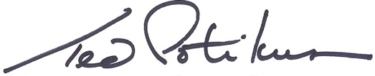

President and CEO
Retail Council of New York State

