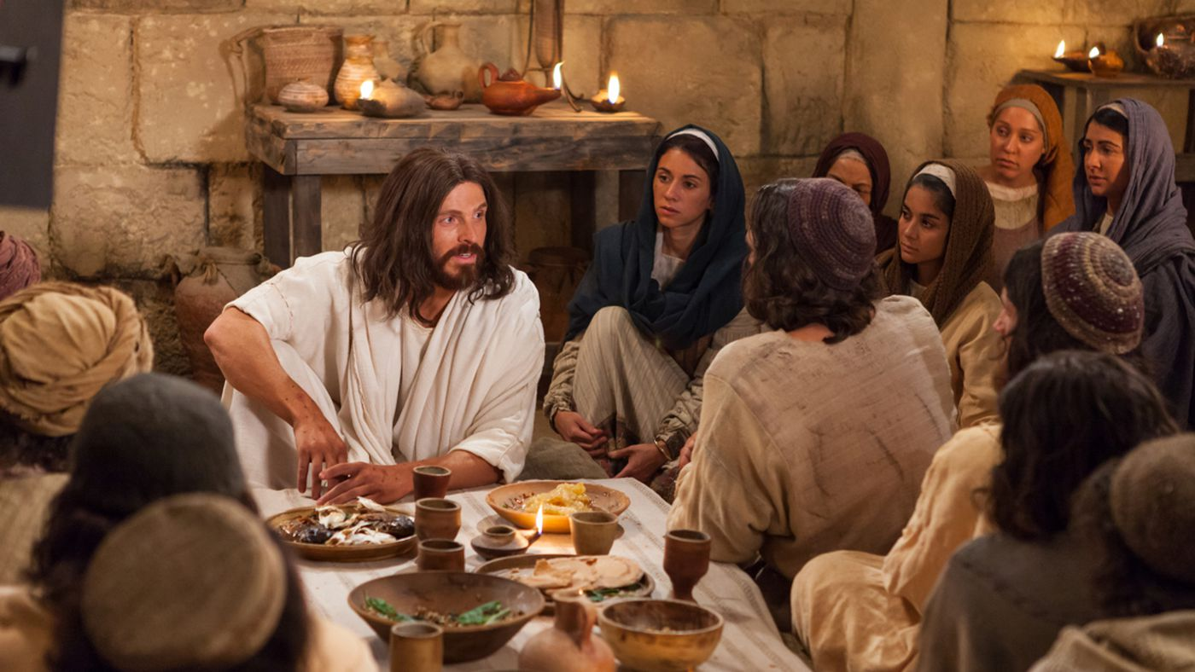

November 14, 2021

25th Sunday after Pentecost

Carson City United Methodist Church

10:30 am
Prelude/Greeting
*Indicates stand as you are able

Call to Worship
L: The Lord can be trusted in all he promises. The Lord is faithful to his people.
P: The Lord upholds all who stumble. and lifts up all who are bowed down.

L: The eyes of all creation look to you, and you give them their food at the proper time.
P: You open your hand and satisfy the needs of every living thing.
L: The Lord is righteous in all his ways and faithful in all he does.
P: The Lord is near to all who call on him, to all who call on him in truth.

*Hymn: Ask Ye What Great Thing I Know UMH 163

Opening Prayer: (unison)
Gracious Heavenly Father, when we feel far from your presence, make our hearts burn within us, until we recognize your presence. When we are feeling lost, may we cling in faith to your Word and the power of Christ’s sacrifice for us, until we are reminded through your Holy Spirit that we our yours. in the name of Jesus Christ our Lord, AMEN.

Contemporary Song: Good God Almighty (Crowder)

Offering

Doxology UMH 95

Offertory Prayer

Gospel Reading: MATTHEW 16:21, MARK 8:31,
LUKE 9.22

Old Testament: PSALM 16:9-10
Epistle Lesson: 1 JOHN 1:1-4
Worship War Zone Song: Every Where I go (VBS)

Children’s Church

THE MESSAGE

Contemporary Song: You Saved the Day
(Phillips, Craig, and Dean)

Sharing of our Joys and Concerns

Call to Prayer: Thy Word UMH 601

Pastoral Prayer

*Hymn: He Lives UMH 310

Benediction

CCUMC – Announcements & Upcoming Events:

=========================================
Please consider helping with the nursery on a Sunday
@ 10:30 every other month. Contact Roberta Kile
@ 989-584-3629 if you would like to be put on the schedule. Thank You.
=========================================
Euchre: Sat, Nov 13th from 5-7:30 pm.
=========================================
COA Lunch: Is cancelled through Nov 19.
========================================
It’s time to “Fill-the-Pew” for IM 3rd Meal on Sun, Nov 14 & Sun Nov 21. The following are items needed for this project.
~Cheerios ~Fruit cups
~Fruit juice boxes – 100% fruit juice
~P-nut butter ~Skittles ~Mini pretzels
~Jell or Jam (grape or strawberry)
~Lunch bags ~Square snack bags
Let’s all work together to “Fill-the-Pew!”
=========================================
Christmas Wreaths for sale: It is not too soon to think about decorating. CCUMC is selling evergreen wreaths on a 10” base with 2 pinecones and a red bow for $20.00. Contact CCUMC at 989-584-3797 to place an order. Proceeds go toward CCUMC mortgage. The more we sell, the greater the debt reduction. Deadline is Nov 21st. Money is due by deadline. Delivery to be announced.
========================================
Finance Budget Mtg: Tue Nov 23 @ 6:00 pm
AD Board/Finance Mtg: Wed Nov 24 @ 6:00 pm
========================================

Announcement’s cont’d

========================================
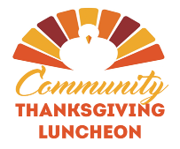
Thanksgiving Meal: We would like to extend an invitation to EVERYONE to join us for our Free Annual Traditional Thanksgiving Dinner, Nov 25th, Noon-2pm @ CCUMC. If you would like to attend and need a ride, please call the Church office at
989-584-3797 by Tuesday, Nov 23rd. We also need donations of your time on that Thursday. It can be 1/2 hour or more. Please come and help us make this day great for others. It is a blessing to them and in turn to those who hear their gratitude and fellowship. The busiest time is getting food onto the steam table so that starts at 10am. Come join us and make the day special for others.
========================================
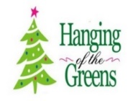
For those decorators or those that just love to get together for some fun and fellowship, decorating of the Sanctuary will be Nov 27th from 10:00 am to about Noon. As the saying goes, many hands make light work.
========================================
Join CCUMC at the following events on Dec 11th:

Holiday Craft/Vendor show 9:00 am – 2:00 pm in CCUMC Hall.
We would love more local crafts.
If you’re a crafter and would like a table,
please contact Dawn Wager at
989-833-8081, or text 989-285-2518, or email at dwnwager@gmail.com as soon as possible.

Snacks with Santa from 2:30 - 4:30 pm in CCUMC Hall
Come get some yummy snacks & meet & Greet Santa

M1CCU Holiday Parade - 5:00 pm Downtown Carson City

Serving and Supporting Sunday Worship Audio/Video: Pat Monroe
Children’s Ministry Audio/Video: Colin Fitzpatrick

Joys, Concerns & Prayer Request
For those battling cancers:
Beth Grienke, Jim Dunlap,
Carolyn Nykerk, Ray Seaman

For everyone who needs support,
guidance or has health concerns.

Monthly Giving
10/31 $2387.57 11/7 $4763.04

Nursery Schedule
11/14 Maryann Severson

Lighting of Candles

Passing of Collections Plate

Children’s Church
11/14 Jenna Benjamin 11/21 Roberta Kile

Our Church in Ministry This Week

Sun 6:30-8 pm Women’s Group | Mon 6:30-8 pm  PT Class | Wed 6:30-8 pm  ARK

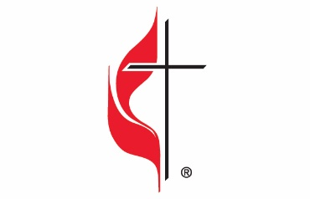

Carson City United Methodist Church
Location: 119 East Elm St., Carson City, MI
Mail: PO Box 298, Carson City, MI 48811
Phone: 989-584-3797 Email: carsoncityumc@gmail.com
Website: carsoncityumc.com
Office Hours: Monday-Thursday, 9:00 am-12:00 pm
After hours by appointment
Pastor: Ian McDonald 906-322-5318
Secretary: Bonnie Seaman 989-763-1674

Weekly Sunday Bulletin now available on our website
@ www.carsoncityumc.com

“Father, help me to keep trusting You. Open my eyes so I can see Your love and faithfulness”

