Major Complaint

- What is your main problem? ______________________________________________________

- When and how did it start? _______________________________________________________

- Was there any of the following before or during the onset? (Please circle)

• Illness / infection • Trauma • Other significant event
- Are your symptoms constant or intermittent? _________________________________________

- Are your symptoms worse at night? Yes / No ________________________________________

- Are your symptoms worse at any specific time of the day? Yes / No (specify)_________________

- Is your problem getting worse? Yes / No ___________________________________________

- What relieves your symptoms? ___________________________________________________

- What makes your symptoms worse? _______________________________________________

- Does stress seem to make your main problem worse? Yes / No

_______________________________________________________________________________

- Do you have any pain traveling down your arms or legs? Yes / No (If yes, describe)

________________________________________________________________________________

Does your current problem involve any of the following sensations in both or either the arms or legs?
(If yes, where?)

Tingling in either arm or leg Yes / No_________________________________
Numbness in either arm or leg Yes / No_________________________________
Weakness in either arm or leg Yes / No_________________________________
‘Weird’ sensations in either arm or leg Yes / No_________________________________
Have you had any previous treatment for your current problem? Yes / No

If yes, please describe_____________________________________________________________

REFERRAL

Personal (name) ____________________________ Yellow Pages

GP (Dr) (name) _____________________________ Other (give details_________________
Where is the problem? Please mark on the diagrams below any areas of discomfort or concern.

LEFT RIGHT RIGHT LEFT
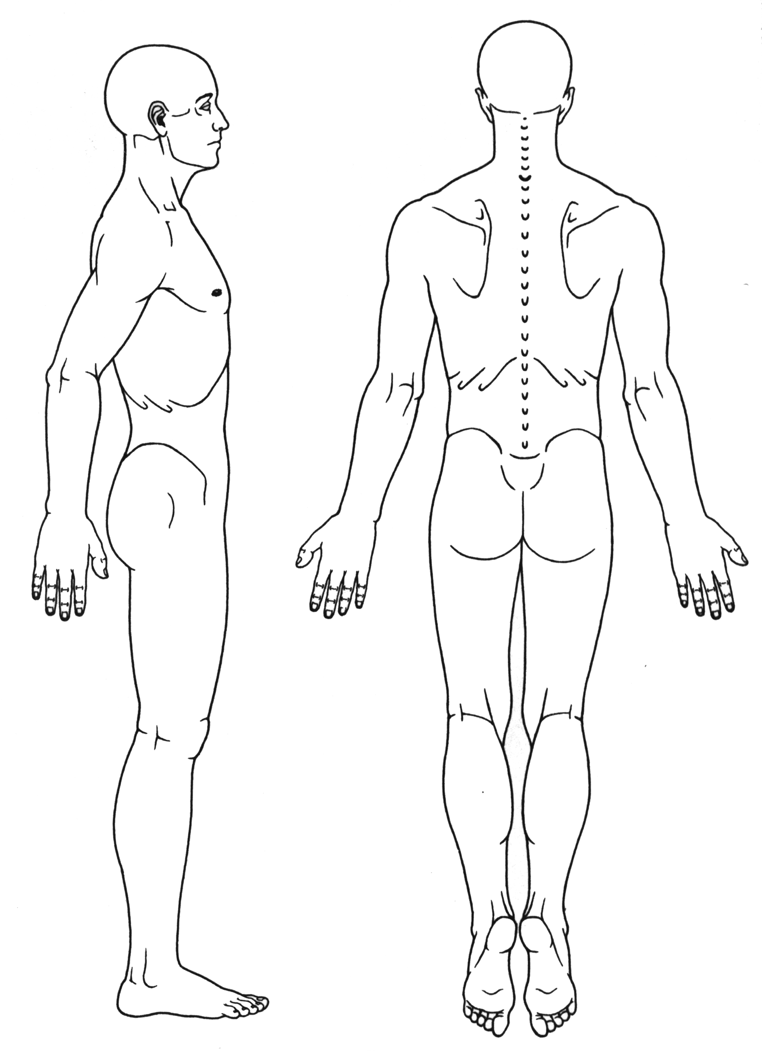
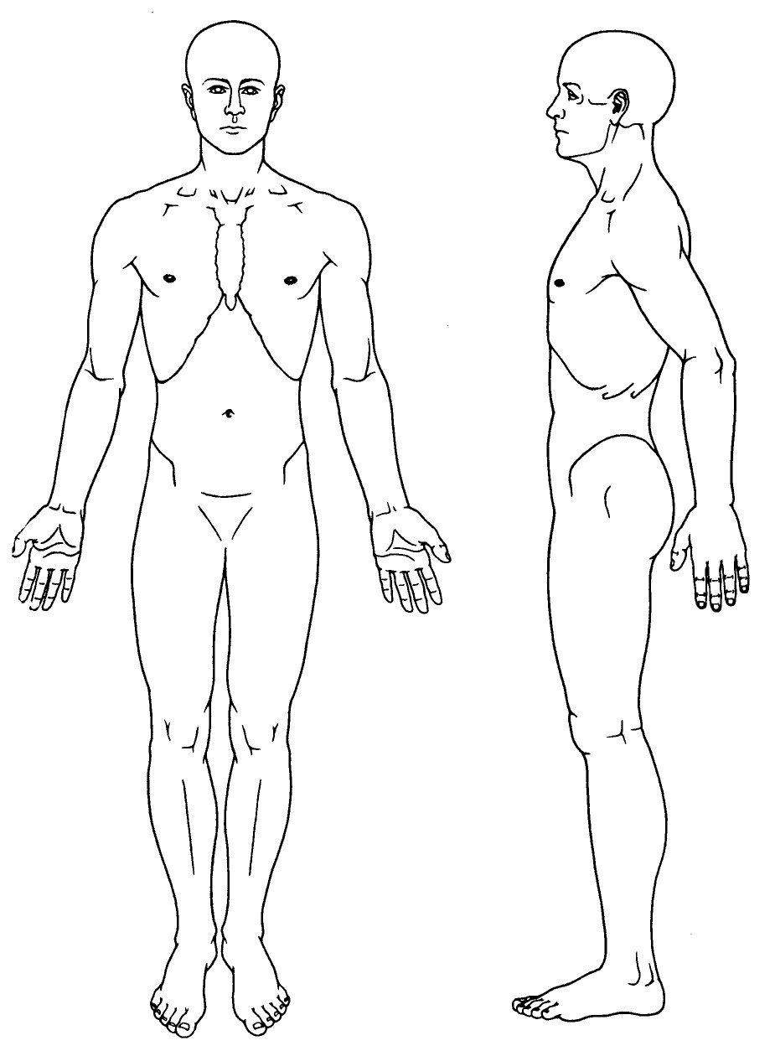

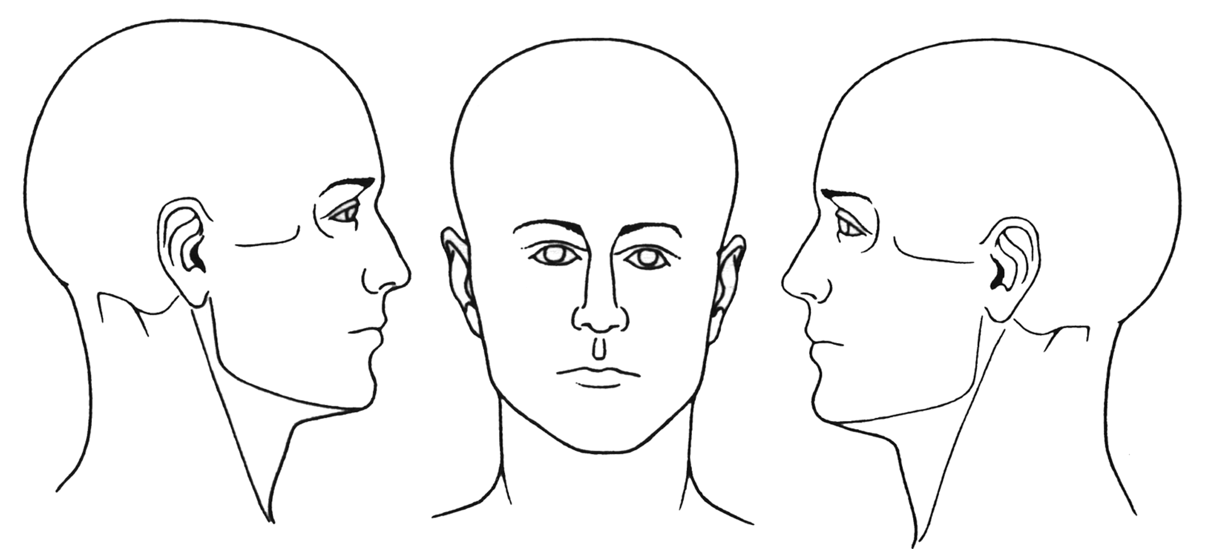

RIGHT LEFT

Medical History

Are you currently taking any form of medication? Yes / No (If yes, please list) ________________

_______________________________________________________________________________

Do you have, or have you ever had, a serious health problem such as high blood pressure, heart
disease, diabetes or any form of cancer? Yes / No

_______________________________________________________________________________

Have you had any form of surgery? Yes / No (If yes, details) ______________________________

_______________________________________________________________________________

Have you had any broken bones? Yes / No (If yes, which bones and how?) __________________

_______________________________________________________________________________
Have you had any car accidents (no matter how trivial)? Yes / No (If yes, when and describe)

_______________________________________________________________________________

Have you had any falls or sports injuries? Yes / No (If yes, when and describe) _______________

_______________________________________________________________________________

Have any of your family members suffered from any serious or hereditary diseases? (e.g. cancer, diabetes, heart disease or any other major health problem) Yes / No ________________________

_______________________________________________________________________________

Females only: Total number of children _______

Are you pregnant? Yes / No If yes – how many weeks? _______

General Health

Please circle Yes/No and complete where applicable

- Did you / Do you smoke? Yes / No ________________________________

- Did you / Do you drink alcohol? Yes / No ________________________________

- Did you / Do you take recreational drugs? Yes / No ________________________________

  - Do you think you have a healthy diet? Yes / No ________________________________

  - Do you take vitamin supplements? Yes / No ________________________________

- Do you exercise regularly? Yes / No ________________________________

- Do you suffer from fatigue? Yes / No ________________________________

- Are you troubled by pain or tightness in
your chest on exertion? Yes / No ________________________________

- If yes: Is it relieved by resting? Yes / No ________________________________

- Do you suffer with a cramp-like pain
in either leg when walking? Yes / No ________________________________

- If yes: Do you have to stop or slow
down to relieve it? Yes / No ________________________________

- Do you have any allergies? Yes / No ________________________________

- Has your weight changed more than
ten pounds (4 Kg) in the last year? Yes / No (up or down) _____________________

- Do you get pain in any of your joints? Yes / No _______________________________

- Do you wake up with stiffness or
aching in your joints or muscles? Yes / No _______________________________

- Do you have any problems with hearing
(including ringing in the ears)? Yes / No _______________________________

- Are you often troubled by headaches? Yes / No _______________________________

- If yes: Are they accompanied by vomiting,
nausea or other symptoms? Yes / No _______________________________

- Have you any lumps, cysts, or unusual
swellings anywhere on your body? Yes / No _______________________________

- Do you have poor balance? Yes / No _______________________________

- Did you / Do you suffer vertigo? Yes / No _______________________________

- Are you subject to blackout, dizzy
spells, or fainting? Yes / No _______________________________

- Do you have a tendency for clumsiness? Yes / No _______________________________

The law requires that all practitioners who manipulate the spine should warn patients of possible risks. In extremely rare circumstances, some treatments of the neck may damage a blood vessel and give rise to stroke or stroke-like symptoms (approx 1 in 5.85 million). [Haldeman, et al. Spine volume 24-8 1999]. Whilst this has never occurred in this practice, we are still required to warn you of the potential risks.

Other very slight risks include strain/injury to a ligament or disc in the neck (less than 1 in 139,000) or the low back (1 in 62,000). [Dvorak study in Principles and Practice of Chiropractic, Haldeman. 2nd Edition]

Chiropractic adjustments (manipulations) of the spine have been recognized as being far safer in dealing with neck and low back pain than medication and some surgical procedures. [A Risk Assessment of Cervical Manipulation, JMPT, 1995. Manga Report, Ontario Ministry of Health, 1993.]

_______________________________________________________________

This clinic specialises in treating problems of the spine and associated disorders of the nervous system. A proportion of our patients come via referral from their medical practitioner and other allied health providers. With your permission, and if necessary, we will keep them informed of your treatment and progress.

Please circle and complete the following:

I GIVE / DO NOT GIVE my consent for my clinical information to be communicated to my medical practitioner and other allied health care providers where appropriate.

______________________________________________________________________________
(Patient Signature) (Patient - Print Name) (Date)

DECLARATION

The information provided is accurate to the best of my knowledge. I understand that this information and any further information verbally provided will be used to help determine the appropriate chiropractic treatment. If there is any change in my medical status at any time I will inform the Chiropractor.

I understand that I am financially responsible for all treatment costs, which are to be paid in full as services are rendered.

______________________________________________________________________________
(Patient Signature) (Patient - Print Name) (Date)

CHIROPRACTOR’S SIGNATURE: ______________________________ DATE: _______________

VCG FOR Rx

