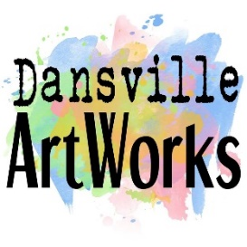
Dansville ArtWorks' Fifth Annual Student Art Showcase
January 3 – February 29, 2020
Sponsored by the Dansville Festival of Balloons Ltd.

Forms due/Art drop off business hours 12/19 – 12/21/19
Reception/Awards Friday, January 24 (4 - 6 PM)
Art Work pick up Saturday, February 29 (10 – 2 PM)

Dansville ArtWorks is seeking 2D and 3D artwork from students in grades K – 12 to participate in the January showcase in our exhibit space at 153 Main Street.

Guidelines for Submitting Items
• Each student can submit up to ONE piece. Work must be delivered in person during delivery days and picked up on pick-up day. If you have a hardship, please email DansvilleArtWorks@gmail.com or call 585-335-4746.
• Items must be ready to hang (wire/string for hanging on back or removable picture hanging strips) or ready to display (stands, etc.). Some pedestals are available for small sculptures. 2D items should avoid using glass in the frame (plexiglass preferred). Maximum size is 30” x 30.”
• All items must be original, unaided work of the student artist. No kits or reproductions.
• Artists must be in grades K – 12 during the 2019-2020 school year. Home schooled students are encouraged to submit.
• All items must be family friendly. If you are not sure then it probably is not.
• There is no entry fee.

How to Submit
• Bring completed paperwork and artwork to 153 Main St, Dansville, NY, on or before Saturday, 12/21.
• Student entries must be submitted with the support of either a parent/guardian or school/art club representative. Forms must be signed by the student and a parent/guardian or representative.
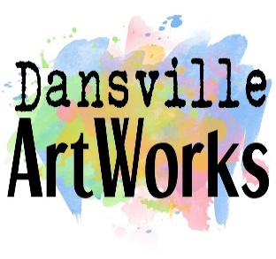
Dansville ArtWorks' Fifth Annual Student Art Showcase – INDIVIDUAL SUBMISSION
January 3 – February 29, 2020
Sponsored by the Dansville Festival of Balloons Ltd.

Forms due/Art drop off business hours 12/19 – 12/21/19
Reception/Awards Friday, January 24 (4 - 6 PM)
Art Work pick up Saturday, February 29 (10 – 2 PM)

Student Name: ________________________________________________________ Grade: ___________
School Name/Teacher: ______________________________ Student/Parent Phone & Email: _______________________________________
TITLE OF WORK | MEDIUM | ESTIMATED VALUE (dollar amount required for insurance coverage)

Artist Agreement I understand that between the drop off and pick-up period, my artwork is insured against damage for 50% of its value. Otherwise, I release Dansville ArtWorks, its Board of Directors, volunteers, and the building landlord from any and all liability. Dansville ArtWorks is not responsible for items delivered early or picked up late. Dansville ArtWorks will hold items for 15 days after the pick-up date; items not picked up may be disposed of if arrangements have not been made. By signing below, I agree to allow Dansville ArtWorks to use photos of my artwork for promotion of the Student Art Showcase. I understand that I retain all rights to the images.

Student Signature:___________________________ Date: ____________ Parent/Guardian/Teacher Signature:___________________

Dansville ArtWorks’ Business Use
Number of items received: _______________ Checked in by: _________________________ Date: _________________________
Number of items returned: _______________ Checked out by: _________________________ Date: _________________________
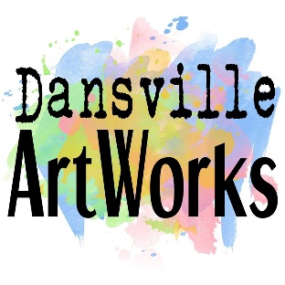
Dansville ArtWorks' Fifth Annual Student Art Showcase – GROUP/SCHOOL SUBMISSION
January 3 – February 29, 2020
Sponsored by the Dansville Festival of Balloons Ltd.

Forms due/Art drop off business hours 12/19 – 12/21/19
Reception/Awards Friday, January 24 (4 - 6 PM)
Art Work pick up Saturday, February 29 (10 – 2 PM)

Teacher Name(s): ________________________________________________________ District/School: ______________________________
Teacher email and phone number: ______________________________________________________________________________________
Teacher Responsibility on behalf of Student Artists
I understand that between the drop off and pick-up period, student artwork is insured against damage for 50% of its value. Otherwise, I release Dansville ArtWorks, its Board of Directors, volunteers, and the building landlord from any and all liability. Dansville ArtWorks is not responsible for items delivered early or picked up late. Dansville ArtWorks will hold items for 15 days after the pick-up date; items not picked up may be disposed of if arrangements have not been made. By signing below, I agree to allow Dansville ArtWorks to use photos of student artwork for promotion of the Student Art Showcase. I understand that students retain all rights to the images.

_____________________________________________________
Teacher Signature(s)

Dansville ArtWorks’ Business Use

Number of items received: _______________ Checked in by: _________________________ Date: _________________________
Number of items returned: _______________ Checked out by: _________________________ Date: _________________________

# | STUDENT NAME | GRADE | TITLE OF WORK | MEDIUM | EST. VALUE  (required for insurance coverage) | STUDENT OR GUARDIAN SIGNATURE
1
2
3
4
5
6
7
8
9
10
11
12
13
14
15
Please make additional copies of this form as needed and edit the numbers accordingly

