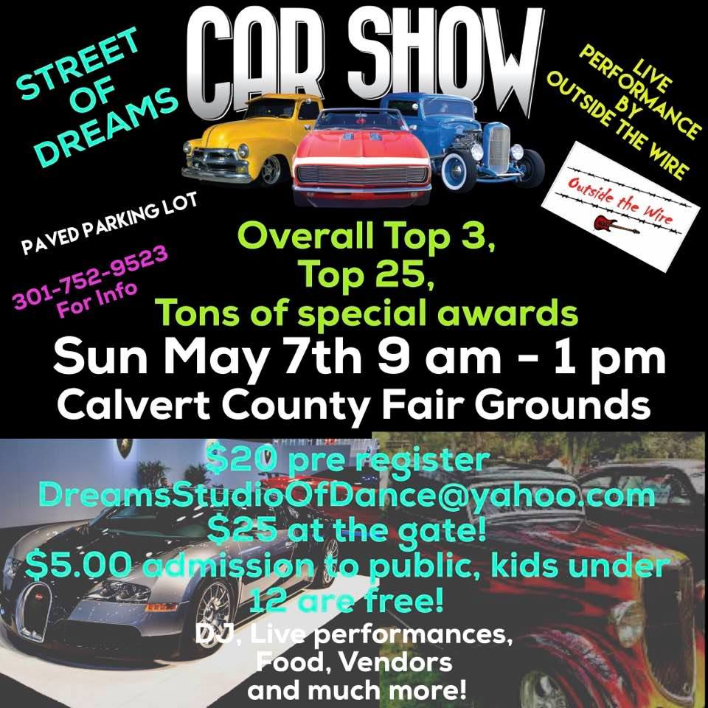

Street of Dreams Registration Form
Car # _________
Name: __________________________________
Address: __________________________________
City: ___________________ State: _______ Zip: __________
Email: ____________________________________________________
Phone: _____________________________
Year of Vehicle: _________________________
Make and Model of Vehicle: _____________________________________________
Club Name: ____________________________

Liability release: Entrants and Participants, by execution of this entry form, release and discharge Dreams Studio of Dance and Calvert County Fair Grounds, their officers, directors, employees, agents, representatives, volunteers, and anyone affiliated with Dreams Studio of Dance or Calvert County Fair Grounds, from any and all known or unknown damages, injuries, losses, judgements, and/or claims, from any causes whatsoever that may be suffered by an entrant, participant, or spectator to this person or property, events, rules, and classes are subject to change at our discretion.

Signature of Entrant ______________________________________ Date ___________________

