REGULAR MEETING
JANUARY 15, 2014

A Regular Meeting of the Town Board of the Town of Hampton, County of Washington and the State of New York was held at the Town Hall, 2629 State Route 22A, Hampton, New York on the 15th day of January, 2014.

PRESENT: David K. O’Brien----------Supervisor
Tamme Taran--------------Councilwoman
David Jensen---------------Councilman
Donald Sady----------------Councilman
Andrea Sweeney-----------Councilwoman
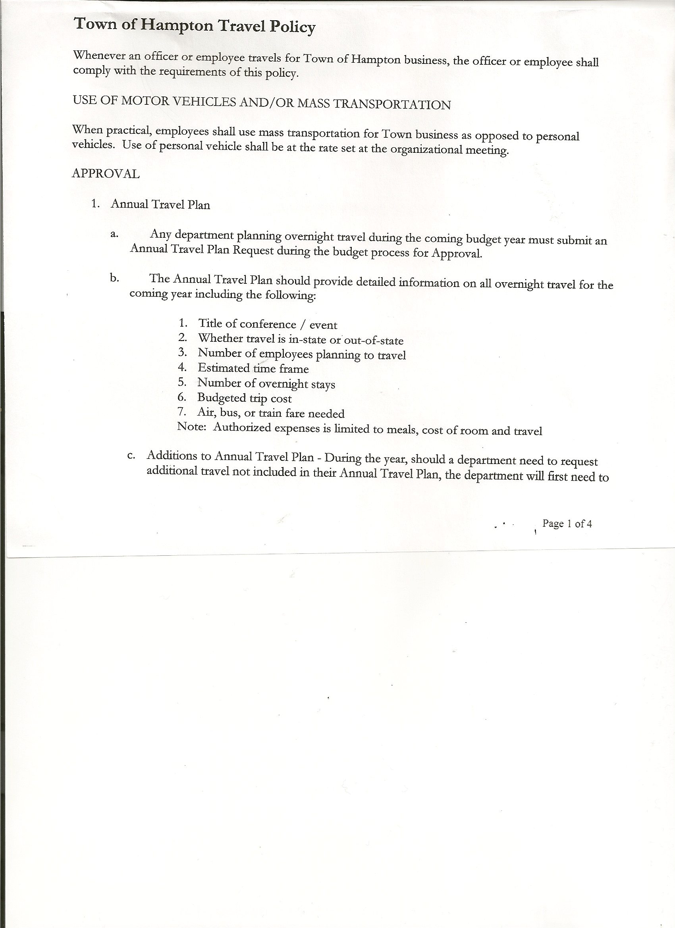 Rebecca Jones--------------Town Clerk
Herbert Sady, Jr.-----------Highway Superintendent

Planning Board Member(s): 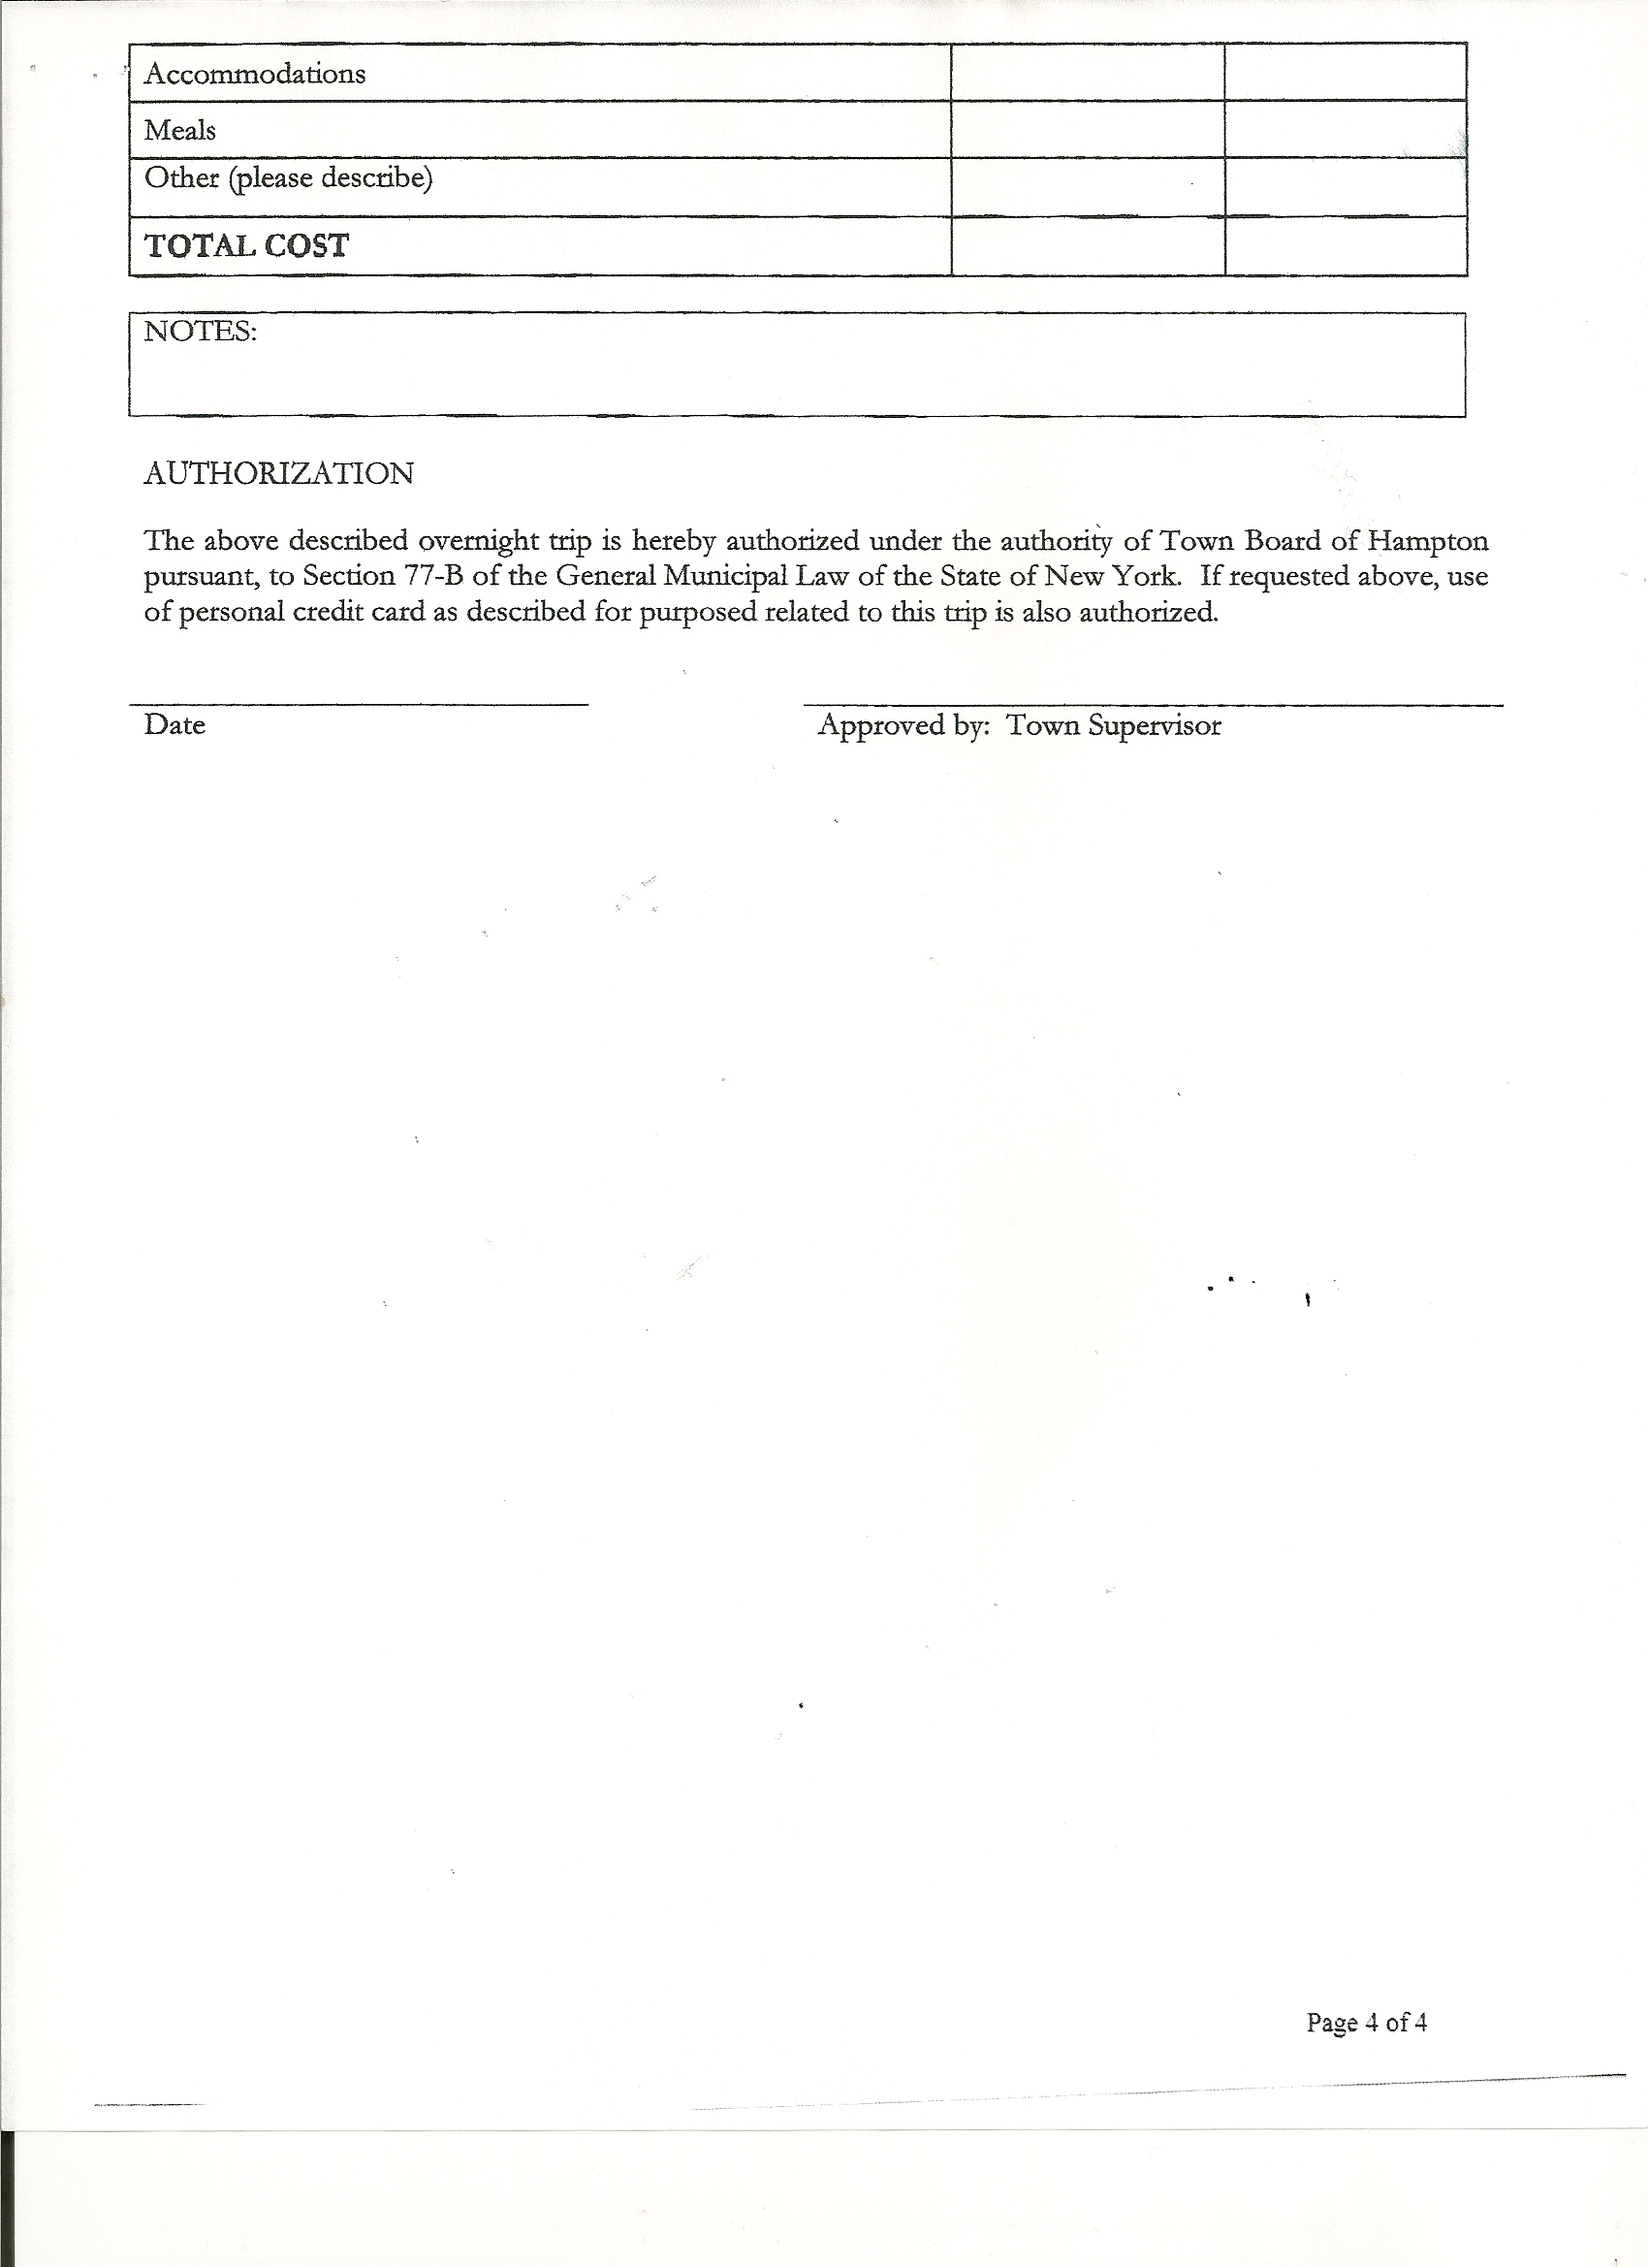 none present

Also present: Derek Liebig, Whitehall Times Reporter;

The meeting was called to order by Supervisor O’Brien at 7:32 pm followed by the Pledge of Allegiance. Locations of Fire Exits were given.

RESOLUTION NO. 7-2014
APPROVAL OF THE MINUTES
On a motion of Councilwoman Taran, seconded by Councilman Jensen, the following resolution was
ADOPTED: Ayes 5 O’Brien, Taran, Jensen, Sady, Sweeney
Nays 0
RESOLVED that the Regular Town Board Minutes for December 18th, 2013 and the Special Town Board Minutes for January 2nd, 2014 be accepted.

Bonnie Hawley, Planning Board Chair submitted Planning Board report, which was read by Supervisor O’Brien…a copy is attached.
- Draft of proposed updated Mobile Home Ordinance has been sent to the Town Attorney for review
- Planning Board will be working on an application form and check list to go with the
Mobile Home Ordinance
- Welcoming new alternate member Dianne Sofia

Larry Carman, Dog Control Officer submitted his report, which was read by Supervisor O’Brien…a copy is attached.

Herbert Sady, Jr., Highway Superintendent gave his report:
- plowing and sanding roads
- Thank you to Malcolm Pratt for taking care of both sides of Hampton, while Nate Saxton
was out for a couple of days with his wife having their second baby.
- doing maintenance on equipment
- ordered another 40 ton of salt and
another 100 yards of winter sand

TOWN BOARD MEETING
JANUARY 15, 2014 PAGE 2

OTHER HIGHWAY INFORMATION
On December 23rd, on the Swamp Road…incident between Town Truck and another truck owned by Hubbard Bros., Inc. involving outside mirrors on both vehicles. Quote for repair to Hubbard Bros. truck was $1605.72. Town Insurance Company Adjuster approved paying half of the quote…bill has been submitted to the Town Board for the remainder.

RESOLUTION NO. 8-2014
BUDGET AMENDMENT
On a motion of Councilwoman Taran, seconded by Councilman Sady, the following resolution was
ADOPTED by Roll Call Vote: Supervisor O’Brien AYE
Councilwoman Sweeney AYE
Councilman Sady AYE
Councilwoman Taran AYE
Councilman Jensen AYE
RESOLVED the following Budget Amendments to the General Fund is approved:
Increase Garage Contractual Expense A5132.4 in the amount of $1974.95
Increase State Retirement A9010.8 in the amount of $3998.00
Decrease Contingent Fund A1990.4 in the amount of $5972.95

RESOLUTION NO. 9-2014
BUDGET AMENDMENT
On a motion of Councilman Sady, seconded by Councilwoman Sweeney, the following resolution was
ADOPTED by Roll Call Vote: Supervisor O’Brien AYE
Councilwoman Sweeney AYE
Councilman Sady AYE
Councilwoman Taran AYE
Councilman Jensen AYE
RESOLVED the following Budget Amendment to the Highway Fund is approved:
Increase State Retirement DA9010.8 in the amount of $2435.00
Decrease Machinery Contractual Expense DA5130.4 in the amount of $2435.00

RESOLUTION NO. 10-2014
APPROVAL OF SUPERVISOR’S MONTHLY REPORT
On a motion of Councilman Jensen, seconded by Councilwoman Taran, the following resolution was ADOPTED Ayes 5 O’Brien, Taran, Jensen, Sady, Sweeney
Nays 0
RESOLVED the Supervisor’s Monthly report be accepted as submitted for DECEMBER 2013
11/30/13 12/31/13
ACCOUNT BALANCE RECEIPTS DISBURSEMENTS BALANCE
General Fund $ 61928.26 $ 4139.08 $ 24981.72 $ 41085.62
Highway Fund $ 41058.08 $ 2.83 $ 18151.49 $ 22909.42
Equipment Reserve $ 64155.83 $ 5.45 $ 0.00 $ 64161.28
Building Fund $ 1258.99 $ 90.11 $ 0.00 $ 1349.10
Fire #1 $ 15155.00 $ 0.00 $ 15155.00 $ 0.00
Fire #2 $ 2270.50 $ 0.00 $ 2270.50 $ 0.00
Totals $185826.66 $ 4237.47 $ 60558.71 $ 129505.42
All Board Members present signed Supervisor’s Report.

TOWN BOARD MEETING
JANUARY 15, 2014 PAGE 3

The Supervisor’s Report for the Year 2013 was given out to Board Members for their information and review.
01/01/13 12/31/13 ACCOUNT BALANCE RECEIPTS DISBURSEMENTS BALANCE
General Fund $ 31626.66 $ 121030.98 $ 111573.74 $ 41083.90
Highway Fund $ 6222.05 $ 205620.79 $ 188933.42 $ 22909.42
Equipment Reserve $ 74214.68 $ 72.79 $ 10126.19 $ 64161.28
Building Fund $ 1180.89 $ 5482.26 $ 5314.07 $ 1349.08
Fire #1 $ 0.00 $ 27813.00 $ 27813.00 $ 0.00
Fire #2 $ 0.00 $ 4541.00 $ 4541.00 $ 0.00
Totals $ 113244.28 $ 364560.82 $ 348301.42 $ 129503.68

Fire Department .… Councilman Jensen and Councilwoman Taran will work with Fire Department on a new lease.

RESOLUTION NO. 11-2014

MOTION BY: COUNCILMAN SADY
SECONDED BY: COUNCILMAN JENSEN

TITLE: RESOLUTION INTRODUCING PROPOSED LOCAL LAW
TO RESCHEDULE THE DATE FOR HEARING COMPLAINTS
BY THE BOARD OF ASSESSMENT REVIEW

WHEREAS, pursuant to Section 512 of the Real Property Tax Law of the State of New York, the Town Board (the “Board”) of the Town of Hampton (the “Town”) has the authority to adopt a local law rescheduling the date for hearing complaints by the Board of Assessment Review pursuant to Real Property Tax Law Section 512; and

WHEREAS, the Board finds that this law is necessary to coordinate the hearing date with the schedule of the Town’s assessor who also works with neighboring municipalities in Washington County; and

WHEREAS, a local law has been drafted to reschedule such date for hearing of complaints.

NOW, THEREFORE BE IT RESOLVED by the Town Board of the Town of Hampton as follows:

Section 1. A public hearing shall be scheduled for the consideration of the proposed Local Law to be held by the Town Board February 19th, 2014 at 7:25 pm.

TOWN BOARD MEETING
JANUARY 15, 2014 PAGE 4

Section 2. The Town Clerk is directed to post and publish a notice of said public hearing in The Granville Sentinel and The Whitehall Times at least five (5) days before the hearing.

Section 3. This resolution shall take effect immediately.

DATED: January 15, 2014 Supervisor O’Brien AYE
Councilwoman Sweeney AYE
Councilman Sady AYE
Councilwoman Taran AYE
Councilman Jensen AYE

Copy of Full Value Tax Rates for Washington County handed out to Board members for their info…tax rates are for the 2013 School and 2014 Town/County.

Health Insurance….
Child Health Care Plus
- if an employer does not pay 100% of health insurance cost, then children are eligible for Child Health Care Plus, which also includes vision and dental plans….working on getting Nate Saxton’s children on this program.
Other options were discussed that may be available for Nate and spouse and Malcolm…will continue to work on and discuss at future meeting.

RESOLUTION NO. 12-2014
HEALTH INSURANCE CONTRIBUTION
On a motion of Councilwoman Taran, seconded by Councilman Sady, the following resolution was ADOPTED Ayes 5 O’Brien, Taran, Jensen, Sady, Sweeney
Nays 0
RESOLVED that all employees will contribute to the cost of their health insurance as follows:
15% single
20% double
25% family

Justice Court Audit was reviewed and completed.
Town Clerk Audit was reviewed and completed.
Both were found to be all correct and records were maintained accurately.

Four properties are up for foreclosure in Hampton.

TOWN BOARD MEETING
JANUARY 15, 2014 PAGE 5

RESOLUTION NO. 13-2014
COMPENSATE DEPUTY TAX COLLECTOR
On a motion of Councilman Jensen, seconded by Councilwoman Sweeney, the following resolution was
ADOPTED by Roll Call Vote: Supervisor O’Brien AYE
Councilwoman Sweeney AYE
Councilman Sady AYE
Councilwoman Taran AYE
Councilman Jensen AYE
RESOLVED that the Deputy Tax Collector be paid an hourly rate of $10.00 for time spent on tax collecting duties.

The Town Clerk’s report for December 2013 was submitted to the Board. The Town Clerk had Board Members review and sign bank reconciliation statements for Town Clerk Account and Special Town Clerk Account dated December 31, 2013.

RESOLUTION NO. 14-2014
CELL PHONE POLICY
On a motion of Councilwoman Taran, seconded by Councilman Jensen, the following resolution was ADOPTED Ayes 5 O’Brien, Taran, Jensen, Sady, Sweeney
Nays 0
RESOLVED that upon review by the Town Board, the above policy is approved for 2014.

RESOLUTION NO. 15-2014
AUTHORIZE TO PRE-PAY ITEMS
MOTION BY: COUNCILMAN DONALD SADY
SECONDED BY: COUNCILMAN DAVID JENSEN

TITLE: RESOLUTION AUTHORIZING THE TOWN SUPERVISOR TO PAY BILLS
IN ORDER TO AVOID PENALTIES AND INTEREST

WHEREAS, the Town has determined that due to certain bills being due prior to the Town Board Audit of bills,

AND WHEREAS, the Town Board is desirous of avoiding late fees, penalties and interest and maintain its good credit standing,

NOW THEREFORE, BE IT RESOLVED:
That the Town Board of Hampton hereby authorizes the Supervisor to approve the payment of bills before audit if in the reasonable discretion of the Supervisor, it is necessary to do so to avoid any costs, penalties, interest or termination of service. The supervisor may pay claims for public utilities, postage, freight and express charges, before they are audited. The term “public utilities” includes electric, gas, water, sewer and telephone services and the
purchase of fuel oil. All claims must be presented for audit at the next regular board meeting audit. The claimant and the town officer incurring or approving these claims are jointly and severally liable for any amount disallowed upon audit.

TOWN BOARD MEETING
JANUARY 15, 2014 PAGE 6

BE IT FURTHER RESOLVED:
That the Town Board is not required by law to pre- audit payments of fixed salaries, compensation of officers or employees, principal and interest indebtedness, or amounts coming due on certain contracts
BE IT FURTHER RESOLVED that in the absence of the Supervisor, the Deputy Supervisor is authorized to review the bills and make the determination to authorize payment for the same reason.
BE IT FURTHER RESOLVED that the Town Clerk is hereby authorized and directed to add the following policy to the policy manual/employee handbook for the Town of Hampton.

DATED: January 15, 2014 Supervisor O’Brien AYE
Councilwoman Sweeney AYE
Councilman Sady AYE
Councilwoman Taran AYE
Councilman Jensen AYE

RESOLUTION NO. 16-2014

AUDIT OF CLAIMS
On a motion of Councilwoman Taran, seconded by Councilwoman Sweeney, the following resolution was ADOPTED Ayes 5 O’Brien, Taran, Jensen, Sady, Sweeney
Nays 0
RESOLVED that the bills have been reviewed by the Town Board and are authorized for payment in the following amounts.
General Fund No. 1 through No. 22 $ 4542.63
Highway Fund No. 1 through No. 14 $ 10744.01
Total both funds $ 15286.64

RESOLUTION NO. 17-2014
TAX COLLECTOR YEARLY REPORT
On a motion of Councilman Sady, seconded by Councilwoman Taran, the following resolution was ADOPTED Ayes 5 O’Brien, Taran, Jensen, Sady, Sweeney
Nays 0
RESOLVED that the Tax Collector’s Yearly Report be accepted as submitted.

Received back a signed copy of the Fair Haven Fire Department Contract for 2014.

On a motion of Councilwoman Taran, seconded by Councilman Jensen, the meeting adjourned at 9:52pm. All in favor Aye.

Respectfully submitted,

Rebecca S. Jones, RMC
Town Clerk

SPECIAL MEETING
JANUARY 24, 2014

A Special Meeting of the Town Board of the Town of Hampton, County of Washington and the State of New York was held at the Town Hall, 2629 State Route 22A, Hampton, New York on the 24th day of January 2014.

PRESENT: David K. O’Brien----------Supervisor
Tamme Taran---------------Councilwoman
David Jensen----------------Councilman
Donald Sady----------------Councilman-came at 8:10pm
Andrea Sweeney-----------Councilwoman
Rebecca Jones--------------Town Clerk

Also present: Darlene Sady, Town Justice, Kim Perry,Budget Officer/Bookkeeper and Justin Perry, President of Hampton Fire Department came at 7:15pm.

The Special Meeting of the Town Board was called to order by Supervisor O’Brien at 7:03 pm followed by the Pledge of Allegiance. Locations of Fire Exits were given.

Health Insurance…Supervisor O’Brien continuing to work on proposal for Nate Saxton and spouse and Malcolm Pratt. Child Health Care Plus for Nate’s dependents has been set up.

Supervisor O’Brien and Fred Wilson have been working on the fireproof storage room in the basement.

Supervisor O’Brien appointed an Audit Committee consisting of Councilman David Jensen and Councilwoman Andrea Sweeney to do a mini (small) audit every quarter on the Town Clerk; Town Justice; Tax Collector and Bookkeeper.

The following Audits were completed at this meeting.
- Town Justice Audit completed by Councilwoman Tamme Taran and Supervisor David O’Brien
- Bookkeeper Audit completed by Councilman David Jensen and Councilwoman Andrea Sweeney and
- Tax Collector Audit was completed by Supervisor David O’Brien

Supervisor O’Brien has spoke with Justin Perry and Michael Stark regarding the lease for the firehouse. Justin Perry, new President of the Hampton Fire Department came before the board at this meeting….had several questions regarding the “new” lease. He feels the new lease is “too complicated”. He and the Town Board Members went over the proposed “new lease”…omitted some items. Justin is going to review and discuss the proposed lease with the Fire Department membership and report back to the town board.
TOWN BOARD MEETING
JANUARY 24, 2014 PAGE 2

RESOLUTION NO. 18-2014
MEDICAL INSURANCE
On a motion of Councilman Sady, seconded by Councilwoman Sweeney, the following resolution was ADOPTED Ayes 5 O’Brien, Taran, Jensen, Sady, Sweeney
Nays 0
RESOLVED that the Town will only provide a single or two person medical policy, it will not provide a family plan.

On a motion of Councilwoman Taran, seconded by Councilman Sady the meeting adjourned at 8:21 pm. All in favor Aye.

Respectfully submitted,

Rebecca S. Jones, RMC
Town Clerk

