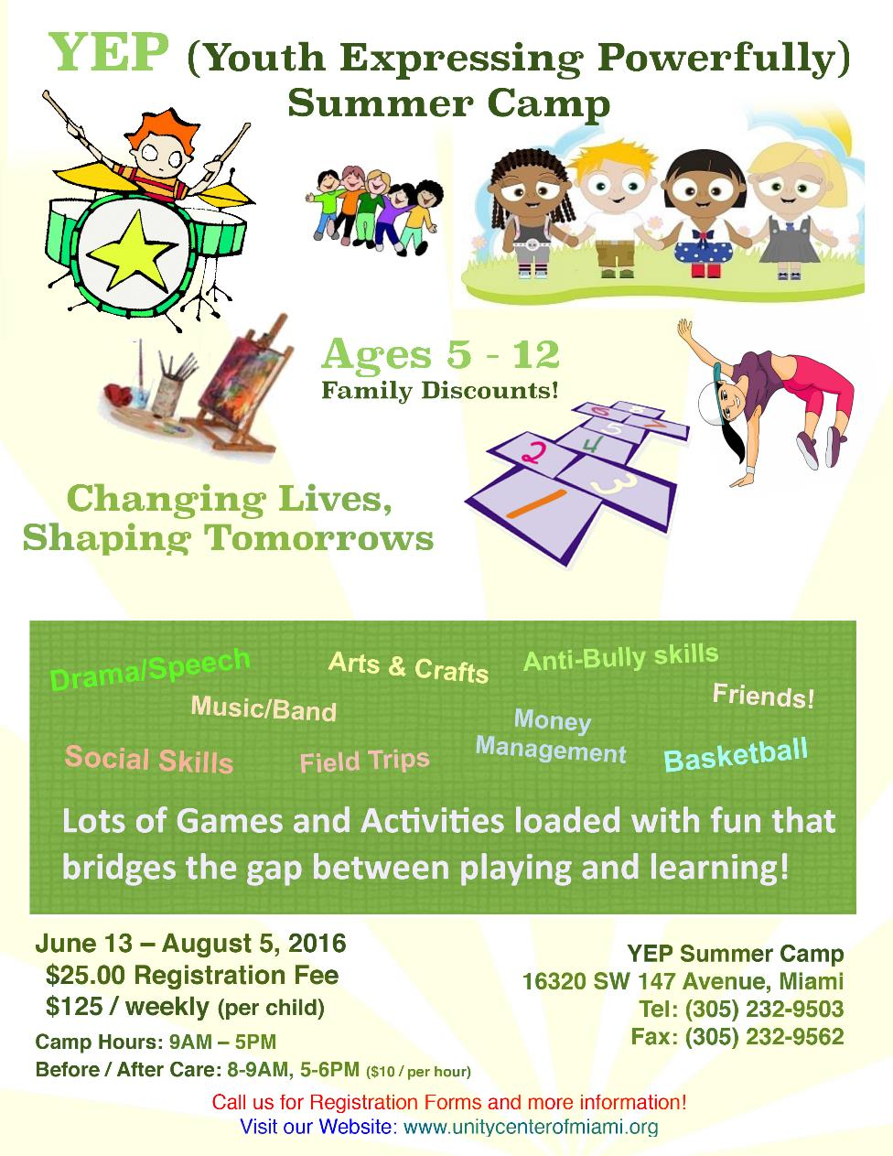
Inquire about AFTER CAMP - August 8-19 9:00a.m. – 5:00p.m.

Parents Open House Tuesdays, April 12, 19, and 26
4:00 p.m. – 7:00 p.m.
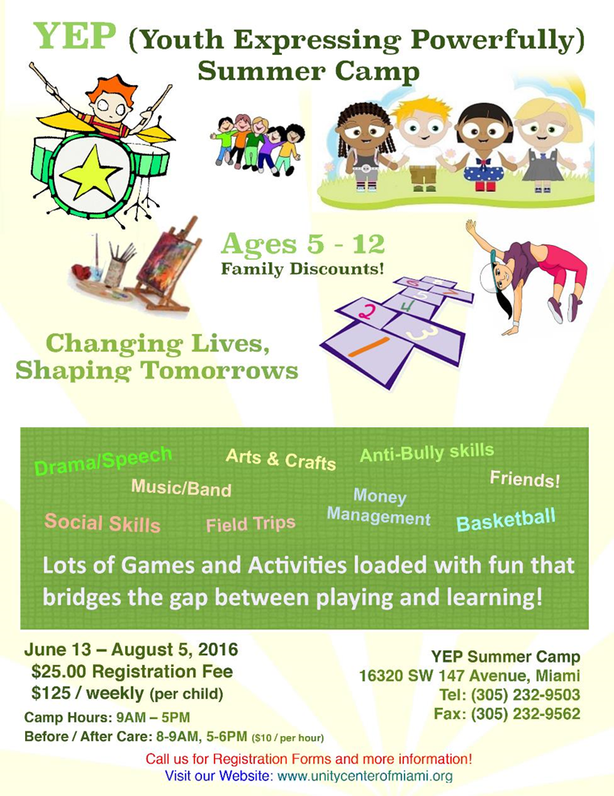
Inquire about AFTER CAMP - August 8-19 9:00a.m. – 5:00p.m.

Parents Open House Tuesdays, April 12, 19, and 26
4:00 p.m. – 7:00 p.m.

Farm Share Distribution at
Unity Center of Miami!
We will be distributing
“FREE” Food
to the community
the second Thursday of every month

DISTRIBUTION DATES:
2nd Thursdays, 11:00AM –1:00PM

Where?...
Unity Center of Miami
‘a positive path for spiritual living’
16320 SW 147 Avenue
Miami, FL 33187
305-232-9503

Sunday Worship Spanish: 10:00AM
Sunday Worship English: 11:00AM

Affiliated with Unity School of Christianity,
publisher of the DAILY WORD

Farm Share Distribution at
Unity Center of Miami!
We will be distributing
“FREE” Food
to the community
the second Thursday of every month

DISTRIBUTION DATES:
2nd Thursdays, 11:00AM –1:00PM

Where?...
Unity Center of Miami
‘a positive path for spiritual living’
16320 SW 147 Avenue
Miami, FL 33187
305-232-9503

Sunday Worship Spanish: 10:00AM
Sunday Worship English: 11:00AM

Affiliated with Unity School of Christianity,
publisher of the DAILY WORD

