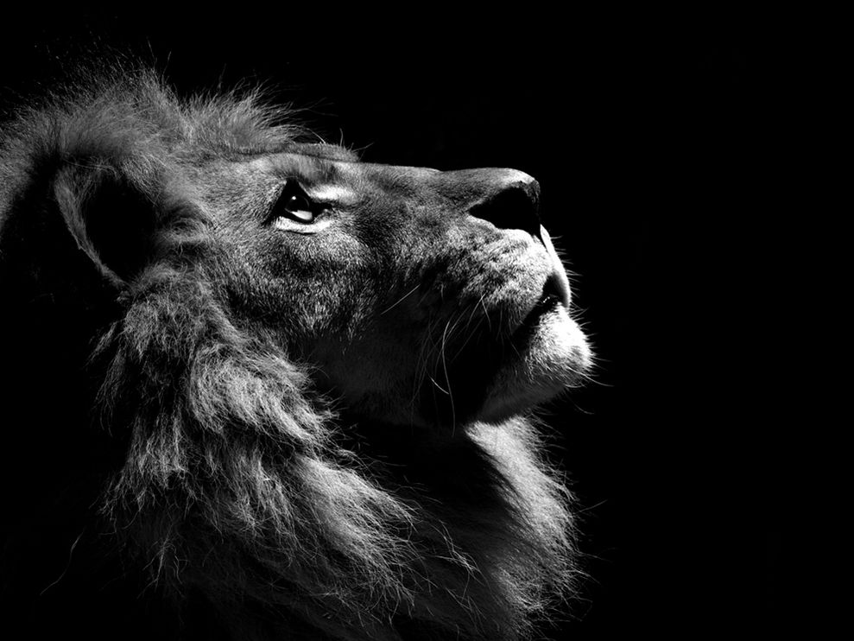

**Lion Profile**

Photograph by Boza Ivanovic

This Month in Photo of the Day: Animals

Profile of a lion in the zoo