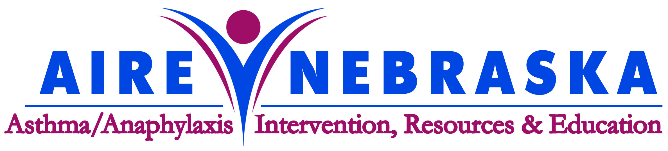

Saving the Lives of Nebraska’s Children
Asthma has reached epidemic proportions over the last 15 years, and is the most common chronic childhood disease. Nearly one in thirteen school-aged children have asthma, causing increased rates of school absenteeism, hospitalizations and even death. Life-threatening allergic reactions are also becoming more common, resulting from exposure to certain foods, stinging insects, medications and latex rubber. Anaphylactic shock can turn deadly in a matter of minutes.

All schools in Nebraska – public, parochial and private – are now prepared to respond to life-threatening asthma and anaphylaxis emergencies. The protocol Emergency Response to Life-Threatening Asthma or Systemic Allergic Reactions (Anaphylaxis) trains school staff members to identify signs and symptoms of a “breathing emergency” and respond by calling 911, and administering EpiPen® followed by nebulized albuterol. All emergency response team members must be trained in CPR.

In a partnership with the Nebraska Department of Education, AIRE Nebraska (Asthma/Allergy Intervention, Resources & Education Nebraska) is the non-profit organization assisting schools with education, training and procurement of medications and supplies.

What do community members need to know?
- Nebraska Department of Education requires schools to follow the protocol through Rule 59, Regulations for School Health and Safety (Title 92, NAC, Chapter 59).
- The protocol addresses life-threatening emergencies and is meant to prevent asthma or anaphylaxis deaths at school.
- The school’s EpiPen® and Albuterol do not replace a child’s own prescribed medications for asthma/allergy control and management. Parents are expected to ensure their children continue to have school-day access to MDI’s, EpiPen®, etc. and to have an Asthma/Allergy Action Plan or emergency medical plan on file with the school.
- Education and training developed by AIRE Nebraska includes general information on asthma and anaphylaxis to increase awareness among all school staff, so a child’s breathing problems are taken seriously and referred to a healthcare provider for proper diagnosis and treatment.
- AIRE Nebraska supported Nebraska legislation (NRS 79-224) that protects students’ right to self-carry and self-administer prescribed asthma and anaphylaxis medications at school and at school-related events. AIRE Nebraska recommends that these students maintain backup medications at school.

Initial funding for AIRE Nebraska was provided by Children’s Hospital in Omaha, Nebraska HHS, and pharmaceutical firms. Private donors, corporations and foundations are contributing ongoing philanthropic support. AIRE Nebraska is a 501(c)(3) organization to which contributions are fully tax-deductible as allowed by law. IRS Tax ID #32-0032483. You can support this initiative in your community!

Please look for AIRE Nebraska in the Combined Federal Campaign this fall - #18230. Thank you for participating in this year’s campaign and thank you for designating!

For more information:

Andrea Holka, Executive Director, AIRE Nebraska
P.O. Box 194, Malcolm, NE 68402
Phone: 402-616-9600 Email: andrea@airenebraska.org
Web: www.airenebraska.org

