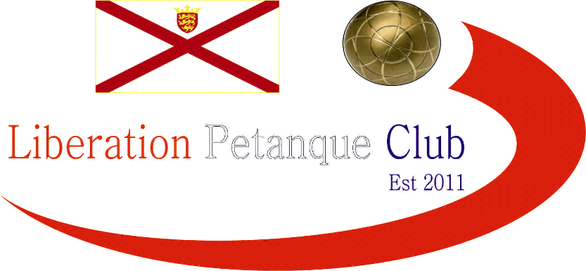

# Summer 2018 Season

# Week 13 – 20.06.18

# Liberation Cup Report

# 

With entries increasing to 15 this year and many new partnerships it was going to be a tough competition.

Well we have to start off with a special mention for Mo De Gruchy and Stephen Stoneman who beat on paper one of the best doubles teams in the Island in Geoffroy Buffetrille and Matt Buesnel 13 – 10. Not bad for the pair especially considering Stephen has only been playing 2 months!!

The biggest win of the round was a 13 – 3 win for Toby Northern & Matt Pinel over Colin & Karen Hidrio. There were also big wins for Alan Oliveira & Craig Kelly over Brigitte & Alice Ibitson and Joey Le Clech & Jonny Hill over Chris Le Gallais & Jean Stewart.

Round two saw the top two teams play each other in Toby & Matt v Jake & Mark. Despite the increase in quality of the opposition Toby & Matt repeated the score from round 1 beating Jake & Mark 13 – 3 with some excellent placing and firing.

Geoffroy & Matt turned disappointment from round one into a positive 13 – 1 win over Colin & Karen. There were good wins for Matt Hutchings & Laurent Pellaton taking their game against David Le Gresley & Paul Bell to the very last end winning 10-9.

Neil Selby & Ross Payne avenged a 13 – 0 defeat in last years Doubles Cup to Joey & Jonny winning 13 – 6. Callum & Cassie Stewart made it two wins against Mo & Stephen.

Brian Harris & Paul Le Moine made it three straight wins in a close game against Callum & Cassie 13 – 8. Alan Oliveira & Craig Kelly moved back into contention after a defeat in round two to Brian & Paul by beating Chris & Jean 13 – 1.

Mo & Stephen continued to provide the shocks by beating another Premier League doubles team in Joey & Jonny 13 – 10, this gave them a chance of making the semi-finals.

Another team making it two wins was Alice & Brigitte who thrashed Geoffroy & Matt Buesnel 13 – 4 and if you can’t guess the score between Toby & Matt v Ross & Neil then the first two rounds scores is a big hint. That’s right Toby & Matt won 13 – 3 for the third straight round.

Going into the final round two teams were on three wins who played each other in Brian & Paul v Toby & Matt but several others on two wins as the final battle for the top four spots reached its climax.

In an incredibly close match Brian fired with his last two boules on the very last end to win the match for himself & Paul 9 – 8 over Toby & Matt. Brian & Paul topping the rankings with Toby & Matt finishing second.

Alan & Craig won a close match against Callum & Cassie 13 – 9 to take third place. Several teams though could have taken forth spot. A big win for Alice & Brigitte over Mo & Stephen ended the fairly tale run for the latter.

Alice & Brigitte finished with 3 wins, 8 BHN and +11 points difference. Jake & Mark recovered well to beat Ross & Neil 13 – 5 to also finish on 3 wins, 8 BHN but their points difference was significantly damaged in their round two defeat to Toby & Matt 13- 3 and only finished + 5 to miss out on a top 4 spot by a narrow margin.

This was exactly what happened to Brigitte last year playing with husband David when they finished 5th by two points on points difference.

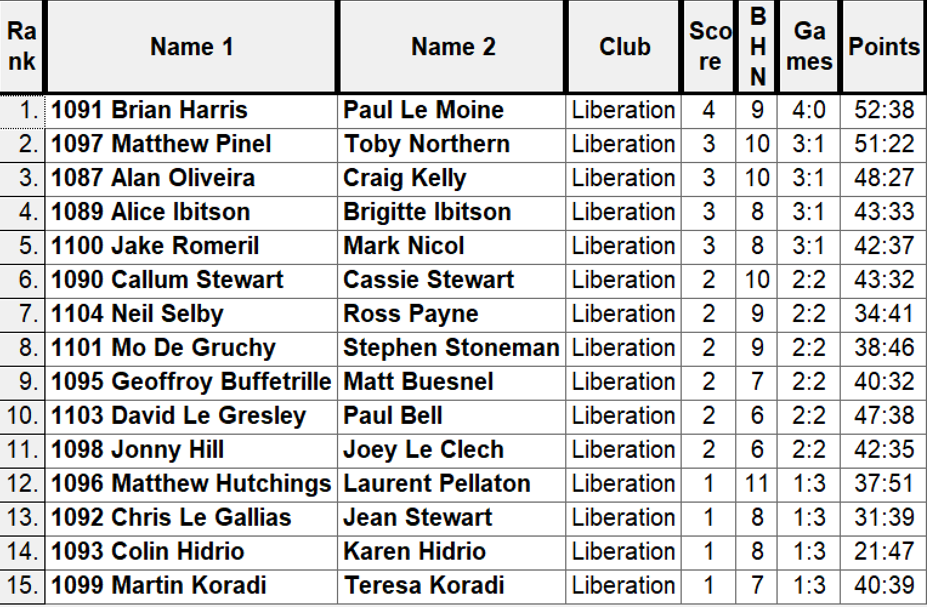

Semi-Finals

Rank 1st Brian Harris & Paul Le Moine v Alice & Brigitte Ibitson Rank 4th

Rank 2nd Matt Pinel & Toby Northern v Alan Oliveira & Craig Kelly Rank 3rd

Well it was a repeat of the 2017 semi-final between Alan & Craig & Toby & Matt. Last year Toby & Matt raced into a 12 – 1 lead before a fight back ending with a 13 – 9 win for Toby & Matt. This year though there was going to be no fight back and not even a point as Toby & Matt fannied their semi-final opponents to make yet another final.

Alice & Brigitte almost got the perfect start against Brian & Paul winning 5 points on the first end and were 6 – 1 and 8 four up before Brian & Paul moved into a 12 – 9 lead. Alice & Brigitte then got two points to make in 12 – 11 but it wasn’t to be as Brian & Paul made the final 13 – 11.

Third place for the second successive year went to Alan Oliveira & Craig Kelly as they recovered from their disappointing semi-final to beat Alice & Brigitte 13 – 2.

With Brian & Paul having already beaten Matt & Toby and actually taken the same numbers of points off them as Matt & Toby’s other 4 opponents put together, they would have been confident of a title win.

The first few ends went Brian & Pauls way as Matt missed a number of fires at six metres to gave away the early advantage. But 13 – 3 seems to be a favourite score line for Matt & Toby as Matt’s firing went back to its usual exceptional best and with Toby constantly out placing Paul and Matt firing all three of Brian’s boules out on the last end as the 2017 (and 2015) champions turned on the style to win 10 ends in a row and hand Brian & Paul a technical fanny winning 13 straight points to become the first team to retain the Liberation Doubles Cup.

Not only that though they handed out several heavy defeats to some exceptional players proving yet again they are the Islands most successful and the top doubles team making it five titles in three years.

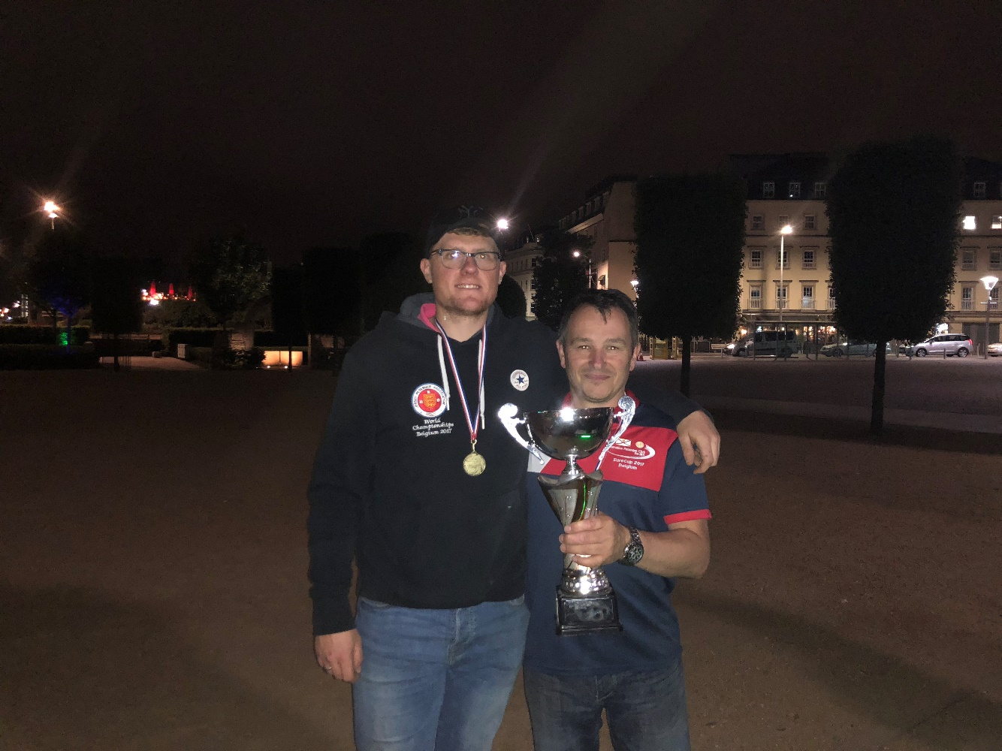

***Special thanks to Ross Payne for setting up and clearing the terrains for the competition really appreciated*** and for members for supporting the club’s tournaments.

Runners Up

Paul & Brian

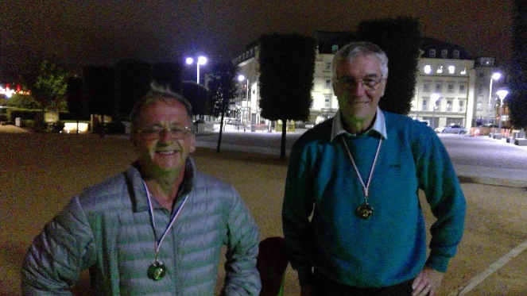

***NEXT WEEK***

**27th June – Singles League – Week 9 & 10**

**(Last Double Fixture Week)**

**WEBSITE** [**www.liberationpetanque.co.uk**](http://www.liberationpetanque.co.uk)

**EMAIL** [**liberationpc@gmail.com**](mailto:liberationpc@gmail.com)

**Kind Regards**

**Toby Northern**

**Chairman**

**Liberation Petanque Club**

SPONSORED BY

# http://nebula.wsimg.com/135a1bd6338e1b589a50cdec98bd84d1?AccessKeyId=C6E923731F1A482DD910&disposition=0&alloworigin=1