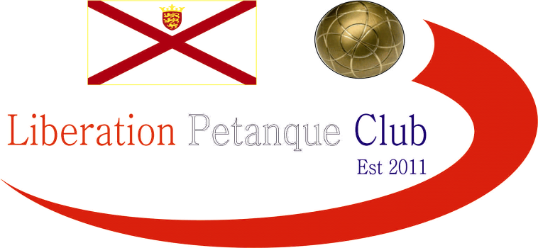

SUMMER – 2021 SEASON
2nd June 2021
Liberation Club Doubles Cup

After 2 last minute withdrawals 14 teams took part this year. Round 1 saw 2019 champions Andrew & Callum overcome tough first round opponents in Gary & Wendy in one of two matches not to go the distance winning 12 – 7. Current Island Doubles champions Geoffroy & Matt started off well with a 13 – 2 win over Daniel & James.

Laurent & Toby started off the best possible way against Jess & Tom taking 6 points on the first end before going on to win 13 – 4 and Branden & Tim won by the same margin against Matt & Mo.

Graeme & Keith just made it over the line 10 – 7 against Kat & Paul.

Round 2 saw Geoffroy & Matt win 13 – 2 again, this time against David & Ross. Branden & Tim made it two from two with a big 13 – 5 win over Graeme & Keith.

Daniel & James also had a big win 13 – 2 over Tom & Jess and Gary & Wendy got their first win 13 -5 over Matt & Mo. Andrew & Callum won again over Cassie & Chris and Alex & Jean lost 5 – 9 to Andrew & Lorna.

The closest match was a 12 – 11 win for Kat & Paul over Laurent & Toby with Paul getting four points for his team on one end with a wayward fire somehow cannoning the right boules out of the way and on the last end Laurent & Toby needed three points to tie with Toby getting two Laurent unfortunately on a difficult terrain get any of his three in for a loss.

In a big shock Daniel & James beat Andrew & Callum 13 – 12 for their second win of the campaign.

Kat & Paul made it back to back wins beating Cassie & Chris 13 – 10 and Geoffroy & Matt won big again 13 – 1 over Branden & Tim. Tom & Jess came from 10 – 2 down against Graeme & Keith to win 13 – 12.

Matt & Mo got their first win 11 – 8 against Alex & Jean and there were two 13 – 3 wins, first David & Ross against Laurent & Toby and Gary & Wendy over Andrew & Lorna.

In the final round Geoffroy & Matt had a much closer match winning 9 – 6 against Gary & Wendy to make in four from 4 to top the rankings with Gary & Wendy missing out finishing fifth.

Daniel & James won their third straight match and a big win 13 – 3 against Kat & Paul to finish second in the rankings with the highest BHN, a great achievement.

Andrew & Callum bounced back in style against David & Ross winning 13 – 2 to finish third and Branden & Tim won 13 – 3 against Alex & Jean to take fourth place.

Jess & Tom won 9 – 4 against Andrew & Lorna and Matt & Mo won back to back matches 13 – 5 over Cassie & Chris. Laurent & Toby luck just wasn’t their as they lost on the end again 10 – 9.

FINAL RANKINGS

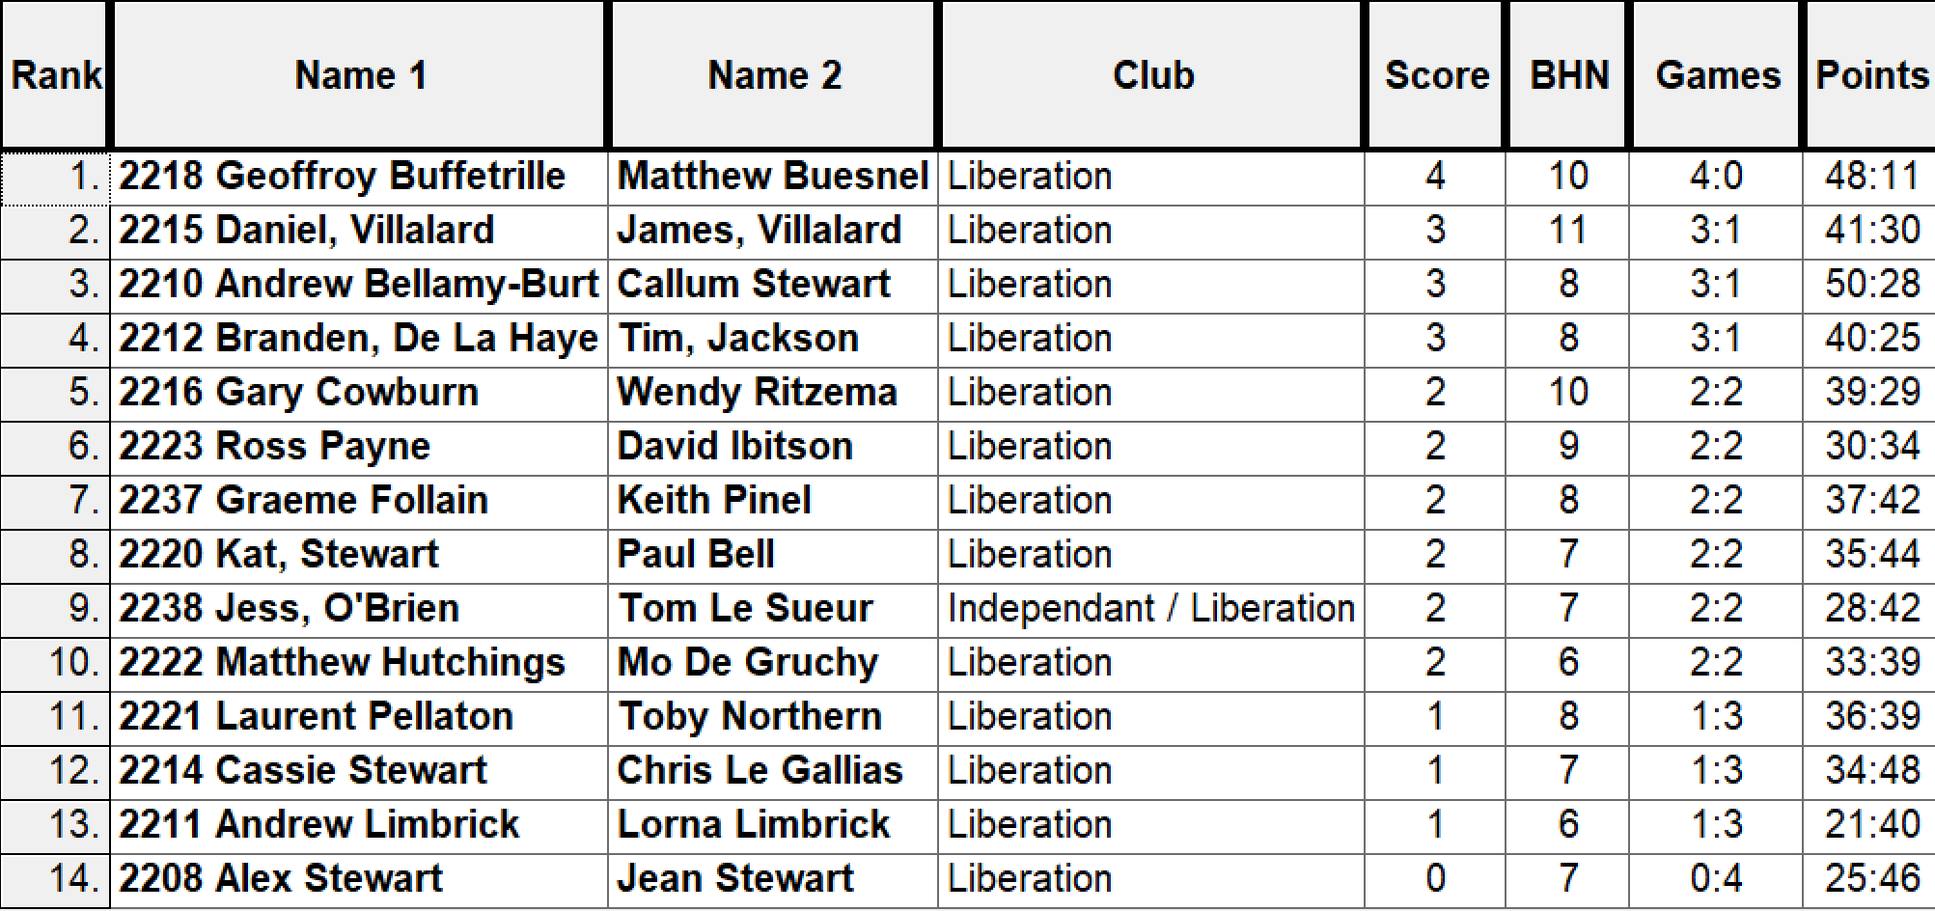

So, the Semi-Finals were as follows:

Ranked 1st Ranked 4th

Geoffroy Buffetrille & Matthew Buesnel v Branden De La Haye & Tim Jackson

Ranked 2nd Ranked 3rd

Daniel & James Villalard Andrew Bellamy-B & Callum Stewart

Well I am sure a few people were hoping for a Daniel & James v Branden & Tim final, but it wasn’t to be as despite both teams playing well Geoffroy & Matt ran out 13 – 0 winners and Andrew & Callum 13 – 2 winners.

Well there has not been a close final for a long time (at least when you look at the score line) and this was the case here as a big 5 point end early in the game gave the advantage to Andrew & Callum and despite some incredible shooting from Geoffroy considering the light, Callum matched it when needed and so many tight ends just went Andrew & Callum’s way as they ran out 13 – 3 winners for their third title.

The third-place play-off went backwards and forwards as Daniel & James shot out of the starting blocks to lead 6 – 0 before Branden & Tim pulled it all the way back to lead 8 – 6. Daniel & James then took a 2 and 3 point ends to lead 11 – 8 before the next end made it 11 -11. But with the match tied at 12 – 12 a great place at distance gave Daniel & James a 13 – 12 win and a fantastic third place finish and not only that they were the only team to beat champions Andrew & Callum

Champions Callum Stewart & Andrew Bellamy-Burt

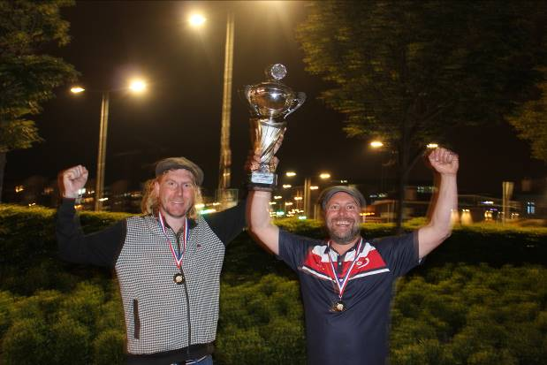

NEXT WEEK - Singles League

Club email address -

Club Website -

Kind Regards

Toby Northern

Chairman

Liberation Petanque Club

