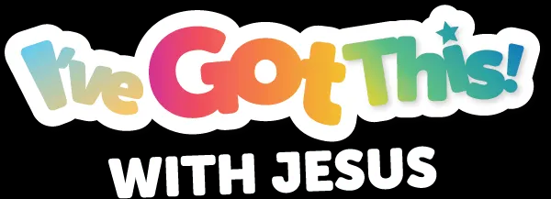

YOUTH/TEEN VIRTUAL VBS LESSON PLAN
Middle District Baptist Association
North Carolina
July 13 - 15, 2021

THURSDAY, JULY 15, 2021

Title of Lesson: WE ARE MORE THAN CONQUERORS

Purpose: During the first two days of VBS, we went from having a battle plan to conquerors. Now students will learn what it means to be MORE THAN CONQUERORS with JESUS! We will use a platform called “It’s About Me!” as a tool and technique to not only get students actively involved, but also to engage students with reflection on learning Bible content.

Learning Outcome: Students will build their trust, faith, and belief on the truth – Jesus Christ!

TIME | ACTIVITY | OUTCOME
6:15pm -6:30pm | GREETINGS | As each student enters the room, the instructors will greet them enthusiastically! We are excited for them to come to Virtual VBS!
6:30pm – 6:35pm | OPENING PRAYER  WELCOME & ICE-BREAKER | Prayer, Welcome and Introduction of each student. Our daily ice-breaker will engage students to know Jesus more.
6:35pm-- 6:40pm | PACE-SETTER:  - Ground Rules finale  - Expectations | We have been in this together, so each student partners with Jesus to proclaim, “I’ve Got This! with Jesus.”
6:40pm – 6:45pm | OPEN THE MAIL  - Lesson Introduction  - Word of the Day | The opening exercise is what is needed for teens to open their Bibles daily, just as they would a text from a friend! Everyday they can open the Good News from Jesus!
6:45pm – 6:50pm | SNACK BREAK  - Bible Memory Verse of the Day | Students will read the memory verse of the day and find an item at their location in which they can relate to the verse. This is not an actual snack break, but a “Bible Verse Break” to taste and see that the Lord Jesus is Good!
6:50pm – 7:10pm | BIBLE LESSON via Mirror Reflection | Use of the Word of the Day, Bible Memory Verse of the Day and the Lesson Introduction to foster learning through various strategies that reflect Jesus.
7:10pm –  7:20pm | LESSON FOR LIFE RECAP FINALE | Each student will relate the Bible Lesson to their individual life. Conversation encouraged. Questions to determine direct application of materials.
7:20pm –  7:30pm | CONQUEROR RECAP CELEBRATION | Closing Activity for retention of learning.
7:25pm –  7:30pm | CLOSING PRAYER & BENEDICTION

