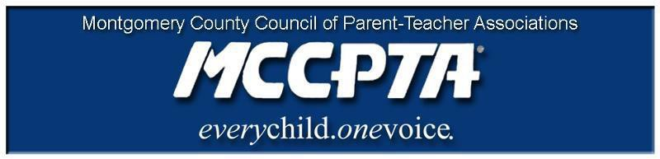

DELEGATES’ ASSEMBLY MEETING AGENDA
Tuesday, February 23, 2021
Meeting Held on Zoom

7:00 pm WELCOME

- Approve Agenda; Approve January minutes

7:05 pm INFORMATIONAL UPDATES

- National/MDPTA Update

7:15 pm OFFICER REPORTS

- Cynthia Simonson, President
- Rodney Peele, Vice President- Educational Issues
- Rochelle Fink, Vice President- Administration
- James Modrick, Vice President- Programs
- Laura Stewart, Vice President- Advocacy
- Khristy Kartsakalis, Treasurer
- All Reports - https://mccpta-my.sharepoint.com/:f:/g/personal/office_mccpta_org/EhwAcYCftEFEv8Et70AG_UsBjiY3VazZ0iaqHiAx1APyPQ?e=4Cr9Bt

7:40 pm COMMITTEE REPORTS

- Membership
- Communications Committee Discussion on e-lists – uses and rules
- Bylaws- MD PTA bylaws amendments (proposals); scope of MCCPTA standing rules
- Awards Update
- Virtual Learning Committee
- Diversity, Equity and Inclusion
- All Reports - https://mccpta-my.sharepoint.com/:f:/g/personal/office_mccpta_org/Enm53T7lfhlFr2j7SUr0cawBmPMfCHWFEv5ve8l4K9yHNw?e=PP6HPK

8:40 pm NEW BUSINESS

- Delegates Meeting- virtual voting approach

8:50 pm ANNOUNCEMENTS & ADJOURNMENT

DATES:

- February 24, 2021 – MCCPTA Diversity, Equity and Inclusion Training for PTAs
- February 27, 2021 – Anti-Vaping Symposium
- February 28, 2021 – MDPTA Bylaws Amendments
- March 2, 2021 – BOE Public Hearing on SROs
- March 4, 2021– BOE Public Hearing on SROs
- March 10, 2021 – BOD Meeting
- March 19, 2021 – MCCPTA Award Nominations Due
- March 23, 2021 – Delegates Assembly
- April 15, 2021 – Blake Cluster Meeting
- April 22, 2021 – Poolesville Cluster Meeting
- May 6, 2021– Gaithersburg Cluster Meeting

